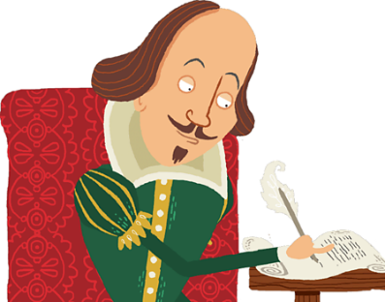
Read the text below about William Shakespeare carefully then complete the questions.
William Shakespeare

William Shakespeare’s Family
William Shakespeare is thought to have been born on 23rd April, 1564 in Stratford-upon-Avon, England. It is not known exactly when he was born, but historians know that he was baptised on April 26th and at that time, people were often baptised three days after their birthday.
William was the third child of John and Mary Shakespeare. His father was a leather merchant and his mother was a local-landed heiress, which basically meant that she came from a wealthy family.
Shakespeare, the Young Man
On November 28th, 1582, at the age of 18, William married Anne Hathaway. Anne was 26 years old when they got married.
They had a daughter Susanna in 1583. Two years later, Anne gave birth to twins – a boy called Hamnet and a girl called Judith. Tragically, at the age of 11 Hamnet died, supposedly from the bubonic plague.
In the mid-1580s, it is thought William left Stratford and arrived in London. The family remained in Stratford. When he first arrived in the capital city, some historians believe that he worked as a horse attendant at some of London’s theatres.
By 1592, he was earning money as an actor and a playwright.
Shakespeare the Playwright
The Lord Chamberlain’s Men was an acting company that William partly owned. Their name was changed to The King’s Men after King James I was crowned the new king of England.
By now, William was beginning to sell some of his written work and by 1597, Shakespeare was beginning to earn a lot of money so he bought the second-largest house in his hometown of Stratford.
However, as it took about four days to get from London to Stratford by horse, William only ever went home during the forty days of Lent when the theatres were closed!
Shakespeare’s Plays
Shakespeare wrote heartrending plays called tragedies and comedy plays. Several of his plays were performed in front of Queen Elizabeth I.
Much Ado About Nothing, The Taming of the Shrew and A Midsummer Night’s Dream are comedies which are based on misunderstandings and mishaps. The tragedies are based around misery, loss and disillusionment. Some of these are Hamlet, Romeo and Juliet and King Lear. Some of his plays have been made into films and cartoons, such as Gnomeo and Juliet, which is the story of Romeo and Juliet retold with two garden gnomes as the main characters!
He wrote about themes which people could relate to: jealousy, anger, love, romance, religion and war.
A Lasting Legacy
Because of Shakespeare, there are over three hundred words and well-known phrases in the English Language that he invented. Some of them are: all that glitters is not gold, fair-play, barefaced, hobnob, wild goose chase, bedazzled, watchdog, lacklustre.
William Shakespeare died on April 23rd, 1616, which was the same day as his birthday, at the age of 52.
Although the cause of Shakespeare’s death is not recorded, some years later, a vicar reported that he died of a fever. Shakespeare had written his will a few months before he died and famously, and rather strangely, left his wife his ‘second best bed’ and all his other
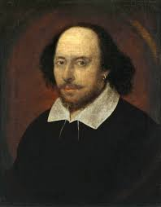
possessions to his daughter.

Each year around the 23rd April, the streets of Stratford-upon-Avon are filled with music, song and performers in celebration of the life of William Shakespeare

.

- How have historians worked out when Shakespeare’s birthday is likely to have been? (2b)

- Look at the second paragraph. Identify two facts we are told about Shakespeare and his family. (2b)

- What word tells us that the cause of Hamnet’s death is unclear? (2a)

- True or false? Read these sentences and rewrite any false sentences so that they are true. (2b)

Around 1585, Shakespeare moved to London.
Anne and the children stayed in Stratford.
Shakespeare became a historian in the capital.
Shakespeare made money as a playwright.

7. What other word could the author have used instead of ‘heartrending’? (2g)

8. Use the table to sort the names of some of Shakespeare’s plays. (2b)
Tragedies | Comedies

9. Why do you think Shakespeare wrote plays about themes that people could relate to? (2d)

Challenge:

What opinion do you have about Shakespeare? Explain your thoughts. (2f)

