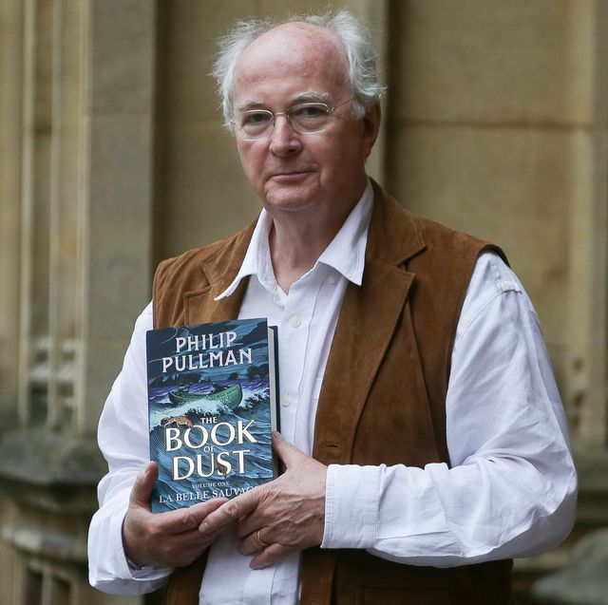
Literacy – biographies continued

Yesterday you should have used your notes to write the first two sections to your biography. E.g. Early life, Education. (If you did not do this look back at the previous days’ learning)

Re-read what you wrote to remind yourself and edit if you need to.

• Past tense
• 3rd person (names person /he/she)
• Chronological order (in date order)
• Time adverbials
• Formal tone or passive voice (eg he was)
• Facts/details
• Quotations (things which Philip Pullman said)

Task:
You are now going to write the next two sections of your biography under your next side headings e.g.
Career
Books he has written

Remember to include the features of a biography listed above. Especially think about including quotations from the video clip you should have watched on Tuesday to help you find quotations. ( look back at Tuesday’s learning if you missed this activity).

Read through everything you have written so far and check that it makes sense and includes all of the detail you found in your research.

