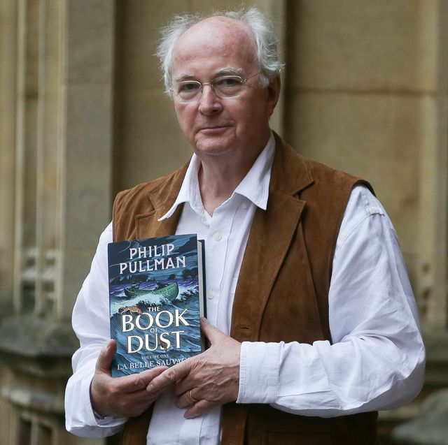
Literacy - biographies

Over the next few days we are going to be writing our biographies of the life of the author Philip Pullman. You have been making notes about him and should have decided yesterday on the side headings you are going to use for your work. We are going to write a bit each day. (If you have missed any of these steps please look back at the previous days’ learning).

By now you should also understand the features needed in this style of writing. It will need:

- Past tense
- 3rd person (names person /he/she)
- Chronological order (in date order)
- Time adverbials
- Formal tone or passive voice (eg he was)
- Facts/details
- Quotations (things which Philip Pullman said)

Today’s Task:

You are going to write the introduction to your biography of Philip Pulman.
You will need to tell your reader some basic details e.g. when and where he was born, what he is famous for, (but not too much information otherwise you will have nothing to write for the middle part). Remember to write 3rd person, past tense using the features bullet pointed above. You could type your work so you can edit it.

It might sound a little like the e.g. below…

Philip Pullman is a much-loved British author who is mainly known for writing children's literature. Born on XXX, in Norwich, he was the son of XXXX and
XXX Pulman. Now aged 72, he has had over 40 of his books published - one of which (The Amber Spyglass) has been made into a blockbuster movie.

Edit and uplevel your work so that it is Year 6 standard.
Make sure you save what you have written so that you can add to it tomorrow.

