The Forbidden City

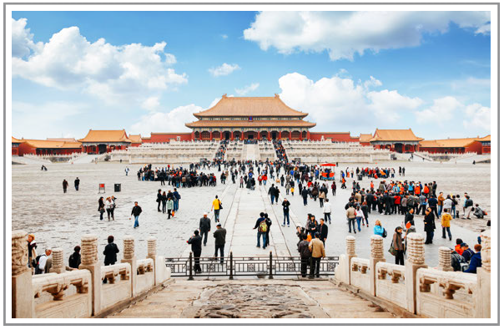

What is the tourist attraction?
Where is it located?
Is it a natural or man-made attraction?
Why do you think it is popular?
Would you like to visit and why?
The Terracotta Army

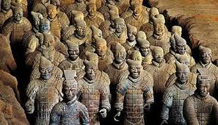

What is the tourist attraction?
Where is it located?
Is it a natural or man-made attraction?
Why do you think it is popular?
Would you like to visit and why?

Leshan Giant Buddha

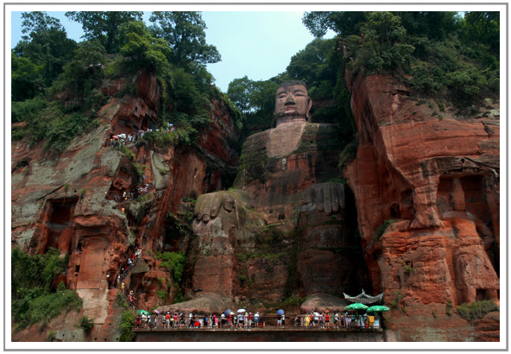

What is the tourist attraction?
Where is it located?
Is it a natural or man-made attraction?
Why do you think it is popular?
Would you like to visit and why?
The Stone Forest

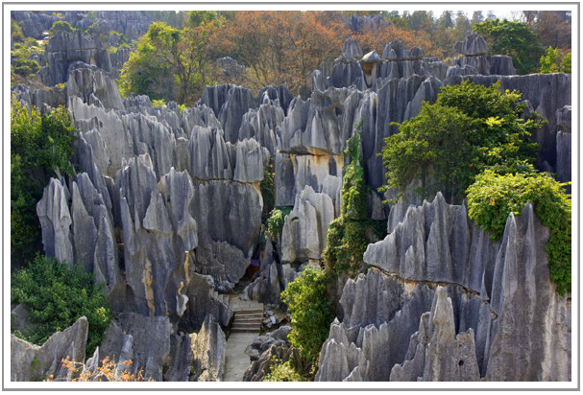

What is the tourist attraction?
Where is it located?
Is it a natural or man-made attraction?
Why do you think it is popular?
Would you like to visit and why?
Jiuzhaigou National Park

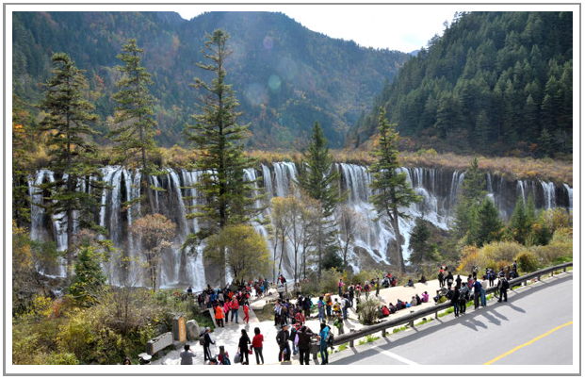

What is the tourist attraction?
Where is it located?
Is it a natural or man-made attraction?
Why do you think it is popular?
Would you like to visit and why?
The Oriental Pearl Tower

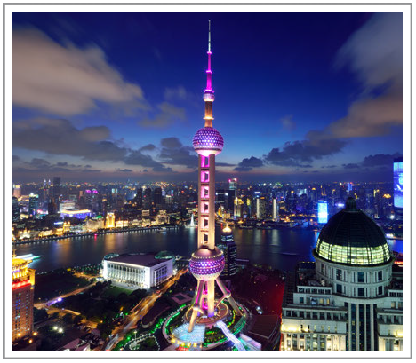

What is the tourist attraction?
Where is it located?
Is it a natural or man-made attraction?
Why do you think it is popular?
Would you like to visit and why?

