Biographies
You should now have lots of notes about the life of Philip Pullman which you are going to use to write a biography of his life.

A well-written biography contains quotes – words that the famous person has said themselves.

- Use the video link below to listen to an interview of Philip Pullman

https://www.youtube.com/watch?v=Yd2TNXC4rxU

- You will need to listen more than once.
- Choose a favourite part of what Philip Pullman has to say and copy it down so that you can use it as a quote in your biography of his life. You can choose several.
- Now you will need to think about how you will organise your biography – it will need to be in sections under side headings.

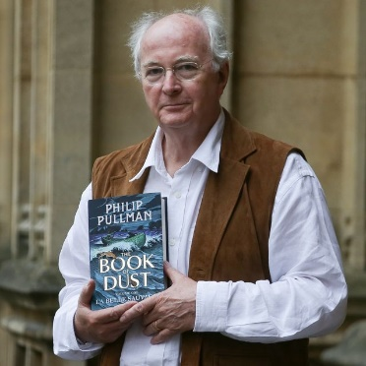
e.g.
Early life/childhood
Schooling
Jobs
Books he has written
Awards he has won

Read through your notes and decide which information will fit under each side heading you have chosen so that you will be ready to start to write your biography tomorrow. Think which information may go in your introduction.

