DT/ART

The children are going to be designing and making some Chinese lanterns similar to the ones below.

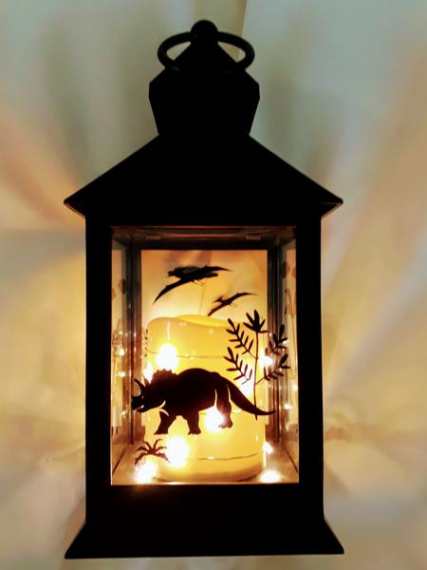
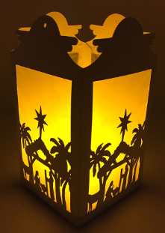

Using the silhouette designs below for ideas, practise drawing some ideas for your own shadow silhouette to go on the sides of your lantern. E.g. Chinese pagodas, dragons. You could colour them in black or cut them out of black paper/card. You can find more ideas on line.

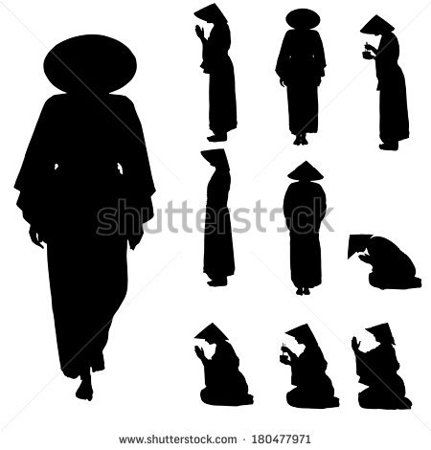
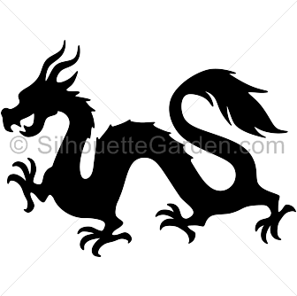

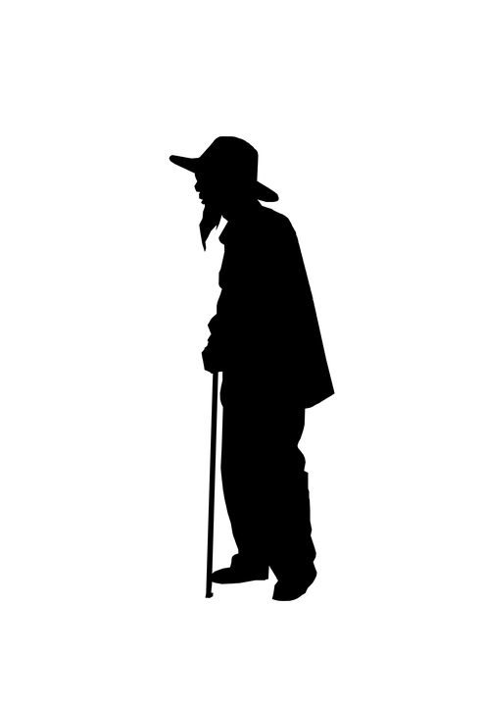

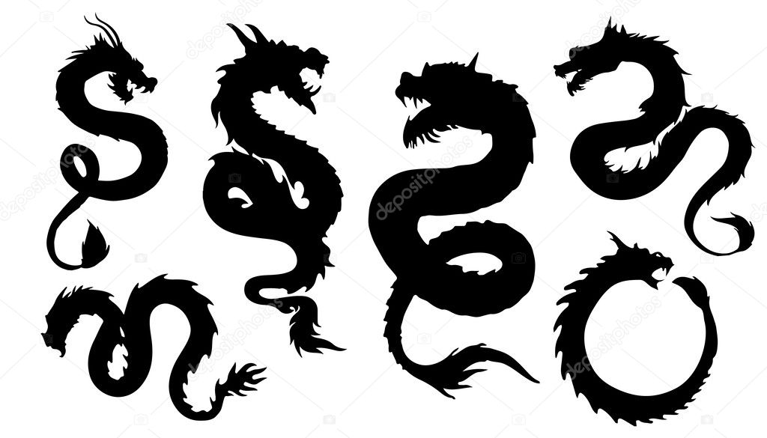

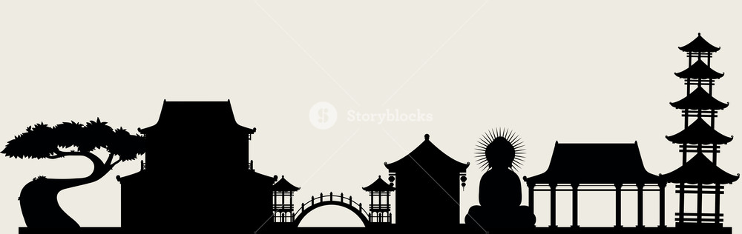

Don’t forget to photograph your ideas and post them on class dojo.

