Re-read the text below from yesterday carefully.

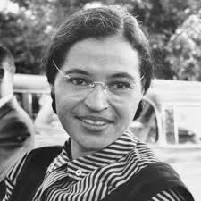
Rosa Parks

Rosa Parks was an African-American woman who made history with her comparatively small action of sitting still on a bus, which went on to spark major changes in American society.

Early Life
Rosa Parks was born Rosa Louise McCauley on 4th February, 1913. After her parents separated, she grew up on a farm with her mother, brother and grandparents in Montgomery, Alabama, USA. She grew up in a time when America was segregated before the Civil Rights Act was enforced.

Segregation in America
Segregation meant black and white people had to be separated by law in many ways. They had separate toilets, water fountains, entrances to public buildings and black and white children had to go to separate schools. It was also clearly apparent that black facilities were of a poorer standard than white families. So not only were black and white people segregated; black people were treated as second-class citizens within society.

The Bus Ride That Changed History
On 1st December, 1955, Rosa Parks was travelling home from work on a bus and sitting – as rules required – in the black section to the rear of the bus. Bus companies prioritised seating for white people and moved black people further back, or made them stand if the white section was full and a white person needed a seat. This happened to Rosa and she was told to move further back to give her seat to a white person … but she refused to move. She was threatened with police action but she stayed sat still, adamant that she would not follow the ‘rules’. Eventually, the police arrested, charged and fined her for breaking the law.

What Happened Next?
Amazingly, Rosa’s defiance unleashed a wave of protest. Around 40 000 black citizens ( and some white citizens) supported the ‘Montogomery Bus Boycott’. The profits of the bus companies fell and the sheer size of the movement could not be ignored. The press reported it all over America and the boycott went on for 381 days. It gained the attention of the USA government and just over a year later, in December 1956, the unfair segregation on buses was lifted.
Rosa’s small actions made history as they acted as a catalyst for the Civil Rights movement, which eventually succeeded. Even though it wasn’t the end of segregation and civil rights still had a long way to go, it was a victory for the rights of black people within society.

“People always say that I didn’t give up my seat because I was tired, but that isn’t true. I was not tired physically, or no more tired than I usually was at the end of a working day. I was not old, although some people have an image of me as being old then. I was forty-two. No, the only tired I was, was tired of giving in.”
Rosa Parks.

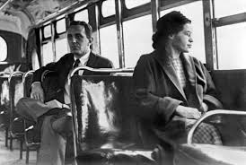

Rosa Parks Refused to move from her seat.

Answer the questions below as fully as you can.
- Where did Rosa grow up? (2b)

- How old was Rosa when she did not move off the bus? (2b)

- What is ‘segregation’? (2a)

- If you ‘boycott’ something what are you doing? (2a)

- What did Rosa Parks do to break the rules? (2f)

- List three places where black and white people had to stay apart from each other. (2b)

- Why do you think Rosa Parks would not move? (2f)

- What was the name of the movement to stop people using buses? (2b)

- In ‘The Bus Ride That Changed History’ why has the author used an ellipsis? (2g)

- In the ‘Segregation in America’ section, the author uses the words ‘second-class citizens’. Explain what you think this means. (2g)

- Near the end of the text, the author writes that ‘it wasn’t the end of segregation when the bus laws changed’. Why wasn’t it the end of segregation? (2g)

- In Rosa’s quote, what was Rosa tired of and why do you think that was? (2d) 2 marks

Challenge

What sort of characteristics and qualities do you think Rosa Parks had? Give reasons for your answers. (2f) 3marks

