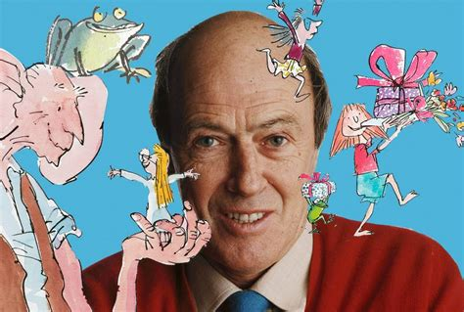
A Biography of Roald Dahl

Roald Dahl was a British novelist, short-story writer, poet, screenwriter and wartime fighter pilot. He is often considered one of the greatest children’s storytellers of the twentieth century. His books have sold more than 250 million copies worldwide.

Childhood
The famous children’s author was born in Llandaff, Cardiff, on 13th September, 1916. Both of his parents were Norwegian and as a boy Roald Dahl was bilingual, speaking both Norwegian and English. He was named in honour of the Roald Amundsen, the famous Norwegian, who was the first explorer to reach the South Pole. His father was a shipbroker. It was a large family; Dahl had four older siblings, his two sisters and an older brother and sister from his father’s first marriage.
In February 1920, Dahl’s older sister, Astri, died from an infection caused by a burst appendix. Within weeks, his father had also died of pneumonia. In his autobiography, Dahl described his father as “overwhelmed with grief” for his daughter. At the time of his father’s death, Dahl’s mother was expecting a baby girl, Asta, who was born later that year.
Dahl’s mother, Sophie, found herself solely responsible for five young children and far away from her home in Norway. Even so, they remained in Wales. At first, Dahl went to local schools, but in 1925, he was sent to a boarding school - St Peter’s in Weston Super Mare. When he was 13, he moved to Repton, a public school near Derby. Dahl didn’t enjoy his time there, and later wrote about how he was treated badly by some of the other boys.

Early Career
When he left Repton in 1934, he took part in an expedition to Newfoundland and then went to work for Shell Oil. Although his mother wanted him to study at Oxford or Cambridge University, Dahl wanted to work for a company that would send him to “wonderful faraway places”. He got his wish, as he worked in Dar-es-Salaam in Tanganyika (now Tanzania) from 1938, until the outbreak of the Second World War.

The War Years
In November 1939, Dahl enlisted in the Royal Air Force and learnt to fly. In 1940, he was posted to Libya, where in September 1940, he was badly injured in a plane crash. It took six months for him to recover from his injuries in Egypt. He returned to his squadron in 1941 and began flying fighter planes. While he was there, he began to suffer terrible headaches as a result of the injuries he sustained in the crash. In the summer, he had to return home to his mother, who by this time was living in Buckinghamshire.
Although he couldn’t fly anymore, Dahl was still able to help the war effort and in 1942, he was sent to Washington D.C. to work at the British embassy. It was in Washington that he began to write, encouraged by C.S. Forrester. At that time, his writing was aimed at an adult audience and he began to get published.

Writing and Family Life
In 1951, he met his future wife, an American actress, named Patricia Neal. They married in 1953 and went on to have five children together. In 1954, they made their home in Great Missenden, Buckinghamshire.
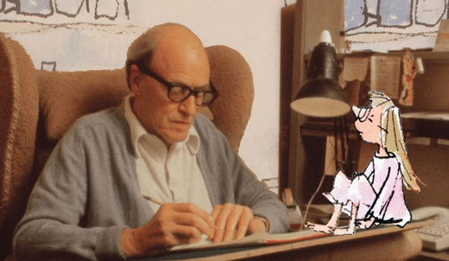
Dahl wrote successful books, plays and television scripts throughout the 1950s. In 1961, his first well-known children’s book, James and the Giant Peach was published. He went on to publish many well-loved children’s books such as Charlie and the Chocolate Factory (1964), Fantastic Mr Fox (1970) and The Twits (1980), to name but a few. Dahl wrote his stories in a writing hut in the garden of his house, which children were forbidden to enter! In the hut, he invented over 500 words, such as “biffsquiggled” (confused or puzzled) and “gobblefunk” (to play around with words, just like he did.)
In 1962, his daughter, Olivia, died from measles. She was seven years old, the same age as his sister had been when she died. Dahl kept a picture of Olivia in his writing hut and both James and the Giant Peach and The BFG are dedicated to her.
In 1981, he separated from Patricia Neal and in 1983, he married his second wife, Felicity Crosland.

Death and Legacy
Roald Dahl died in Oxford on 23rd November 1990 and is buried in the parish church of St Peter and St Paul in Great Missenden. This town is now home to the Roald Dahl Museum and Story Centre.

COMPREHENSION: A Biography of Roald Dahl

① Where did Roald Dahl’s parents come from? (2b)
② Why was he called Roald? (2b)
③ What was the cause of Astri’s death? (2b)
④ Why was Dahl pleased with his new job at Shell Oil? (2b)
⑤ How might Dahl have felt, when he wasn’t able to fly anymore? (2d)
⑥ Why do you think Roald Dhal invented new words? (2d)
⑦ Where is Roald Dahl buried? (2b)
⑧ Why is the Roald Dahl Museum in Greta Missenden? (2d)

CHALLENGE: What did you learn about Roald Dahl’s life that surprised you? Explain why. (2f)

