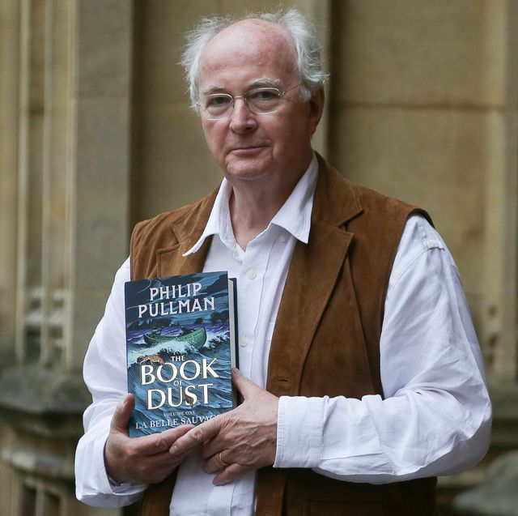
Literacy – biographies continued

Yesterday you should have used your notes to write the introduction to your biography. (If you did not do this look back at the previous days’ learning)

Re-read what you wrote to remind yourself and edit if you need to.

• Past tense
• 3rd person (names person /he/she)
• Chronological order (in date order)
• Time adverbials
• Formal tone or passive voice (eg he was)
• Facts/details
• Quotations (things which Philip Pullman said)

Task:
You are now going to write the next two sections of your biography under your first side heading e.g.
Early childhood/life.
Schooling

Remember to include the features of a biography listed above.

