CHALLENGE:

Q1 Jemma thinks of a number. She says,
'Add 3 to my number and then multiply the result by 5 The answer is 35'
What is Jemma's number?

Q2. The three numbers on each line add up to 763
Write in the missing numbers.
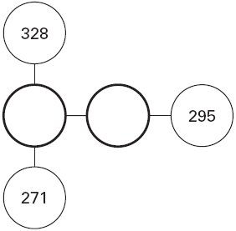

Q3. Josh thinks of a number.
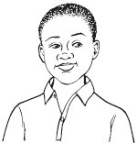
He adds 4
He multiplies his result by 3
Then he takes away 9
His final answer is 90
What number did Josh start with?

Q4. Emily chooses two numbers.
She adds the two numbers together and divides the result by 2
Her answer is 44
One of Emily’s numbers is 12

What is Emily’s other number?

Q5. Liam thinks of a number.
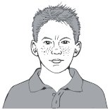
He divides it by 9 and then adds 25 to the result.
His answer is 36
What number did Liam start with?

Q7. A shop sells jars of honey and honey dippers.
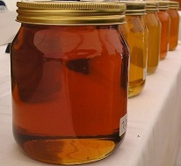
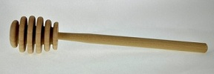

Chen bought three jars of honey and a dipper.
The total cost was £5.40
The dipper cost 75p.
How much did each jar of honey cost?

Q8. Seb bought 2 apples and 3 pears.

He spent £1.59 altogether. | 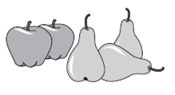

Apples cost 24p each. How much does one pear cost?

SUPER CHALLENGE
Q9. Ben thinks of a number.
He adds half of the number to a quarter of the number.
The result is 60
What was the number Ben first thought of?

Q10. Sima thinks of a number.
She divides it by 12. Her answer is 26.
What is the number Sima thinks of?

