Year 5 & 6 science
Summer Term 1
Living things and their Habitats.
Week 3:
Prior Learning
- What did you learn last lesson?
- What animals did you find in your chosen habitat?
- What plants live there?

This week you will use keys to classify and sort animals into groups.
Activity 1
Living things jigsaw (separate sheet)

Activity 2
Complete the animal flow chart activity (separate sheet)
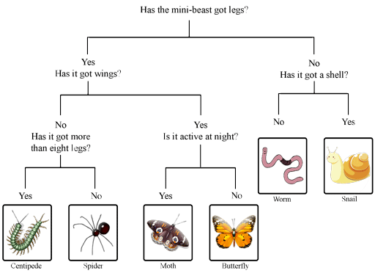

Challenge:

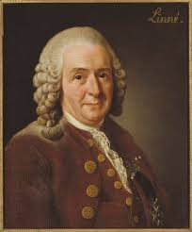
Research the work of Carl Linnaeus, a pioneer of classification.
Produce a fact file on his work.
What was he famous for?
When and where was he born?
Research and include these key terms in your fact file.
- Taxonomy
- Binomial nomenclature

Be as creative as you would like with your fact file. It could be presented in the form of a word document, a poster, or a small booklet.

Then upload photos of your completed activity onto Class Dojo for Dojo Monster points.

Have fun!!

