P.E. – Week 2 – Host your own Olympic Games!
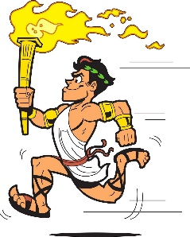
After completing your topic work on the ancient and modern Olympic Games, you (and your family) could host your own Olympic Games!
Think of which events are possible for you and your family to compete in, and preferably outside to avoid injuries and damages.

Some ideas you may want to take part in:
- Throwing events (inspired by discus and javelin)
- A range of running events, including hurdles
- Gymnastics (please be careful!)
- Ball games – volleyball, netball, basketball, football
- Racquet games – tennis, badminton, table tennis
- Curling (on a hard/laminate surface)

You could hold your own opening and closing ceremony with marching and music. Each person involved could design a flag that will represent them in the games.
Keep score of points or just participate for the excitement,
but most importantly have fun!
Take photos of your Olympic Games for your teacher on Class Dojo!
