Literacy - Week 3 11.5.20
Monday 11th May
Task 1 – read the following text about the Trojan war.
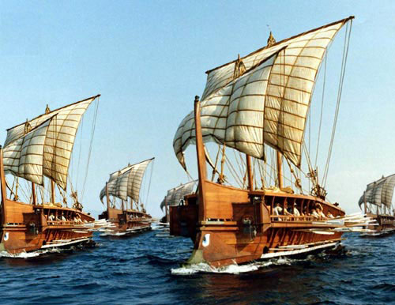
The Trojan War

Many great heroes of Greece and Troy fought a bloody battle to the death, all because a handsome prince fell in love with a beautiful, but already married, young woman.

The Cause of the Trojan War.
Troy was among the greatest cities in the ancient world. It was surrounded by mighty walls, so huge they were considered impenetrable. One of the Trojan princes who lived in the city was called Paris.
One day Paris travelled to Greece to meet the king, Menelaus, and Helen his wife, who was undoubtedly the most beautiful woman he had ever set eyes on. Instantly Paris fell deeply in love with her; so deeply that he secretly asked her to go back to Troy and live with him there, for ever. Initially Helen would not hear of it, but eventually Paris Persuaded her, and they secretly eloped while Menelaus was away from the country.
It is not difficult to imagine the king’s bewilderment and anger when he returned. He sent his messenger to ask the Trojans to ensure the immediate return of Helen to Greece, but when the Trojans refused, he brought together his best ships and bravest soldiers under the command of Agamemnon, his brother. It was thus that the Trojan War started.

The Greek hero Achilles.
Legend has it that one of the great Greek heroes who fought in the Trojan War was Achilles, a half-god, being the son of Zeus, the Greeks’ most important god.
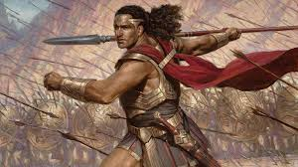
When he was a baby, Achilles’ mother had dipped him in the magic waters of the Styx River. This meant every part of his body was thus protected from harm, except the heel by which his mother had held him when she dangled him in the waters. To give him extra power and strength his mother fed him on lion meat and the marrow from bear’s bones. So it was that Achilles grew to become a strong, powerful soldier who could fight any battle, and without fear of ever being wounded!

One such battle led to the death of Paris’s younger brother, Hector, but eventually Paris brought this revenge. One day, when
Achilles was kneeling at his heel, killing the hitherto invincible hero. To this day, people talk of someone’s Achilles’ heel, meaning his or her weak point.

The Trojan Horse
The brave warriors on both sides continued to fight and to die. Neither side seemed to be getting the upper hand in the conflict. In desperation, the Greek hero Odysseus devised a plan. They would build a huge wooden statue of a horse and leave it as a religious offering. Out of sight of the Trojans, they constructed the huge wooden horse, but unbeknown to the Trojans a large number of Greek warriors hid inside the wooden statue. Then the Greeks made a great issue about gathering together all their troops, boarding the ships and sailing away from Troy.
Delighted with the apparent retreat of their enemy, the Trojans opened the gates and flooded out of their city. As they were celebrating they cam across the horse. Intrigued, they poked it and tapped it, and then found Sinon, a Greek soldier hiding nearby. They threatened him with swords and spears, forcing him, so they thought, to divulge the secret of the horse. Sinon said that if the Trojans ‘captured’ the horse, the Greeks would be so demoralised they would never return to threaten Troy again.
The Trojans were delighted! Their strongest men heaved and dragged the wooden monster into the city, needing to destroy part of the city wall in the process as it wouldn’t fit through even the widest gate. That night there was a great celebration in Troy with feasts and dancing, and lots of liquor! Later, with everyone exhausted and sleeping soundly, Sinon crept up to the huge horse and released the Greek soldiers. Then he ran to open all the city gates to let in the other Greek soldiers, whose boats had returned under the cover of dark.

It was a rout! The Greeks totally destroyed the Trojan army before it could properly gather itself, and set fire to the city. Helen was taken captive and forced to return to King Menelaus, and the long, bloody, Trojan war ended.

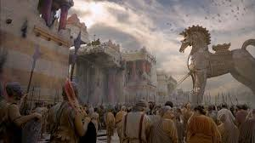

Task 2:
Answer the questions on a piece of paper and photograph and post on Class Dojo.
Answer T true or F false…

- The Trojan War was fought between the people of Troy and Greece.
- Most of the Greek soldiers came from the city of Athens.
- Menelaus was the king of Greece.
- His wife was Helen.
- Paris forced Helen to run away with him.
- They eloped while Menelaus was visiting his mother.
- Achilles was the greatest hero Greece has ever had.
- It was totally impossible for him to be killed.
- The Greeks built the Trojan horse.
- The Greeks won the Trojan War, and Helen returned to Greece.
Task 3:
- In your own words, describe what caused the Greeks to declare war on the Trojans?
- Why do you think Helen didn’t go away with Paris as soon as he asked her?
- What clues can you find in the passage to show that the two armies were fairly evenly matched?
- In the text what do the following phrases mean? Write them in your own words
- They secretly eloped
- The king’s bewilderment and anger
- Hitherto invincible hero
- Unbeknown to the Trojans
- It was a rout.
Task 4: Use a dictionary to help you match each of these definitions to a word in the grid.
The first one is done to help you. Take a photograph for class dojo of your tasks.

 | A | B | C
1 | eventually | heaved | divulge
2 | ensure | initially | intrigued
3 | devised | instantly | invincible

- Reveal, or let out C1
- At once, or immediately
- In the end
- Invent, or worked out
- Lift with effort
- Impossible to beat
- Fascinated
- At first
- Make sure

