Ancient Greece – Week 3 – Years 5 & 6 – Summer Term

Fun fact: The Ancient Greeks invented the first Olympic Games in 776 BC in Olympia!
The Olympic Games are held every 4 years in a different city across the world. Nowadays, countries compete against each other to win medals for their achievements in a range of sports.
Do you know where the next Olympic Games are to be held?
(Answer: Tokyo, Japan)

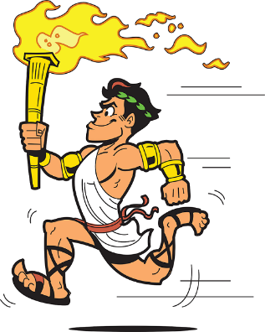
Follow this link to watch a short video about the Olympic Games:
https://www.youtube.com/watch?v=VdHHus8IgYA
In Ancient Greece, only men were allowed to compete and they had far less sporting events. The event would still take place every 4 years with around 50,000 Greeks travelling to watch and take part. The games were a religious festival to Zeus, the King of Gods. Winners didn’t receive medals, they received a wreath of leaves.
Follow this link for more facts about the Olympic Games and pictures:
https://www.bbc.co.uk/bitesize/topics/z87tn39/articles/z36j7ty
Task:
Complete the Venn diagram on the next page (or create your own on paper), and fill in the sections using the internet to show which events at the Olympic Games are modern events, ancient events or both ancient and modern events! Hint: if an event is held in both the modern and ancient games it should be placed in the middle, where the circles cross over!
Take a picture of your finished Venn diagram for your teacher on Class Dojo.
Challenge (optional):
Create an advert/poster to advertise either the modern day or ancient Olympic Games on paper or electronic. Use the events you have researched to help your advert. Think of a catchy title/slogan for your advert.
Take a picture of your finished advert/poster for your teacher on Class Dojo.

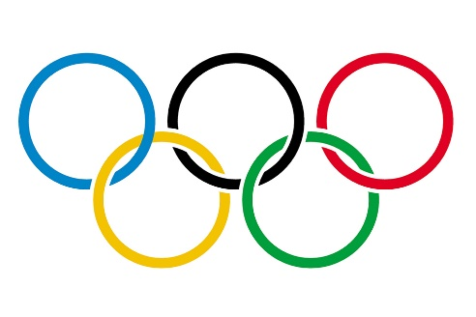
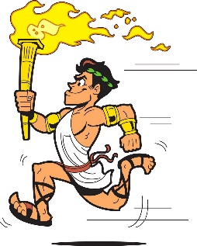
Boxing
Volleyball
Chariot Racing
Ancient Greece
Modern Day
The Olympic Games

