We are going to be learning about biographies.
A biography is when someone writes the story of another person’s life (remember the prefix ‘bi’ = 2 so a biography takes 2 people).
Read through Jeremy Strong’s biography below and see if you can find examples of the text features in the attached ‘features of a biography’ table. Repeat for the second biography on Anthony Horowitz.
(If you haven’t got a printer just write the features down on a piece of paper).
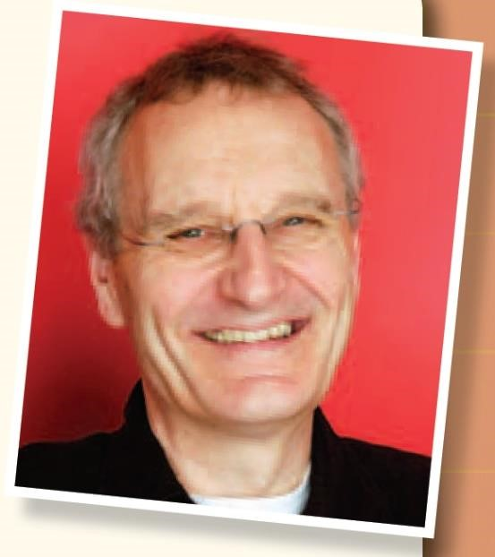
Biography

JEREMY STRONG

Jeremy Strong was born on November 18th 1949.
At the age of three, he fell out of an upstairs window. The head-first landing resulted in: a) an acceptance that the scientists who say humans can’t fly were probably right, and b) a slightly scrambled brainbox, re-wired to look at things in an oddly different way from the rest of us.
His mother, a teacher, was from Northern Rhodesia (now called Zambia), and her stories of life in the wilderness, full of lions and deadly snakes, fed his imagination. He inherited his writing skills from his father, who, although he was a chemist, had also written three novels. With his sister and two brothers he grew up (quarrelling, as you do) in a house on the outskirts of London. The garden backed onto fields, so his free time was spent playing and exploring in the wild outdoors. As a result he was happy, healthy, and generally suffering from some kind of injury or other – scratches from branches and scuffles, and bruises from falling out of trees.
He enjoyed reading, particularly
Rudyard Kipling’s Just So Stories.
No comics or pop music were allowed at home – so at school he would keenly read any comics his friends had.

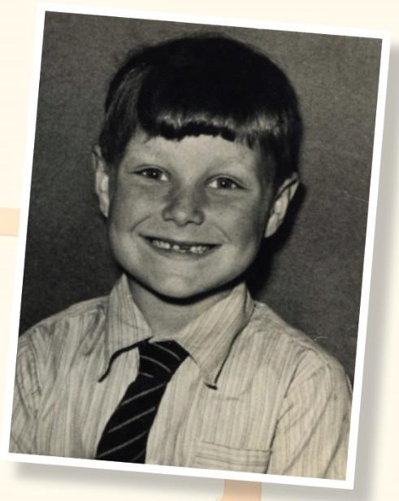
Beginnings
Jeremy was successful in only four areas of school life: playtimes, lunchtimes, going home...
and writing stories. He was fortunate in having a teacher in Years 3 and 4 who not only encouraged him to write, but also told him that his stories were very good. Looking at the shelves of books in his local library, he dreamt that one day somebody would pull one of his books down from the shelf and actually enjoy reading it.

Development
After leaving school Jeremy went to university to study English, and got a job in a bakery, stuffing jam into doughnuts. When not at work he was writing stories, perfecting his craft. Training as a teacher, he took a job in a primary school, and moved away from writing for adults to concentrate on books for children.

The finished article
Over the years Jeremy climbed his way up the teaching tree to the giddy heights of Headmaster, writing in his spare time. By 1991 his books were successful enough for him to become a full-time writer. Since then he has averaged three or four books every year, and his total is currently over seventy. His home today is in Bradfordon-Avon near Bath, and when not writing he spends his days visiting schools, looking to inspire new young writers. He lives with his second wife Gillie, her two children and his cat Jeeves.

Timeline

1949 Born in Eltham, South-East London
1954–1968 Educated at Wyborne Primary School thenHaberdashers’
Aske’s, both in London
1969–1972 Studied English at York University
- Trained to be a teacher at College of Ripon and St John, York
1974–1991 Taught at various schools in the south of England
1978 Published first book, Smith’s Tale
1997 The Hundred-Mile-An-Hour Dog won Children’s Book of the Year Award

Jeremy Strong’s books have won many awards:
1997 The Hundred-Mile-An-Hour Dog won the Children’s Book of the Year Award.
2004 My Granny’s Great Escape won the Prix Chronos Award.
2006 Stuff won the Manchester Book Award.
2008 Beware! Killer Tomatoes won both the Sheffield and Leicester Book Awards.

Autobiography

My (Not So Serious) Story
By Jeremy Strong

Children often ask me why my books are always ‘funny’. I suppose my sense of humour has always been a bit wacky. As a child I loved Spike Milligan’s daft poetry, and I like to think that some of that surreal daftness comes through in my books.
Maybe it was the bang on my head when I fell out of the window, but my imagination has always been rather odd. I remember not wanting to throw a sweet wrapper into an empty bin because I thought it might feel lonely in there on its own. I ended up tearing it in half so that each piece would have a friend to talk to. Bizarre? Yes, I suppose it is.
I have tried to write serious books. In fact my Viking books were originally intended to be the gruesome adventures of a quite vicious character. The problem was that I didn’t really enjoy the brutality of it all, so I started to add funny bits to lighten it up. Before I knew it he’d turned into a rather lovable, cuddly, comic Viking.
My brain is always ready, waiting for the next idea to hatch. It might be something I see or hear on the street, or even a dream. Wherever I go I carry a notebook so that I can jot down ideas. Some of them never come to anything, and some may stay as notes for years before I come back to them. Once my mind gets to work on a new story I have to spend weeks writing down ideas, fleshing out my characters, deciding how the plot line will go, sorting out problems, and generally staring out of the window while the brain cogs slowly turn.
After all that planning, the writing’s the easiest part. Mind you I don’t always get it right first time. One of my favourites, The Hundred-Mile-AnHour Dog, had to be written three times before my publisher was happy – it took me the first two goes to realise that it would be much better written in the first person, through the eyes of Streaker’s owner, Trevor. Which shows you’re never too old to learn!
Most of my writing is done in my garden ‘shed’ (it’s actually quite grand, with a huge desk and even a fridge), under the watchful eye of Jeeves. Like any other writer though, I never know when my mind is going to start churning words out, so I also write ‘on the move’, wherever I happen to be.

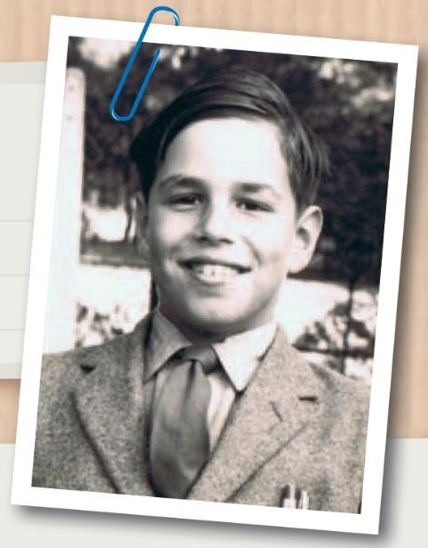
Biography

Anthony Horowitz

THE BOY:
Born: April 5th 1955 in
Stanmore, England (at the northern edge of London).

Family: A middle child with an older brother and younger sister. Father worked as a solicitor but he was very mysterious and never talked about his work. Much closer to his mother who introduced him to books and used to read horror stories to him at night.
Had a 'truly evil' grandmother (Anthony’s words)!

Lifestyle: Big house, lots of nannies, gardeners, butlers but not much fun.
Packed off to boarding school ASAP. The Tintin adventure books inspired him to become a writer. Loved spy adventures, especially James Bond.

Education: Orley Farm boarding school (boys only) from age 8.
Nightmare of a place with vicious staff and a brutal Headmaster. Used stories as a way of escape…telling stories to entertain the other boys. Moved on to happier times at Rugby School and the University of York.

THE MAN:
Career: Knew he wanted to be a writer from age 8. First book to be published was Sinister Secret of Frederick K Bower in 1979 at age 23. Researches thoroughly before writing, travelling to places where books set, trying to experience at first hand what characters experience in books. People from life often appear as characters in his books (yes, including that Headmaster).

Family: Married Jill Green in 1988, in Hong Kong. Ceremony in Chinese so didn’t understand a word! Two sons: Nicholas Mark (b. 1989), Cassian James (b. 1991).
Hobbies: Travel, scuba diving, going to cinema (fav. film The Third Man spy adventure).

Pets: Chocolate Labrador, “Lucky”.
Run over twice, so probably not!

THE BOOKS:

Major breakthrough: The Diamond
Brothers series, heroes Nick and Tim.
The Falcon’s Malteser was turned into a film (Just Ask for Diamond).

Most famous for: Teen spy adventure series about 14-year-old spy Alex Rider, who works undercover for MI6. 12 million copies sold worldwide. Also hit TV drama series, Foyle’s War.
Awards: Red House Children’s Book
Award, 2003, for Skeleton Key. The
Lew Grade Audience Award at the BAFTA Television Awards for Foyle’s War in 2003.
British Book Awards – Children’s Book of the Year for Ark Angel, 2006. In 2008, Anthony made the National Year of Reading’s first Champion Author.

Also written: 22 two-hour films for Foyle’s War! Plus Collision, Midsomer Murders, and Poirot.
Feature films – The Gathering (horror) and Stormbreaker.

TIMELINE:
1955 Born April 5th, London
1963 Sent to Orley Farm boarding school
1979 First book published
1988 Got married in Hong Kong
2000 First Alex Rider novel, Stormbreaker, published
2006 Stormbreaker feature film released
2009 Crocodile Tears published, (Alex
Rider series book 8)

