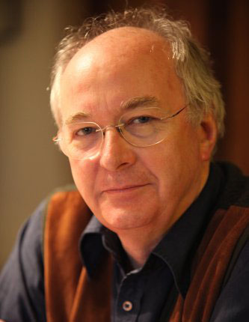
What can you find out about Philip Pulman?

Where was he born?

When was he born?

Who were his parents?

Where was he educated?

What jobs has he had?

Family…

What books has he written?

First book -

Awards he has won:

Other information…

