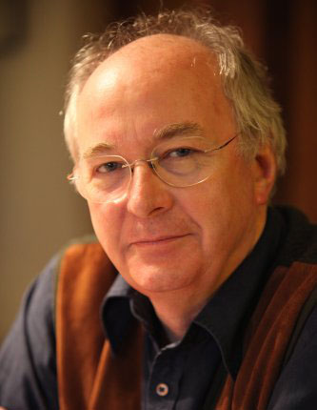
Biographies

We are going to write our own biography about the life of Philip Pullman the author who wrote ‘The Firework Maker’s Daughter,’ which we have been reading in class.

You will need to look at Literacy task sheet 2 and 3 too.

You are going to read and research information about his life and make notes under the headings on Literacy task sheet 3. You will need these notes for your work over the next week of literacy lessons so make sure that you write down lots of detail.

Read the information below, which was taken from the back of ‘The Firework Maker’s Daughter,’ to get you going. Make notes under the questions on sheet 3.

About the author – Philip Pullman

Philip Pullman was born in Norwich, Norfolk. He spent a lot of his childhood on board ships, as his father and stepfather were both in the Royal Air Force and his mother and brother seemed to be constantly following them around the world by sea.
Philip read English at Oxford University and for a long time he taught in schools before becoming a full time writer. He is now one of our best storytellers. He has written many books for children and has won numerous awards for his work.
The Firework Maker’s Daughter was a Gold Medal Smarties prize-winner. Clockwork a Silver Medal Smarties prize-winner, and Northern Lights, the first volume in his trilogy. His Dark Materials, won the Carnegie Medal and was joint winner of the Guardian Children’s Fiction Prize. His novel The Amber Spyglass was the first ever children’s book to win the overall Whitbread Award. The His Dark Materials trilogy has been made into an acclaimed production at the National Theatre and a TV series.
Philip Pullman lives in Oxford, and is married with two sons.

Now read the information about Philip Pullman on Literacy sheet 2 and add more detail to your notes.
We will continue with your notes next Monday so don’t worry if you have not found out all the information you need. Make sure that you keep your notes safe.

If you enjoy the work of Philip Pullman his books ‘His Dark Materials’ have been made into a tv series currently on a Sunday evening. Click on the link below to watch a trailer.
https://www.youtube.com/watch?v=64JAZKy8BpA&ab_channel=BBC

