Maths – Year 5 – Week 9 – Identify, Describe & Classify 2D & 3D Shapes Based on Properties

This week, we are going to be looking at 2D and 3D shapes – their mathematical names, as well as the properties used to classify them.

Click on the links below to access the learning for each day.
You can work on paper if you wish to, or take a picture of your screen of work for your teacher on Class Dojo.
The activities below have been designed so that you can complete 1 activity a day. You do not have to stick to the schedule below, and you can merge the activities together if you wish to do so.
Day 1 – Introductory Quiz
https://classroom.thenational.academy/lessons/to-identify-describe-and-classify-shapes-based-on-the-properties/activities/1
Day 2 – Video
https://classroom.thenational.academy/lessons/to-identify-describe-and-classify-shapes-based-on-the-properties/activities/2
Day 3 – Main Teaching
https://classroom.thenational.academy/lessons/to-identify-describe-and-classify-shapes-based-on-the-properties/activities/3
Day 4 – Quiz
https://classroom.thenational.academy/lessons/to-identify-describe-and-classify-shapes-based-on-the-properties/activities/4

Day 5 – Measure & Identify Angles around a Point
Follow the link for video & examples:
https://www.bbc.co.uk/bitesize/articles/zdp8bqt

Then, complete the worksheet:
1) Calculate the missing angles of these right angles (90º):
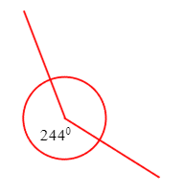
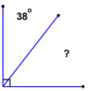
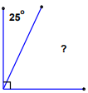
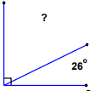
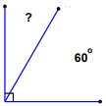
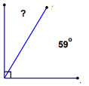
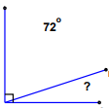
2) Calculate the missing angles of these straight lines (180º) and full circles (360º):
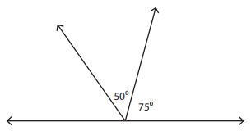
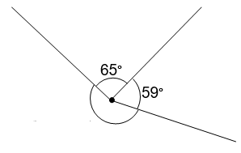
a) b) c)
b
a
c
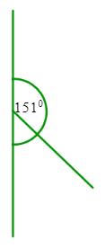
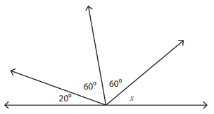
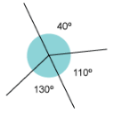
d) e) f)
f
d
e

