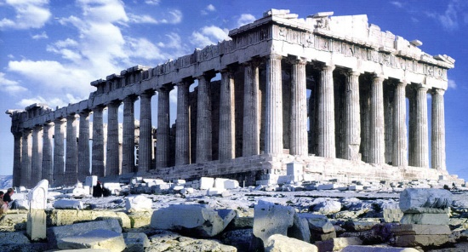
Art – Week 9 – Greek Temples
The Ancient Greeks believed that the secret to making a great building was maths. They carefully designed and measured their buildings, making sure they got all their angles, shapes and sizes right.
Their temples were held up with stone columns and sometimes decorated with stone carvings of famous battles from Greek myths.
There were three main designs of columns in Greek architecture:
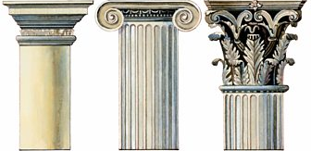

Doric Ionic Corinthian
Task: Can you make or draw a Greek temple?
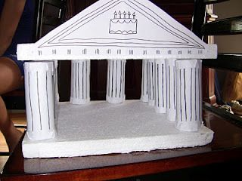
You could make a 3D temple out of straws, Lego or cardboard…
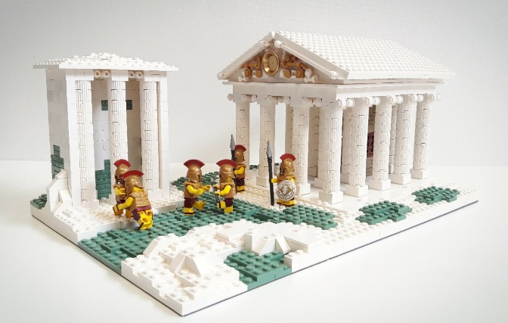

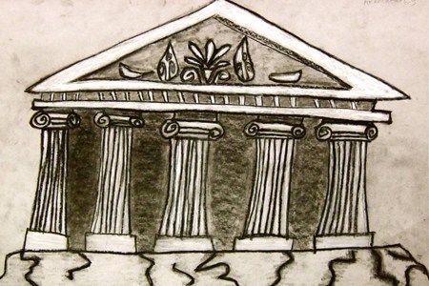
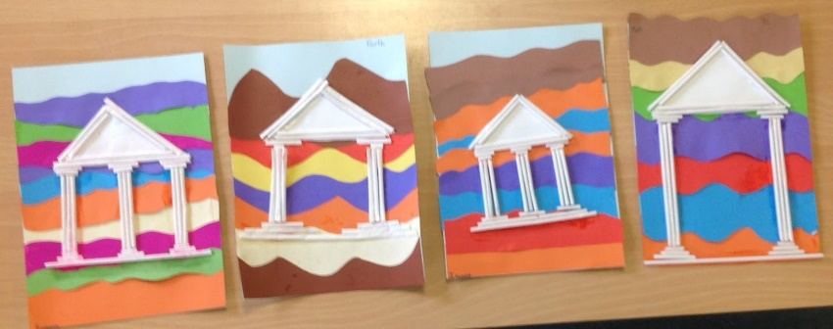
Or you could create a 2D temple using paints, crayons, straws or even sketch a temple.

Take a picture of your temple creation for your teacher on Class Dojo!

