Maths – Year 5 – Week 8 – Addition & Subtraction of Decimals

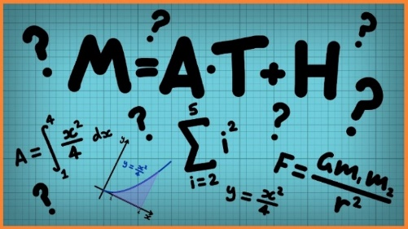
This week we are looking at adding and subtracting decimals.
When adding and subtracting decimals, just like with whole numbers, use the column method to solve the calculation.
Remember, the decimals point is concrete and must stay in line with each other – think of your place value chart!
Hundreds | Tens | Ones | ● | tenths | hundredths
 | 3 | 4 | ● | 2
1 | 1 | 5 | ● | 0 | 3

Click on the links below to access the learning for each day.
You can work on paper if you wish to, or take a picture of your screen of work for your teacher on Class Dojo.
The activities below have been designed so that you can complete 1 activity a day. You do not have to stick to the schedule below, and you can merge the activities together if you wish to do so.
Day 1 – Introductory Quiz
https://classroom.thenational.academy/lessons/decimals-to-derive-addition-and-subtract-decimal-facts/activities/1
Day 2 – Video
https://classroom.thenational.academy/lessons/decimals-to-derive-addition-and-subtract-decimal-facts/activities/2
Day 3 – Main Teaching
https://classroom.thenational.academy/lessons/decimals-to-derive-addition-and-subtract-decimal-facts/activities/3
Day 4 – Quiz
https://classroom.thenational.academy/lessons/decimals-to-derive-addition-and-subtract-decimal-facts/activities/4
Day 5 – Convert improper fractions and mixed numbers
Follow the link for video & examples: https://www.bbc.co.uk/bitesize/articles/z4ypscw
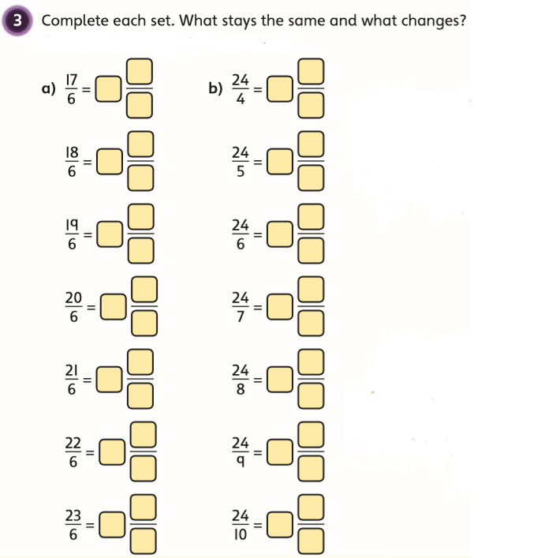
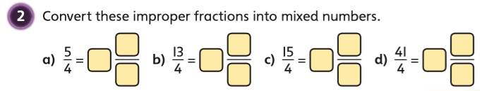
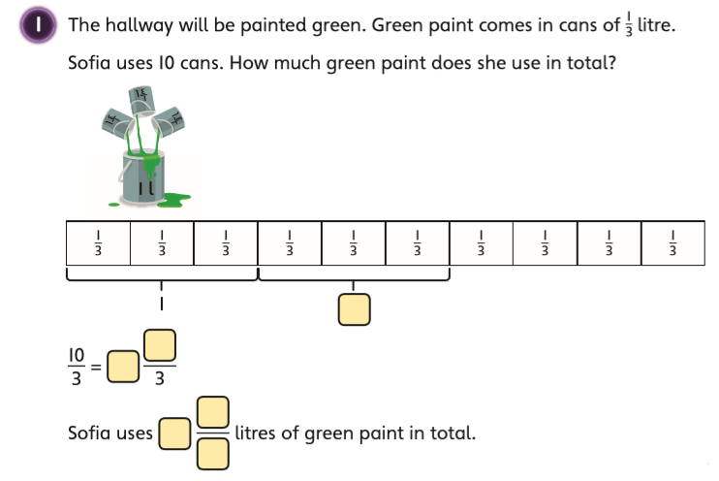
Then, complete the worksheet:

