Ancient Greece – Week 8 – Philosophy

Philosophy was invented by the Ancient Greeks in the 6 century BC. The word philosophy means “the love of wisdom” in Greek. Philosophy was invented for the Greeks to try make sense of the world around them.
Some of the most famous Greek philosophers were Aristotle, Socrates, Pythagoras and Plato.
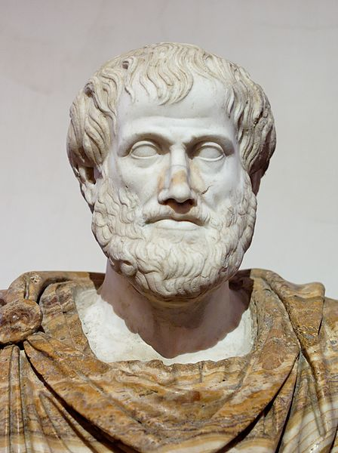
Socrates was one of the first thinkers to question, “What is right and wrong?”.
Aristotle came up with the idea of ‘The Golden Mean’ – an idea of a middle ground between good and bad, and the belief in moderation.
Plato focused on “What is justice?” and how a government should be run.
Pythagoras was one of the first to think of the idea of reincarnation.
Task 1: The Naughty-ometer!
A school teacher doesn’t know which of her children is the naughtiest!
Sort the naughty behaviour into your own naughty-ometer, where you decide (with reasons) which behaviour is the most and least naughty.
Take a picture for your teacher on Class Dojo!
- Not doing any work in school for a day.
- Seeing someone hit someone, and doing nothing.
- Hitting someone.
- Hitting someone back.
- Stealing someone’s lunch.
- Stealing someone’s pencil case.
- Swearing at another pupil.
- Swearing at a teacher.
- Forgetting to throw away a banana skin, and someone
getting hurt by slipping on it.
- Planning to make someone slip on a banana skin, but it
not working.
Naughty-ometer
Least Naughty
Most Naughty
Task 2:
You are going to think like a philosopher!
Read the ‘sticky questions’ and discuss with someone in your household.
Remember to let everyone have their say, be respectful of their opinion and think carefully about your response!
You may have different opinions and that is OK!

