DT – Greek Food

The Ancient Greeks ate fairly simply. Their three main staple foods were wheat, oil and wine. They typically ate 3 meals a day. Breakfast was usually bread or porridge. Lunch was light where they would eat bread but with cheese or figs. Their big meal of the day was tea – it was a long, social event with foods such as vegetables (cucumber, cabbage, onions, beans), bread, eggs, fish and cheese. Only the wealthy could afford beef, chicken, lamb and pork.

You can try these recipes at home…
Please be aware of any food allergies you may have in your household & complete with adult supervision!!

Greek Honey Cake
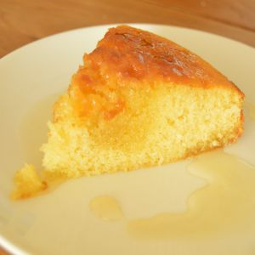
It was often offered to the gods as a thank you – honey was the Ancient Greeks only sweetener.
Ingredients:
- 125g flour
- 60ml of milk (optional)
- 170g butter
- 350g honey
- 3 medium eggs
- 150g caster sugar
- ½ tbsp. cinnamon (optional)
- 350g honey & 200g sugar for the syrup
Preheat the oven to 180°c. Combine the flour, eggs, cinnamon, milk, 150g caster sugar and butter to make the cake mixture. Bake for around 40 minutes or until baked fully.
To make the honey syrup – in a saucepan combine the honey with 200g sugar and water. Bring to a simmer and cook for a further 5 minutes. Option to add a splash of lemon juice and cook for another 2 minutes.
Once the cake and syrup are cooled, drizzle the syrup slowly over the cake. Spike holes in the cake to allow the syrup to really soak into the cake and enjoy!

Pasteli (Greek Sesami Honey Candy)
The Ancient Greek version of a power/energy bar!
The classic Pasteli recipe only contains honey and sesame seeds making it chewy.
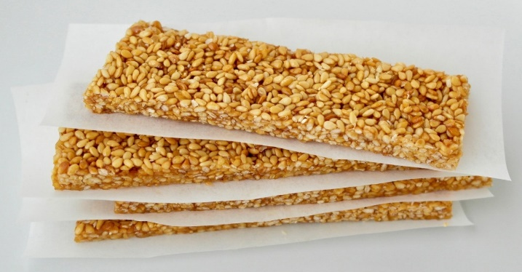
The modern day recipe also includes sugar which makes it hard, like certain sweets.
There is also the option to add extra flavour, such as lemon or orange.
Ingredients:
- 200g sesame seeds
- 200g honey
- Optional lemon & orange peel for extra flavour
In a saucepan, bring the honey to a boil (add any peel if you want extra flavour). Add the sesame seeds and stir continuously. When the seeds are fully mixed in the honey, remove the fruit peel. Place baking/greaseproof paper in a baking tray and spread the mixture out evenly. Once the Pasteli cools, place in the fridge for 2-3 hours. Slice/cut or break into bars to eat and store in the fridge.

Portokalia me Meli (Oranges with Honey)
Easy to make in minutes. Fresh fruit is a favourite Greek dessert and snack.
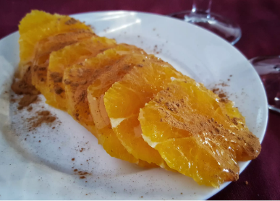
Ingredients:
- 1 or 2 oranges
- 2 – 3 drops of honey
- Cinnamon (optional)
Peel the oranges and break into pieces or slice. Arrange in a dish or plate and drizzle with honey. Optional, add a light sprinkle of cinnamon, then enjoy!

Take a picture of your creations for your teacher on Class Dojo!

