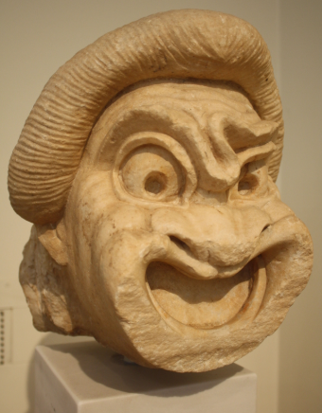
Art – Week 8 – Greek Plays & Masks
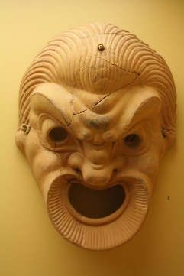
The Ancient Greeks enjoyed playwriting and performance. They took their drama very seriously and used drama to investigate the world around them and what it meant to be human.
They had 3 genres of drama: comedy, satyr plays and most importantly tragedies.
Follow this link to watch a video about the Greek theatre:
https://vimeo.com/164710800
The actors were always men, so would often wear masks during their performances, so that they could play more than one role in a play – such as monsters or a different gender.
Task 1:
Read the statements about Greek masks below and use research to find out if they are True or False.
- Greek masks had large mouths to help project sound all around the theatre.
- Many masks have survived so we know what they looked like.
- Masks were made to be comical or ugly, depending on the role.
- They were made from hair, wood, linen and cork.
- The use of masks came about from worshipping the god, Zeus.
- Masks were usually small that only the people sitting at the front could see the facial expressions.
- The use of masks meant actors could play more than one role.
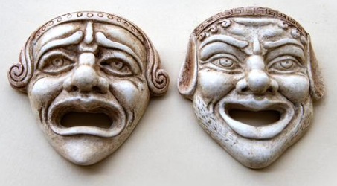
Take a picture of your findings for your teacher on Class Dojo.

Task 2:
The comedy/tragedy masks are a famous symbol of theatre even today.
Use the templates on the next page to decorate your own masks or draw your own design. You can use a paper plate if you prefer. If you want to, you can add hair, teeth or a beard to your mask to create a character or monster.
Take a picture of your masks for your teacher on Class Dojo.
