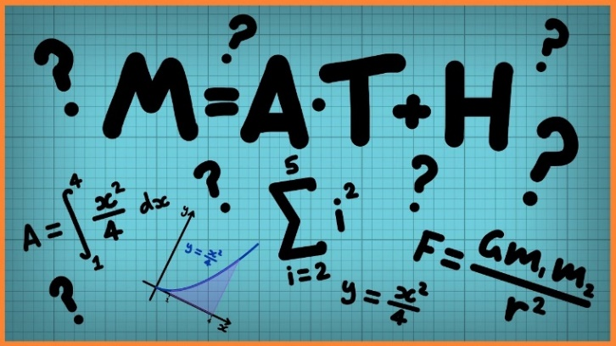
Week 1 – An Introduction to Translation
In this first unit we are studying transformations. Transformations are a way of changing the size or position of a shape. This week we will be exploring coordinates and translations. Some of the lessons should be familiar as it is revision of what you learnt in Year 4.
Click on the links below to access the learning for each day.
You can work on paper (but you don’t have to) or click on the screen and upload a photo onto Class Dojo showing your completed work.
These activities have been designed so that you can complete 1 or more activity a day. You do not have to stick to the schedule below and you can merge the days together if you wish to.
Day 1- Quiz
https://www.thenational.academy/year-5/maths/an-introduction-to-translation-year-5-wk1-1/#
Day 2 -Video
https://www.thenational.academy/year-5/maths/an-introduction-to-translation-year-5-wk1-1/#
Day 3-Main Teaching
https://www.thenational.academy/year-5/maths/an-introduction-to-translation-year-5-wk1-1/#
Day 4- Quiz
https://www.thenational.academy/year-5/maths/an-introduction-to-translation-year-5-wk1-1/#
Day 5 – Revision of previous learning
Lesson 1 (only ) decimals up to 2 places
https://whiterosemaths.com/homelearning/year-5/

