Week 1 literacy 27.4.20

This term our theme is ‘The Ancient Greeks’. Our work in literacy is going to be based upon Greek Myths.
Greek Myths were stories told by the ancient Greeks, which included heroes and mythical creatures.

Monday
Task 1:
Make a list of any Greek Myths you have heard of (you may have some ideas from your second home learning pack – if not ask an adult or research on line).
Take a photograph of your list of Greek Myths and upload it on to Class Dojo. There will be points for the best lists!
Task 2: Theseus and the Minotaur
Watch the cartoon version of the story of Theseus and the Minotaur on line at
https://www.youtube.com/watch?v=xQuAUBX5xBw
Task 3:
Read the story version of Theseus and the Minotaur on the next page (if you have learning pack 2 it is printed for you).
Task 4:
Draw a picture of the Minotaur – use the text to help you. Add labels to your drawing.
Challenge: write a list of words to describe how Theseus felt before he went into the maze, whilst he was in the maze and after he came out safely.
Take a photograph of your drawings and word lists and upload them onto Class Dojo. Again Dojo points can be won for good efforts.

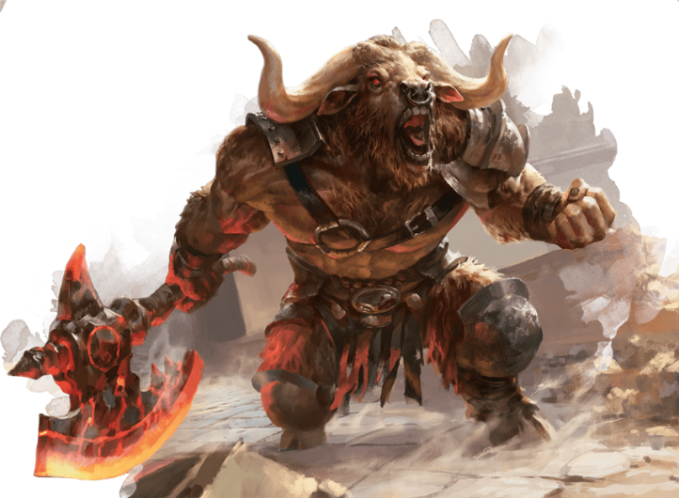
Story: Theseus and the Minotaur

King Minos of Crete was protected by a fearsome monster called the Minotaur. It was two metres tall and was half human and half animal. Its head was like a shaggy bull with curved horns as sharp as razors. Its eyes flashed fire. From the neck downwards, it was human and had a huge, hairy, barrel chest. The Minotaur did not eat ordinary food. It fed on human flesh!
Now the Minotaur was so savage and dangerous that King Minos kept it hidden in a dark, dank maze of caves and tunnels called the Labyrinth. Each year Minos sent seven boys and seven girls down into the Labyrinth. They were never ever seen again. The people of Crete were terrified that King Minos would choose their children to feed to the Minotaur.
In the end, Princess Ariadne, the daughter of King Minos, took pity on the people. She persuaded Theseus, a young warrior, to climb down into the Labyrinth and get rid of the Minotaur for ever. Ariadne told him to take a ball of wool with him and unwind it as he passed through the maze of tunnels so that he could find his way out again afterwards.
With trembling legs, Theseus began to grope his way through the pitch-dark twisting tunnels. In a short while Theseus heard the snuffling of the monster as it smelt him coming. A blood-chilling roar echoed through the passages as the Minotaur charged. Theseus knew he could never defeat the monster face to face so he decided to trick it. He flattened himself against the cave wall as the beast thundered towards him. Its foul stink filled his nostrils and the ground beneath his feet shook as the monster thundered past him. It passed so close to him that its bristly hair scratched his chest like thorn twigs.
As soon as it had passed him, Theseus struck the Minotaur with his sword. The monster fell in a heap bellowing with fury but Theseus plunged his sword in again and killed the beast.
He threaded his way back to the surface again and was greeted by cheering crowds. The evil king’s protector, the Minotaur, was gone for good. They would never be troubled by it again and all their children could sleep safely in their beds once more.

Tuesday

Task 1: Re-read the story of Theseus and the Minotaur from yesterday. Answer the following questions (Write in full sentences with as much detail as you can). If you have learning pack 2 these questions are in your envelope.
Type your answers on the sheet below and e-mail back to school or write on a piece of paper and take a photograph to put on Class Dojo.
- What was the name of the beast?

- Write a description of the Minotaur. Look for clues in the passage. Describe its appearance, where it lived and what it ate.

- What was the name of the hero? Write down what you think of him.

- List all the problems Theseus faced.

- Explain how Theseus overcame each problem.

- How do you think Theseus felt when he entered the Labyrinth?

- What do you think of the ending? Give a reason for your answer.

- ‘This story shows how good usually triumphs over evil.’ Do you agree with this statement? Say why or why not.

Challenge: use capital letters, full stops, ? ! and commas to punctuate these sentences:
princess arieadne the daughter of king minos felt sorry for the people
she sent theseus a brave warrior down to fight the minotaur
the minotaur was a fearsome monster it lived underground
do you want to know something horrible the minotaur fed on human flesholding his sword in his hand theseus went to fight the beast

Wednesday

Today you are going to plan a description of the Minotaur. On a piece of paper write your ideas under the following headings. (This task is in home pack 2 so if you have already done this very well done – you could repeat the activity but do a description of Theseus the hero instead). Include adjectives e.g. fearsome, solid; carefully chosen verbs e.g. growls, drools; and adverbs e.g. ferociously, dangerously.
Photograph your plan and upload it to Class Dojo.

What does your beast look like? Think about…
His body parts e.g. his head, body, eyes, mouth, horns, teeth

How he moves

What he is doing/his actions

The noises he makes:

STUCK? Why not google for more pictures of the beast on line or find another cartoon video to watch (make sure that you check with an adult that it is age appropriate).

Thursday

You are now going to write a draft of your character description. Please remember what you have been working on in class and try to include these features in your writing. There is an afl grid below which may be of help to you (do not worry about filling it in if you do not have a printer – it is just there for help).
You can do your work on paper or if you want you can do it in word on your laptop (just don’t forget to save it). Do not worry about sending your work to your teacher today as you are going to edit it an up level it tomorrow. You can send your masterpieces then.

W.I.L.F |  | What I think | What my mum/dad  thinks
1. | Use noun phrases, verbs, adverbs and prepositions.
2. | Adverbials (time, place and manner), conjunctions and relative clauses.
3. | Modal verbs (could would shall)
4. | Tense action – short sentences, rhetorical questions, character’s speech combined with action.
5. | Similes, metaphors personification
6. | ( ) - - , , for parenthesis  , to separate clauses
7. | Year 6 children challenge:  Semi-colons ;  Colons:  Dashes –  Hyphens e.g. emerald-green

Try to start your sentences in different ways and vary your sentence types e.g. short sentences for effect e.g. He was huge. Repetition e.g. He was huge. He was hairy. He was wild. And questions e.g. Would he hurt me?
As well use sentences which start with adverbs of time e.g. In an instant… Place e.g. Up ahead of me… and Manner e.g. Slowly and carefully…

Friday

Please read carefully through your character description – either The Minotaur or The hero Theseus. You are going to edit it and make improvements to up level it. If you have an adult to help you that may be useful (don’t worry if not – you are used to doing this for yourself in class).

- Check that it makes sense and you have not missed any words out
- Check your spelling
- Check your punctuation
- Check your content against your plan – have you missed out any of your original ideas?
- Check against the afl grid on Thursday’s lesson.

When you have made your changes re-write your work neatly if you feel that you need to. Take a photograph and post it on Class Dojo. Alternatively, you can word process your best copy and email it if you prefer.

Fed up? Want more?
Try the wordsearch or the crossword puzzle on Theseus and the Minotaur

Challenge
Google for a ‘Map of the Greek islands’. Can you find the Greek island of Crete where this Greek Myth is set? If you can you could print off the map and label it. Go round the coastline of the islands in blue. I will give you more challenges to find other Greek islands mentioned in Greek myths another time.

Next week – we are going to look at a different Greek Myth.

