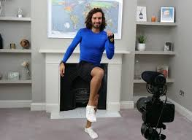
Log in every week day to do PE with Joe Wicks
https://www.youtube.com/channel/UCAxW1XT0iEJo0TYlRfn6rYQ

Or if you prefer something a little more relaxing then log in to Cosmic Yoga.
https://www.youtube.com/user/CosmicKidsYoga

Upload your photos onto Class Dojo to get Dojo monster points.

