DT – Panpipes (Syrinx)
The panpipes (syrinx) was a musical wind instrument first used by the Ancient Greeks. They were most commonly used by shepherds. They were constructed from 4 to 18 cane tubes fastened together. Blowing across the top the different lengthened tubes would produce different notes.
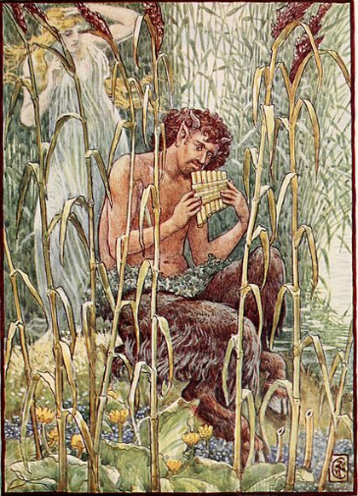
In Greek mythology, the half-human half-goat god Pan (patron of shepherds) is credited with the creation of the panpipes.
Pan had fallen in love with the nymph (pixie) Syrinx, daughter of the river god. She ran away from his attentions to Zeus, the King of Gods, and begged Zeus to save her. Just when Pan captured her, Zeus turned Syrinx into reeds.
Angered and annoyed, Pan smashed the reeds into pieces, but suddenly he was struck with remorse and regret and kissed the broken reeds, all that remained of his beloved Syrinx. As he kissed the reeds, he discovered that his breath could create sounds from them, and so he made the musical instrument that would carry Syrinx’s name.
Task: Can you create your own panpipes?
You could use straws or cardboard tubes to create your own panpipes.
Take a picture of your musical instrument for your teacher on Class Dojo!
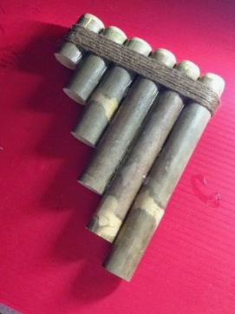

Design and Technology Planning Sheet
My project: What are you going to design?

Purpose: What must your creation be able to do?

Design: Draw your design and make sure you include labels for each part.

Resources: What resources do you need?

Steps to create: What are the key steps in your creation process?

Evaluation: Does your design work like you planned? How did you change it?

