RE – Week 10 – Faith in Action
Key Question: What inspires people to follow a faith and what is the cost?

What is Marriage?
Every wedding is different…
- Some are held in places of worship and some are held at local registry offices or hotels.
- Some weddings have thousands of people there, while others might have less than five.
- At some weddings, the bride might wear a big, white dress while at others they may wear a suit.
- At some weddings, it can be a man and a woman making a commitment to each other while at others it could be two men or two women making the same commitment.
A Hindu Marriage
For Hindus, a marriage is a duty that links the couple together for the rest of their lives. Hindu weddings take a lot of planning because they contain so many different parts.
Follow the link to watch a Hindu wedding in the UK:
https://www.bbc.co.uk/teach/class-clips-video/a-hindu-wedding/zmqrkmn
They also wear traditional Hindu dress and have different celebrations throughout the ceremony.
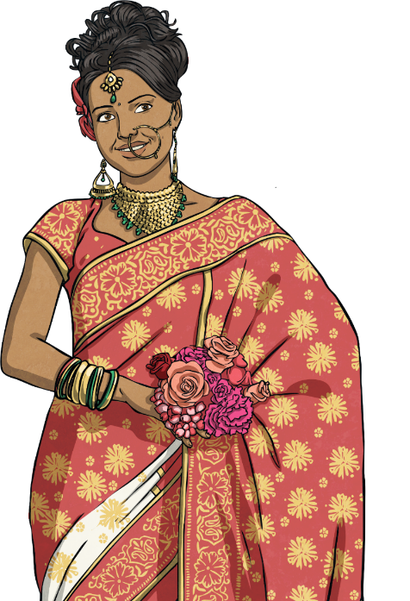
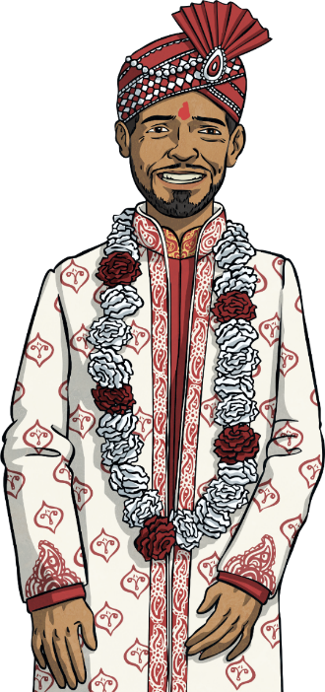

Task:
A covered canopy with good energy inside where the wedding will take place.
In this part of the ceremony the couple make their vows.
The couple climb over a rock to show strength, walk around a sacred fire and the husband will put red powder on his bride’s hairline to show she is married.
The bride’s parents welcome the husband-to-be with a red powder on his head. The couple give each other a garland.
The main and legal part of the marriage – the couple walk seven steps together reciting a prayer for each step.
A sacred fire is lit and the Purohit (priest) says sacred mantras in Sanskrit – the language of their holy books.
There are 6 main parts to plan in a Hindu marriage. Can you match the description to the correct word – use the internet to help you. Draw lines or write out the description to the correct word.
Jayamaala
Mandap
Vivaha-homa
Paanigrahan
Rituals
Saptapadi

Take a picture of your RE work for your teacher on Class Dojo.

