Maths – Year 5 – Week 10 – Use a Range of Multiplication Strategies

This week, we are going to use our multiplication knowledge to help us double numbers, including decimals, along with multiplying by 2, 4 and 8.
Don’t forget to log onto TT Rockstars to practise all your times tables!
Click on the links below to access the learning for each day.
You can work on paper if you wish to, or take a picture of your screen of work for your teacher on Class Dojo.
The activities below have been designed so that you can complete 1 activity a day. You do not have to stick to the schedule below, and you can merge the activities together if you wish to do so.
Day 1 – Introductory Quiz
https://classroom.thenational.academy/lessons/to-use-a-range-of-multiplication-strategies/activities/1
Day 2 – Video
https://classroom.thenational.academy/lessons/to-use-a-range-of-multiplication-strategies/activities/2
Day 3 – Main Teaching
https://classroom.thenational.academy/lessons/to-use-a-range-of-multiplication-strategies/activities/3
Day 4 – Quiz
https://classroom.thenational.academy/lessons/to-use-a-range-of-multiplication-strategies/activities/4
Day 5 – Regular and Irregular Polygons
Follow the link for videos & examples:
https://www.bbc.co.uk/bitesize/articles/zgmcf82
Then, complete the worksheet:
Regular polygons have all sides and angles the same size.
Irregular polygons have different sized angles and sides.
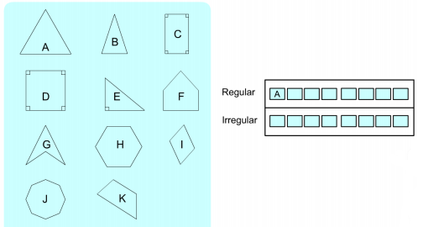
1) Put the letter of each of these 2D shapes into one of the boxes. The regular polygon triangle ‘A’ has already been done for you. Boxes you don’t need should be left empty.

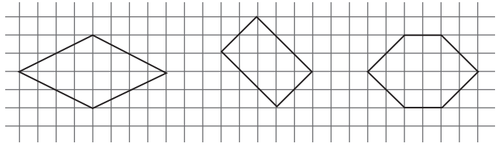
2) Explain why each shape is irregular.

The rhombus is irregular because the ________________ are not all the same size.
The rectangle is irregular because _______________________________________
_________________________________________________________________.
The hexagon is _____________________________________________________
_________________________________________________________________.

