Literacy – Week 10 – 13.7.20

Monday 13th July – Aesop’s Fables
Aesop was a storyteller. He lived about 2,500 years ago in ancient Greece. Some don’t believe Aesop existed as he never wrote anything down, it is thought he remembered his stories and told them over and over again. About 2000 years later, a monk wrote down these wonderful tales of talking animals and morals, known as ‘Aesop’s Fables’.
A fable is a short story with a moral – a lesson learnt at the end of the story.
Task: Read the fables and decide what you think the morals of the stories are.

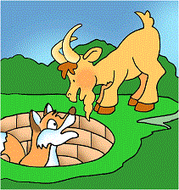
The Fox and the Goat
Once upon a time, a long time ago, a fox fell down a well. He was stuck there for quite a while. Finally, a goat wandered by.
“What are you doing?” asked the goat curiously.
“Stay away,” snarled the fox. “This is my water.”
“That’s not fair,” snapped the goat. “Why should you get all the water?” Before the fox could say another word, the goat jumped in the well.
Quick as a flash, the fox leaped on the goat’s back and out of the well. He ran happily off, leaving the goat stuck in the well.
What do you think is the moral of this story? ___________________________________________________________
___________________________________________________________

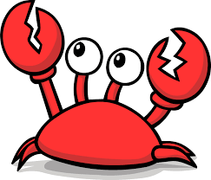
The Little Crabs Who Walked Zig Zag
A mother crab was watching her young son walk.
“Why do you walk sideways like that?” she asked, “You should always walk straight forward with your toes turned out.”
The little crab tried to walk straight forward but only succeeded in walking sideways again. “Show me how to do it, Mother,” he cried, “I want to learn how to do it right.”
So the old mother crab demonstrated how to walk and she walked sideways. She tried and tried to walk sideways and could not do it. When she tried to turn her toes outward, she stumbled and fell on her face.
What do you think is the moral of this story? ___________________________________________________________
___________________________________________________________

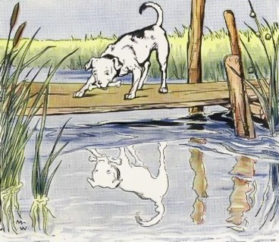
The Dog and the Bone
A dog once had a large bone that his master had given him. As he trotted off to enjoy it, he went across a bridge across a river. He looked down into the water and saw another dog.
The other dog was also carrying a bone in his mouth. The dog stopped to look. The other dog’s bone was bigger than his bone. He dropped his bone and lunged for the other dog’s bone. His bone fell into the water with a splash. The dog fell into the water and struggled to shore. As he climbed out of the water, he realised how stupid he had been.
What do you think is the moral of this story? ___________________________________________________________
___________________________________________________________

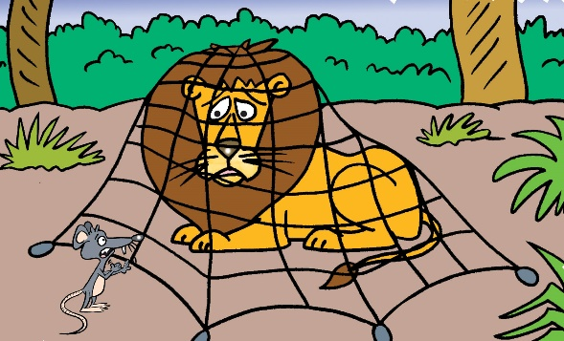
The Lion and the Mouse
A lion was sleeping one day. A small mouse ran up and down upon him. The lion woke up and pinned the mouse beneath his paw.
“Oh please, lion,” pleaded the mouse. “I am sorry I disturbed you. Please forgive me this one time. I may be small but someday I may be able to help you.”
The lion laughed. How could a little mouse hope to help a strong animal like him? But he lifted his paw and let the mouse go.
Sometime later, the lion was walking through the forest and walked into a hunter’s trap. Try as he might, he could not free himself from the rope net. Just then, the little mouse happened by and saw the lion. He wasted no time but set about gnawing the ropes of the net and the lion was soon free. “Was I not right?” said the little mouse.
What do you think is the moral of this story? ___________________________________________________________
___________________________________________________________

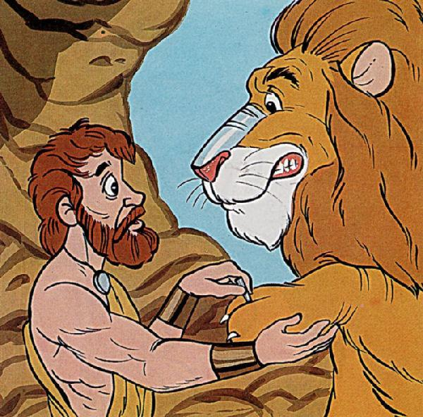
The Man and the Lion
There was once a man who refused to obey his king. He was sentenced to die. Before they could kill him, the man escaped and ran into the forest. He met a lion with a thorn in his paw. The man pulled the thorn out. As the lion was licking his paw, he said, “I am grateful to you. I will never forget what you have done. You will always be my friend.”
So, the man told the lion goodbye and left. It was not long before the man was captured by the king’s soldiers. They brought him back and he was sentenced to die in the arena. When the lion was released, the man recognised the lion. It was the very same lion that he had helped. He bravely reminded the lion of his promise and asked the lion not to eat him because they were friends.
However, the lion was hungry, and he jumped upon the man and ate him whole.
What do you think is the moral of this story? ___________________________________________________________
___________________________________________________________

Take a picture of your morals for your teacher on Class Dojo!

Tuesday 14th July – Adverbials & Fronted Adverbials
An adverbial is a word or phrase that adds detail to a verb – it ADDS to the verb, ad-verb!
Adverbials are used to explain when (time), where (place) or how (manner) something happened; they are like adverbs made up of more than one word.
Fronted adverbials are ‘fronted’ because they appear at the front of the sentence, before the verb.
For example, ‘Gently, she lifted the baby.’ Gently is the fronted adverbial describing the verb ‘lifted’.
Or, ‘In the morning, Alfred brushed his teeth.’ In the morning is the fronted adverbial phrase describing when the verb ‘brushed’ is being done.

Task 1: Decide whether the fronted adverbial underlined in the sentence below is of time (when), place (where) or manner (how).
- With a huge smile, the boy hugged his mum. ___________________
- In a forest clearing, the wolf howled to the moon. _________________
- When the taxi arrived, the clowns piled inside. ________________
- Running quickly, the dog grabbed the tennis. ___________________
- With a flick of his wand, the book floated in the air. _______________
- As the sun was rising, the birds awoke in their nests. _______________
- After eating lunch, the baby needed a nap. __________________
- For three years, the eerie house stood empty. __________________

Task 2: Spot the adverbial in the sentence below – the part of the sentence that tells you when something is being done (time), where something is being done (place) or how something is being done (manner). Write the adverbial out or underline in the sentence.
- He threw the ball against the wall.
- Through the forest, the dinosaur stomped and roared.
- The little girl jumped up and down like a yo-yo.
- Finally, the plane landed at the airport.
- An enormous boat sailed along the River Humber.
- The fairy flew like a firework.
- As the sun began to set, birds twittered in the trees.
- The ballerina was practising her dance moves throughout the day.
- He stood and waited under the clock.
- After completing the race, Julie yawned and felt tired.

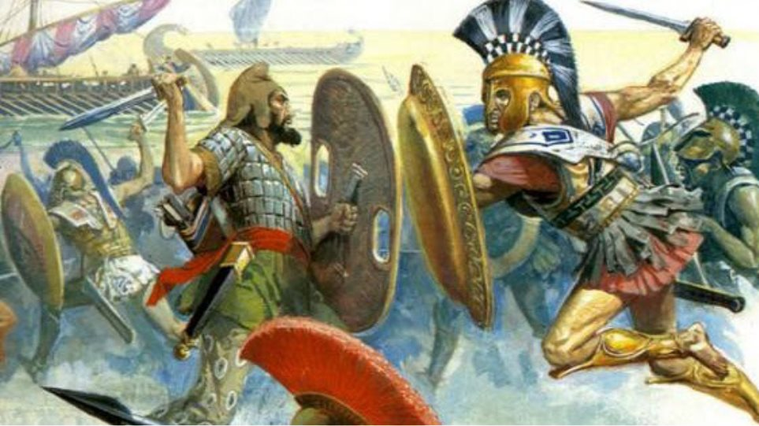
Task 3: Look at this picture of two warriors fighting in the Battle of Marathon.

Create your own adverbials (of time, place and manner) based on this picture, an example for each has been given for you.
Time | Place | Manner
- In ancient times, | - On the beach, | - Angrily,

Challenge: Using the picture of the Battle of Marathon and your adverbials from Task 3, write a description of the picture. See how many of your adverbials – and extras – you can use in your description. Remember to use fronted adverbials as well as adverbials within and at the end of sentences.
___________________________________________________________
___________________________________________________________
___________________________________________________________
___________________________________________________________
___________________________________________________________
___________________________________________________________
___________________________________________________________
___________________________________________________________
___________________________________________________________
___________________________________________________________
___________________________________________________________
___________________________________________________________
___________________________________________________________
___________________________________________________________
___________________________________________________________
___________________________________________________________
___________________________________________________________
___________________________________________________________
___________________________________________________________
___________________________________________________________
___________________________________________________________
Take a picture of your work for your teacher on Class Dojo!
Wednesday 15th July – Reading & Comprehension Questions
King Midas & the Golden Touch
Once upon a time, in ancient Greece, there lived a king named Midas. King Midas loved three things more than anything else in the world – his little daughter, his rose garden, and gold. Nothing gave him more pleasure than seeing his little daughter picking roses in the garden, roses she placed in a golden vase to decorate the castle.
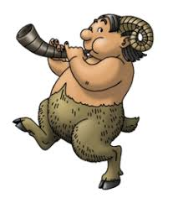
One night, while strolling through his rose garden, the king stumbled over a satyr. A satyr was half-man, half-goat. This satyr looked half-starved and very ill. King Midas brought the satyr into his castle. He made sure the satyr was washed and fed and tucked into bed for a good night’s sleep. When the satyr woke up the next morning, his fever was gone. The king and the satyr had quite a nice chat over breakfast. King Midas was surprised to hear that the satyr belonged to the powerful god Dionysus, the god of wine and truth. That very day, the king personally took the satyr home in his very best chariot. The satyr might only be a servant, but he was the servant of a god, and deserved the very best treatment, which is something the king would have done anyway, because the king had a very kind heart.
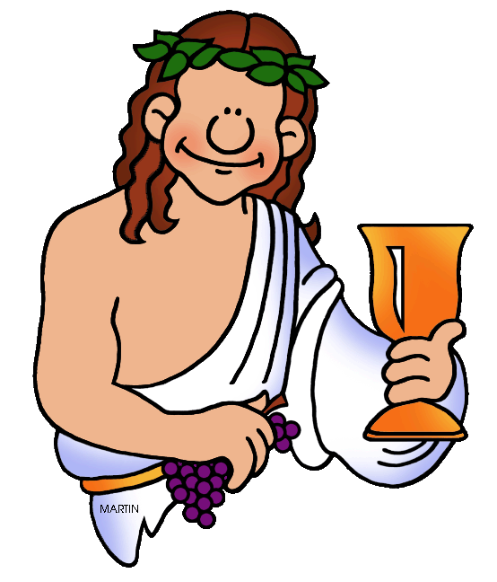
As it turned out, the satyr was more than a servant. To Dionysus, the satyr was his teacher and good friend. Dionysus told the king he would grant any one wish the king made to thank him for taking such good care of his friend. The king did not wish anything for his daughter because he had given her everything she wanted and more. He did not wish for anything for his rose garden because everyone knew he grew the finest roses in all the world. That left gold. King Midas wished that everything he touched would turn to gold.
The king did not have much hope that his wish had been granted, because if it had been granted, his chariot would have turned to gold when he climbed aboard to go home, and it had not. Still, he was happy he had helped the satyr, and not just because the satyr was a servant of god. Satyrs were not always treated kindly in the ancient Greek world because they looked rather different – being half-man and half-goat. When the king arrived back at his castle, he pulled out a chair to sit down at his table. The minute he touched it, the chair turned to gold. King Midas raced through his castle. Everything he touched turned to gold! He was so happy. He shouted to his servants to cook him a feast in celebration!
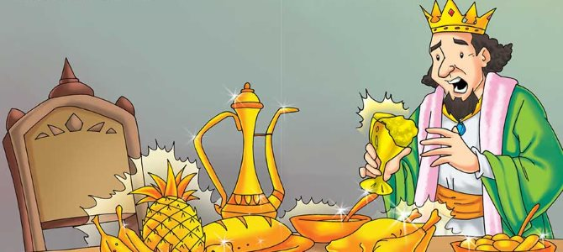
His servants were very fond of King Midas. They knew he was foolish, but he was rather a dear, so they cooked and cooked and served him a feast. That’s when the trouble started. Everything looked and smelled so good that King Midas did not wait for his daughter to show up for lunch. He reached out and grabbed a fistful of food. The food made quite a clatter when he dropped it back on the table in shock. It had turned to gold in his fist. He touched other food. Whatever he touched turned to gold. He tried leaning over and ripping a piece of meat with his teeth, but that did not help. The meat turned to gold in his mouth. The king’s eyes filled with fear. He knew if he could not eat, he would starve. This was terrible. The king did not know what to do.

King Midas wandered sadly out to his rose garden. His little daughter was in the garden, picking roses. When she saw her father, she ran into his arms for a hug and turned straight to gold. King Midas hung his head and cried. As his tears fell on his precious roses they too turned to gold, but the king did not care. He did not care about his roses or his gold or himself.
“Dionysus, hear my prayer!” the king begged, “Take my wish back! Please, take my wish back and save my daughter!”
One last time, the king’s wish was granted.

Questions:
- What three things did King Midas love in the world more than anything else?
- ____________________________________________________
- ____________________________________________________
- ____________________________________________________

- How do we know the king was a kind man?
___________________________________________________________

- What is Dionysus the god of?
___________________________________________________________

- Why did the king not make a wish regarding his daughter or his rose garden?
___________________________________________________________
___________________________________________________________

- Why were satyrs not treated kindly in ancient Greek times, and do you think this was fair? Explain your opinion.
___________________________________________________________
___________________________________________________________
___________________________________________________________

- When does King Midas realise that his wish for gold has been a mistake?
___________________________________________________________

- What thoughts do you think were running through King Midas’s head as his food turned to gold?
___________________________________________________________
___________________________________________________________

- What thoughts do you think were running through King Midas’s head as his daughter turned to gold?
___________________________________________________________
___________________________________________________________

- How did the king’s opinion of his gold powers change throughout the story?
___________________________________________________________
___________________________________________________________
___________________________________________________________

- If you were Dionysus, would you have reversed the king’s wish and powers? Yes, no or maybe? Explain your answer in full.
___________________________________________________________
___________________________________________________________
___________________________________________________________

Take a picture of your answers for your teacher on Class Dojo!

Thursday 16th July – Letter to Your Next Teacher
As we reach the end of the school year, we are all thinking of what is in store for us in September. One thing that is for certain in these times, is the excitement of a new teacher or teachers!
For year 5s, you will become the oldest in the school and move into year 6.
For year 6s, you will make the jump to secondary school and be introduced to many new teachers.
Year 5 Task: Write a letter to your new Year 6 teacher(s), tell them about yourself – your likes, dislikes, siblings and best friends! What are your favourite subjects and your least favourite subject? What are you looking forward to in year 6 and what are you nervous for?
Year 6 Task: Write a letter to one of your secondary teachers (if you know their name) or just a letter to any of your potential new teachers. Tell them about yourself – your likes, dislikes, any siblings or best friends! What are your favourite and least favourite subjects from primary, and what new subjects are you looking forward to? Are you excited to move to secondary school or are you feeling a bit nervous?
You can add illustrations if you wish to your letter.
Assessment for Learning
W.I.L.F | What I think | What my friend  thinks | What my teacher thinks
Fronted Adverbials
First Person & Past Tense
2 A Sentences
Informal Language
Thoughts & Feelings
Paragraphs
Challenge:
Parenthesis ( ) , , - -
Use the AfL grid as support for your writing:

Dear _______________________________________,
___________________________________________________________
___________________________________________________________
___________________________________________________________
___________________________________________________________
___________________________________________________________
___________________________________________________________
___________________________________________________________
___________________________________________________________
___________________________________________________________
___________________________________________________________
___________________________________________________________
___________________________________________________________
___________________________________________________________
___________________________________________________________
___________________________________________________________
___________________________________________________________
___________________________________________________________
___________________________________________________________
___________________________________________________________
___________________________________________________________
___________________________________________________________
___________________________________________________________
___________________________________________________________
___________________________________________________________
___________________________________________________________
___________________________________________________________
___________________________________________________________
___________________________________________________________
___________________________________________________________
___________________________________________________________
___________________________________________________________
___________________________________________________________
___________________________________________________________
___________________________________________________________
___________________________________________________________
___________________________________________________________
___________________________________________________________
___________________________________________________________
___________________________________________________________
___________________________________________________________
___________________________________________________________
___________________________________________________________
___________________________________________________________
___________________________________________________________
___________________________________________________________
___________________________________________________________
___________________________________________________________
___________________________________________________________
___________________________________________________________
___________________________________________________________
___________________________________________________________
Friday 17th July – End of Year Memories
This is Me!

Best Activity Outside the Classroom
Funniest Memory
Favourite Book
Greatest Hope for the Future
Best In Class Activity
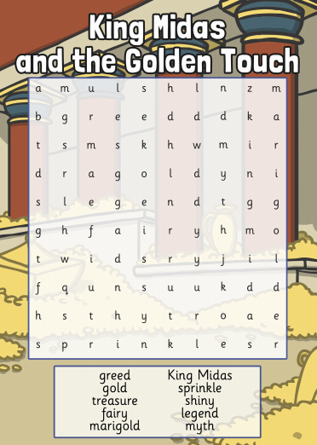
Extra Activity:

