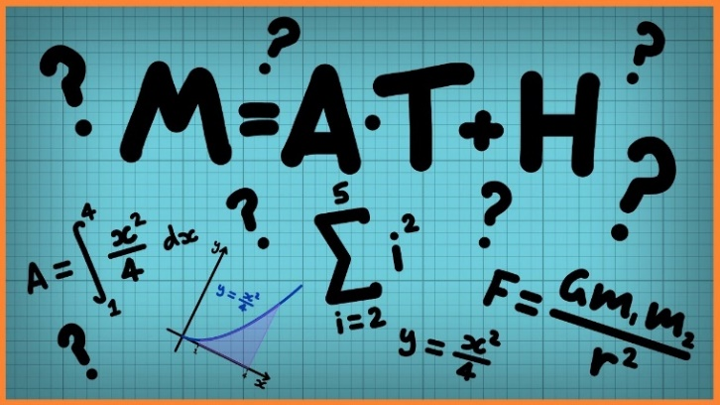

Week 2 Maths Convert between seconds, minutes and hours

In these lessons we are starting a new unit of work on converting measurements. We will be looking at time. We will start with a revision of time facts. As the lessons develop, we will hone our skills of converting between seconds, minutes and hours and by the end of this lesson, you will be solving time-related problems on a blank numberline whilst also converting units of time.

Click on the links below to access the learning for each day.
You can work on paper (but you don’t have to) or click on the screen and upload a photo onto Class Dojo showing your completed work.
These activities have been designed so that you can complete 1 or more activity a day. You do not have to stick to the schedule below and you can merge the days together if you wish to.
Day 1- Introductory quiz
https://www.thenational.academy/year-5/maths/to-convert-between-seconds-minutes-and-hours-year-5-wk3-1#slide-2
Day 2 –Video
https://www.thenational.academy/year-5/maths/to-convert-between-seconds-minutes-and-hours-year-5-wk3-1#slide-3
Day 3-Main Teaching
https://www.thenational.academy/year-5/maths/to-convert-between-seconds-minutes-and-hours-year-5-wk3-1#slide-4
Day 4- Quiz
https://www.thenational.academy/year-5/maths/to-convert-between-seconds-minutes-and-hours-year-5-wk3-1#slide-5
Day 5 – Develop your reasoning skills by challenging yourself. Click on the link and complete as many as you can.
https://www.bbc.co.uk/bitesize/articles/zfcnscw

