In RE this half term we will look at Ramadan and Eid.
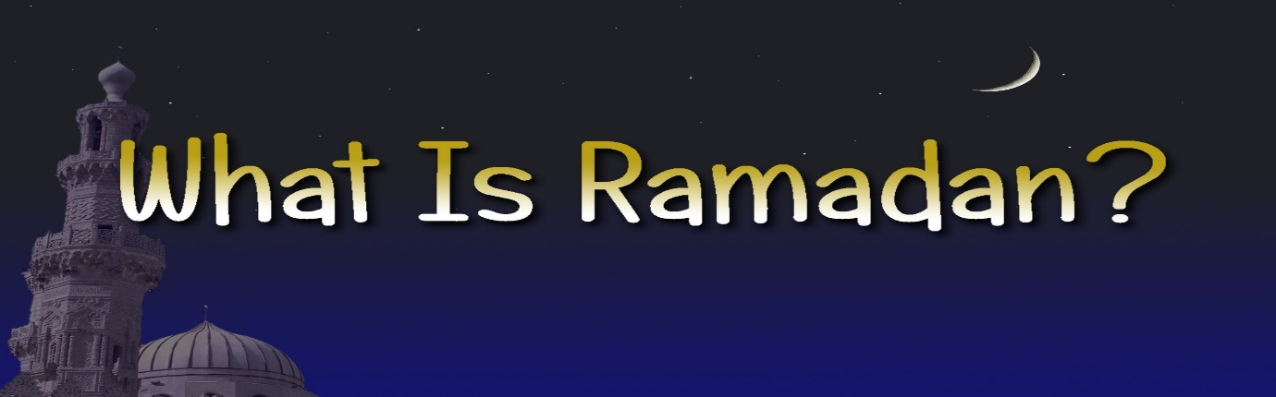

Ramadan is the ninth month of the Islamic calendar, observed by Muslims worldwide as a month of fasting, prayer, reflection and community.

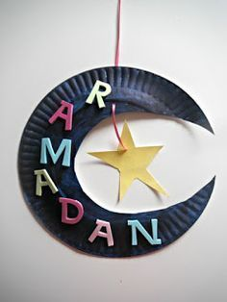
Use these easy Ramadan craft ideas to decorate your home or as part of a project to learn about Ramadan.

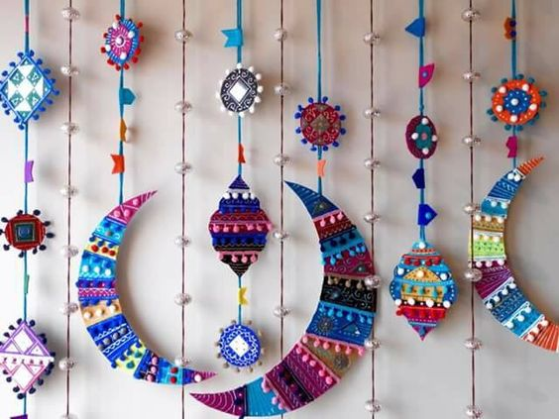

Week 1- Design your own mobile hanging moon (crescent) and star.

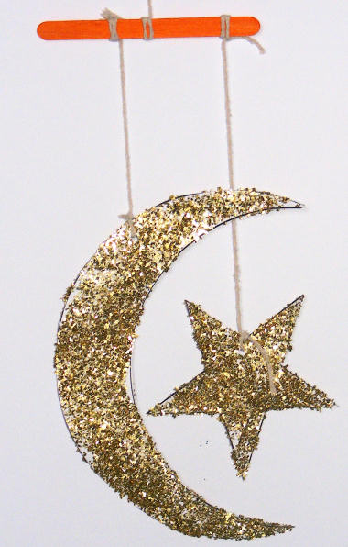

Upload a photo of your completed activity onto Class Dojo.

Feel free to use either the template provided (separate sheet) or design your own crescent and moon mobile.

Get creative and we look forward to viewing your photos on Class Dojo

