Maths – Year 5 – Week 7 – Convert Between Grams and Kilograms
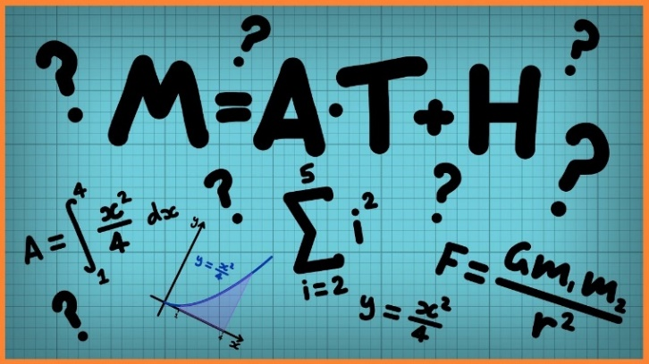
This week we are going to look at converting between grams and kilograms.
Grams and kilograms are used for weighing objects. Think of baking and cooking, food is given in grams and sometimes kilograms. Normally, grams are used for lighter objects while kilograms are heavier objects.
There are 1000 grams in 1 kilograms. Remember this by knowing the word ‘kilo’ = 1000 in Greek. This is the same when dealing with metres and kilometres. 1000m = 1 kilometre.
Click on the links below to access the learning for each day.
You can work on paper if you wish to, or take a picture of your screen of work for your teacher on Class Dojo.
The activities below have been designed so that you can complete 1 activity a day. You do not have to stick to the schedule below, and you can merge the activities together if you wish to do so.
Day 1 – Introductory Quiz
https://classroom.thenational.academy/lessons/to-convert-between-grams-and-kilograms/activities/1
Day 2 – Video
https://classroom.thenational.academy/lessons/to-convert-between-grams-and-kilograms/activities/2
Day 3 – Main Teaching
https://classroom.thenational.academy/lessons/to-convert-between-grams-and-kilograms/activities/3
Day 4 – Quiz
https://classroom.thenational.academy/lessons/to-convert-between-grams-and-kilograms/activities/4
Day 5 – Rounding Decimals
Follow the link for video & examples: https://www.bbc.co.uk/bitesize/articles/zm6g9mn
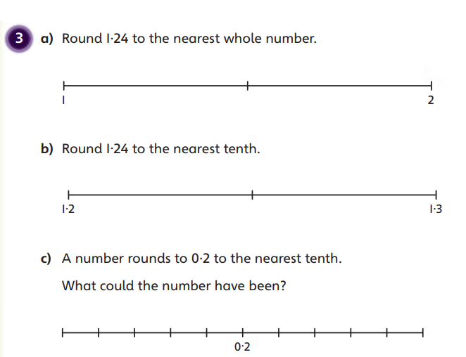
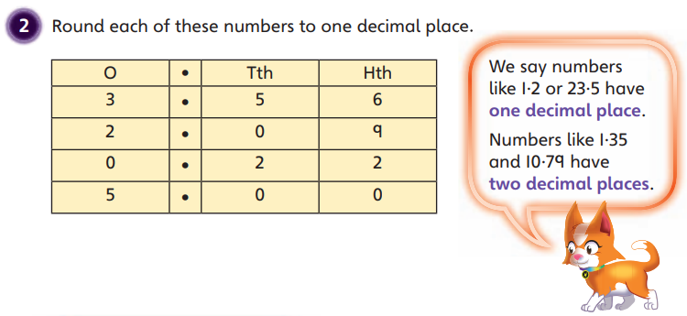
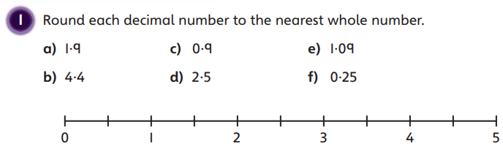
Then, complete the worksheet:

