Literacy – Week 7 – 15.6.20
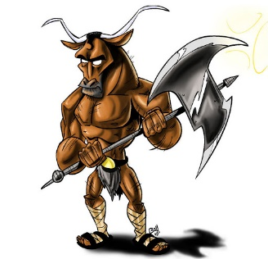
Monday 15th June - Mythical Beast
Yesterday, you created your hero/heroine.
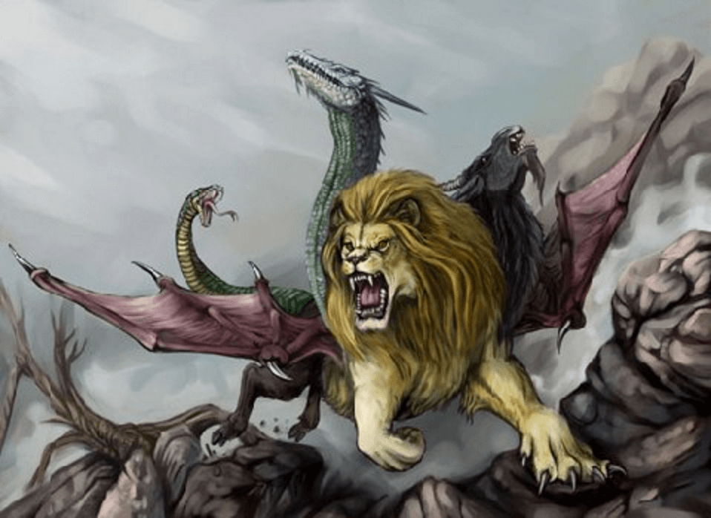
Today, we are creating the mythical beast they are going to battle – and possibly kill. Think of the mythical beasts you have read about so far in our Greek myths – Cyclops, Medusa, Minotaur, Hydra, Chimera evil spirits from Pandora’s Box.
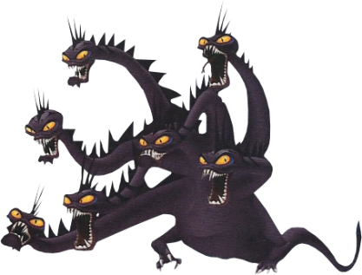
Task: Draw your mythical monster and add colour. It can be as wild as your imagination! Add labels to show any powers or strange body parts, or write a small paragraph describing your beast. Remember to give it a name!
Take a picture of your beast for Class Dojo!

Tuesday 16th June – Mythical Beast Character Description
Yesterday, you drew and labelled your mythical beast. Today, describe your mythical beast! Write a character description of your creation. Make sure your writing stays in the same tense (past or present) and in the third person (they, he, she).
Choose a name for your mythical beast and make sure it has capital letters – it is a proper noun!

Try to include as many of the AfL grid points as you can:
Assessment for Learning
W.I.L.F | What I think | What my adult thinks
2 Adjective Sentences
Fronted Adverbials (Time, Place, Manner)
Similes / Metaphors
Personification
Parenthesis ( ) , , - -
Challenge:
Relative Clauses

Take a picture of your mythical beast description for your teacher on Class Dojo!

_________________________________________________________________
_________________________________________________________________
_________________________________________________________________
_________________________________________________________________
_________________________________________________________________
_________________________________________________________________
_________________________________________________________________
_________________________________________________________________
_________________________________________________________________
_________________________________________________________________
_________________________________________________________________
_________________________________________________________________
_________________________________________________________________
_________________________________________________________________
_________________________________________________________________
_________________________________________________________________
_________________________________________________________________
_________________________________________________________________
_________________________________________________________________
_________________________________________________________________
_________________________________________________________________
_________________________________________________________________
_________________________________________________________________
_________________________________________________________________
_________________________________________________________________
_________________________________________________________________
_________________________________________________________________
_________________________________________________________________
1) Problem to be solved? 2) Hero/heroine’s name & abilities? 3) Problem, threat, issue?
Wednesday 17th June – Plan our Greek myth. Use the plan below to draw and write a short sentence for your myth (or complete on paper), which will be written next week. Take a picture of your plan for your teacher on Class Dojo!

4) Special power/Greek God involved? 5) Mythical creature & how beaten? 6) How story ends?

Thursday 18th June – Set the scene!
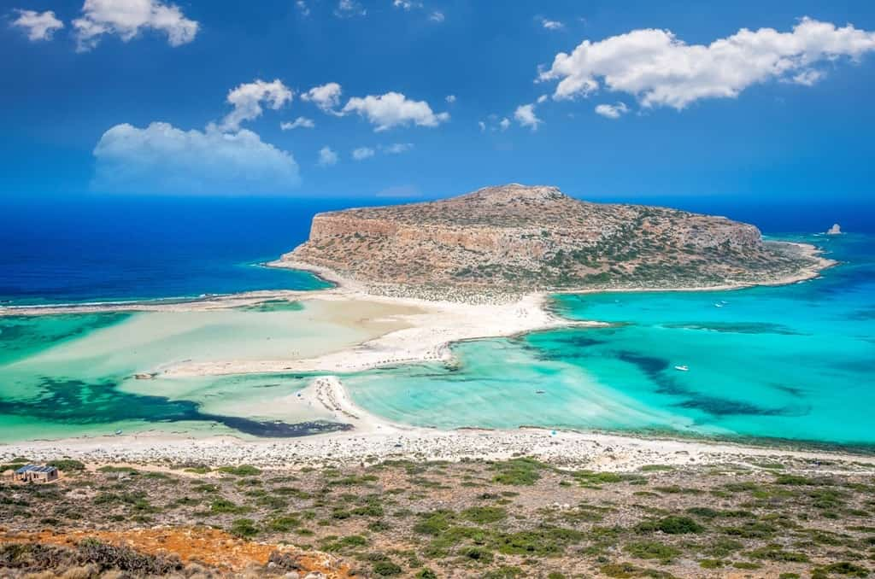
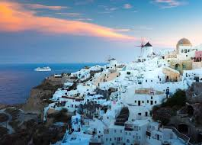
Where will your Greek myth be set? Choose (or make up) a city, island or even on top of a rock/mountain name for your setting.
Crete
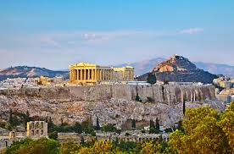
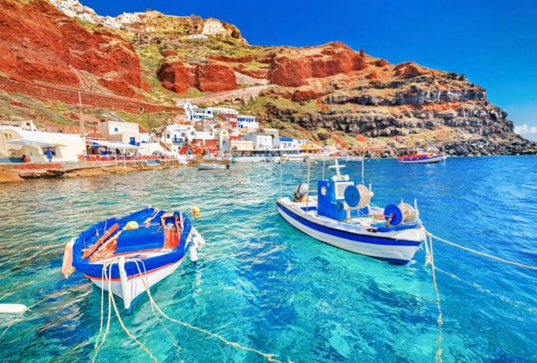
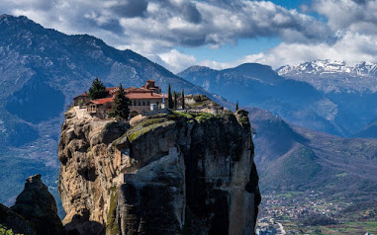
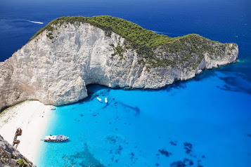
Mykonos
Athens
Zakynthos
Meteora
Santorini

Once you have chosen your setting and a name, write a scene description to set the scene for the opening of your myth.
- What are the houses like?
- What is the weather like?
- Is it on the beach? Top of a hill? Middle of a city?
- What animals live there?
- What are the people doing?
Remember! This is Ancient Greece – there will be no phones, electricity, cars, planes, laptops etc.
Try to include as many of the AfL grid points as you can:
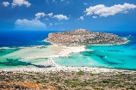
Assessment for Learning
W.I.L.F | What I think | What my adult thinks
Past Tense & Third Person
2 Adjective Sentences
Fronted Adverbials (Time, Place, Manner)
Similes / Metaphors
Personification
Parenthesis ( ) , , - -
Challenge:
Relative Clauses

Take a picture of your scene description for your teacher on Class Dojo – you may include a picture of your scene too if you wish!

Next week, we will continue our Greek myth!
_________________________________________________________________
_________________________________________________________________
_________________________________________________________________
_________________________________________________________________
_________________________________________________________________
_________________________________________________________________
_________________________________________________________________
_________________________________________________________________
_________________________________________________________________
_________________________________________________________________
_________________________________________________________________
_________________________________________________________________
_________________________________________________________________
_________________________________________________________________
_________________________________________________________________
_________________________________________________________________
_________________________________________________________________
_________________________________________________________________
_________________________________________________________________
_________________________________________________________________
_________________________________________________________________
_________________________________________________________________
_________________________________________________________________
_________________________________________________________________
_________________________________________________________________
_________________________________________________________________
_________________________________________________________________
_________________________________________________________________
Friday 19th June – Prefixes & Suffixes
Prefixes come before a root word and change the meaning of that word.
For example: Behave means you are good. Misbehave means you are bad. The prefix is ‘Mis’.
Task 1: What do these prefixes mean when used before a root word?
- Dis - _______________________________________________________
- Mis – _______________________________________________________
- Re – ________________________________________________________
- De – _______________________________________________________
- Over - ______________________________________________________
Task 2: Insert a prefix before the underlined root words to make the sentences make sense.
- The builders had to do a quick ____design when it was clear the windows didn’t fit.
- A completely new species of bear had been ___covered only recently.
- The lorry was so big it took a long time to ___take.
- The thought of not leaving on time ___motivated the workers.
- The class were known to ___behave when the teacher was unwell.
- The couple had to completely ___store the old, abandoned house.

Suffixes come after a root word and change the meaning of that word.
For example: Electric describes something (an adjective), electrify becomes a verb (something you can do). The suffix is ‘-ify’.
Task 3: Make the noun or adjective a verb by adding ‘-ate’, ‘-ise’ or ‘-ify’. You may need to slightly change the root word.
- Computer - ____________
- Mystery - ____________
- Apology - ____________
- Notice - ___________
- Caffeine - ___________
- Pollen - ___________
- Value - ___________
- Clear - ___________
- Advert - __________
Take a picture of your work for your teacher on Class Dojo!
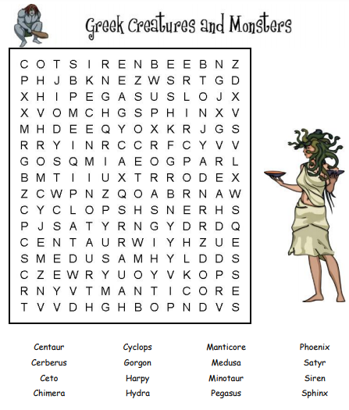
Extra Activity:

