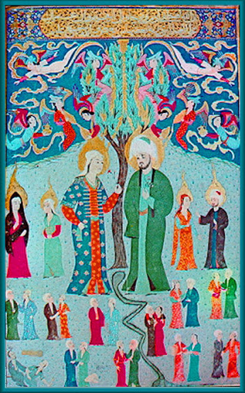
Lesson 5
R.E
At the start of our work on ‘our world’ we learnt about how Jews and Christians thought the world began. Now we are going to see how Muslims think the world began. Please read the Powerpoint about Islam creation.
Task.
- At the end of the story, Allah says he will give Adam and Eve rules to live by.
- Think about, what rules would you give to help people live in peace and harmony?
- Write down the rules you would have in place for people to live in peace and harmony.
- You might want to write your rules on paper that is stained so it looks very old.
- You could write your rules on a scroll.
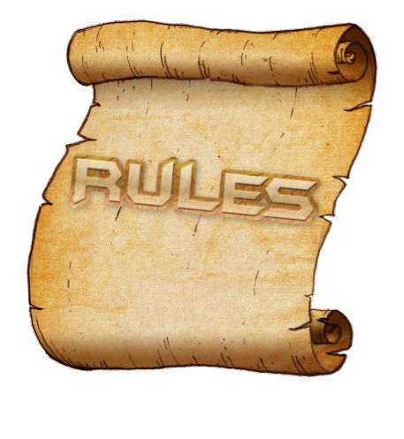

Don’t forget to take a picture and upload it onto Class Dojo as soon as you can.

