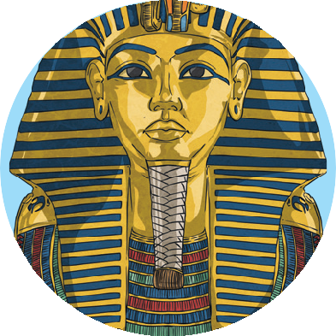
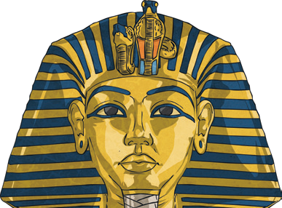
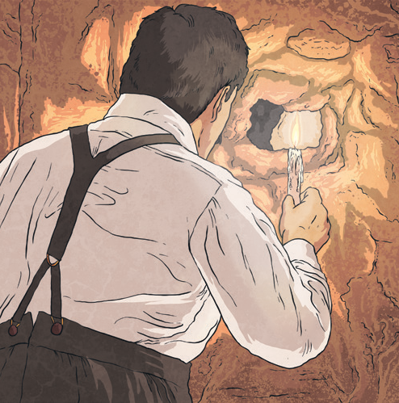
Howard Carter
Howard Carter was a British Egyptologist and archaeologist who became famous worldwide when he made an incredible discovery in Egypt.

Early Life
Howard Carter was born in Kensington, London on 9th May 1874. His father, Samuel John Carter, was an artist and he taught Howard how to accurately paint and draw from a young age. As a child, Howard
spent a lot of time near Norfolk with his relatives. They lived very close to Didlington Hall – a mansion with a sizeable
collection of Egyptian artefacts. It was here that Howard first developed an interest in ancient Egypt. When he was 17 years old, Howard got a job creating accurate drawings and diagrams of important Egyptian finds.

Discovering Tutankhamun’s Tomb
Several years into his archaeological career, Howard was employed by Lord Carnarvon – a wealthy man who was interested in the Valley of the Kings (a known burial place for many Egyptian pharaohs). After many years of discovering very little, Lord Carnarvon told Howard that he would cease all funding if he did not discover something significant within the year.
On the 4th November 1922, Howard Carter’s water boy stumbled across a stone in the place that Howard and his team had been excavating. Howard recognised this stone as one that belonged to a set of stairs; he believed that the stairs could lead to a previously undiscovered tomb. Immediately, Howard summoned Lord Carnarvon and, on the 26th November 1922, the two of them were ready to see the most famous Egyptian tomb ever discovered.
Using the same chisel that his grandmother had given him as a present for his 17th birthday, Howard made a small hole in the wall they had found. We now know that this wall led to the antechamber of the famous Egyptian pharaoh Tutankhamun. When Howard looked through the small hole, his eyes were greeted with hundreds of golden objects. Famously, when Lord Carnarvon asked Howard what he could see, he replied, “Wonderful things.”

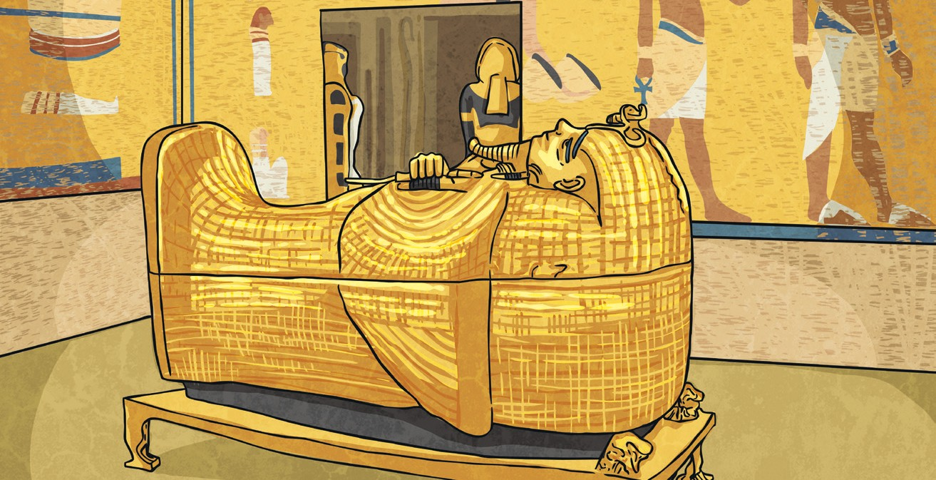

Howard Carter

After the Discovery
On the 16th February 1923, Howard Carter opened the sealed door within the antechamber and discovered the burial chamber of Tutankhamun. Like the antechamber, this room was filled with golden objects that Tutankhamun would need in the afterlife. Among these objects was the incredibly ornate sarcophagus of Tutankhamun. News of this amazing find quickly spread across the world. Soon, journalists were travelling from far and wide; they all wanted to catch a glimpse of the tomb (which had remained undiscovered for 3,000 years) and the man who had uncovered it. For the next nine years, Howard Carter tirelessly documented each of the thousands of objects buried with Tutankhamun. He drew each object, as well as diagrams showing their position within the tomb. After this, they were moved to a museum in Cairo where many of the objects remain today.

