GEOGRAPHY
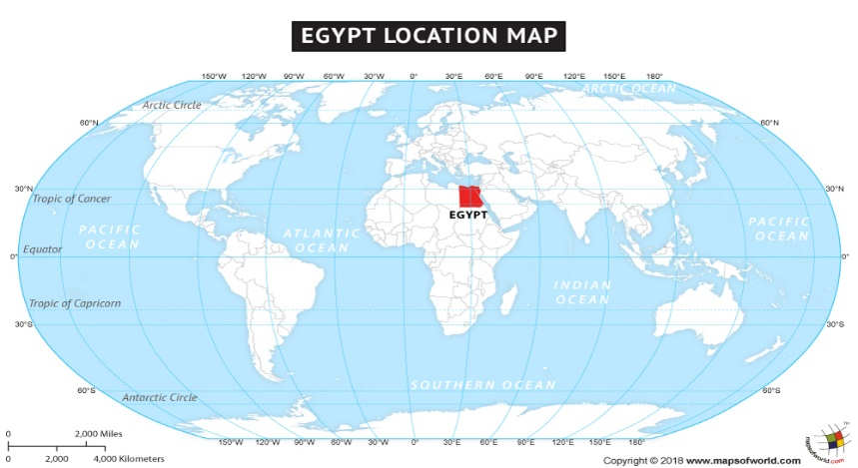
Lesson 2
Today we are going to look at Egypt’s climate.
Climate is the average measurements of temperature, wind, humidity, snow, and rain in a place over the course of years. Climate is like the weather, but over a long time.

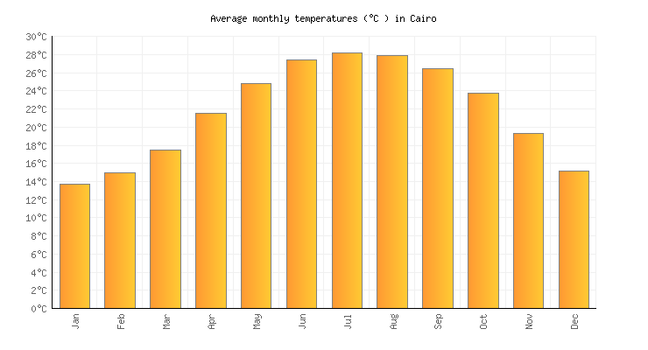
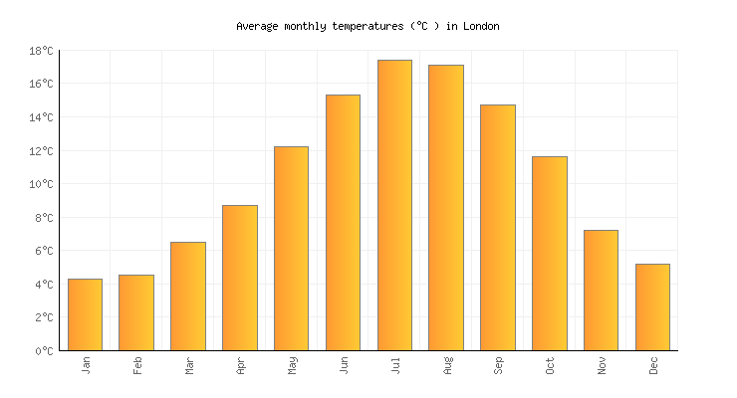
Here are two graphs showing the temperature over a year in Cairo, Egypt and London, England.
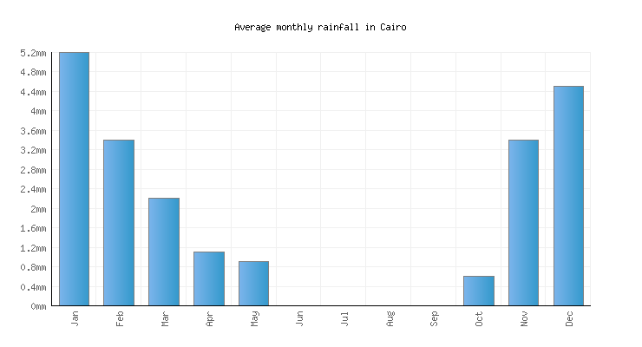
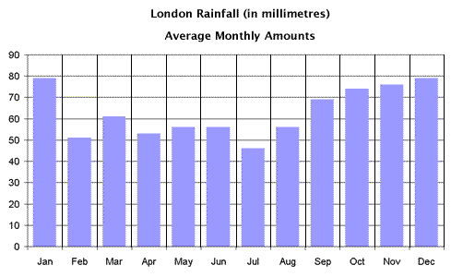
Here are two graphs showing the rainfall over a year in Cairo, Egypt and London, England.

- Look at the temperature charts and look at temperatures over a year.
- Look at the rainfall charts and look at how much rain falls over a year.

Task
Using the graphs for temperature and rainfall, answer the questions below.
Remember to answer in full sentences and make sure your handwriting is beautifully presented and neat.

Questions
- Which months had the highest temperature in London?
- Which months had the lowest temperature in London?
- Which months had the highest temperature in Cairo?
- Which months had the lowest temperature in Cairo?
- Which month had the most rainfall in London?
- Which month had the least rainfall in London?
- Which month had the most rainfall in Cairo?
- Which month had the least rainfall in the Cairo?

Challenge
If you would like a challenge, what other information can you find out about the climate in Egypt?

Put a photo on Class Dojo of your work, don’t forget to label the work Geography.

