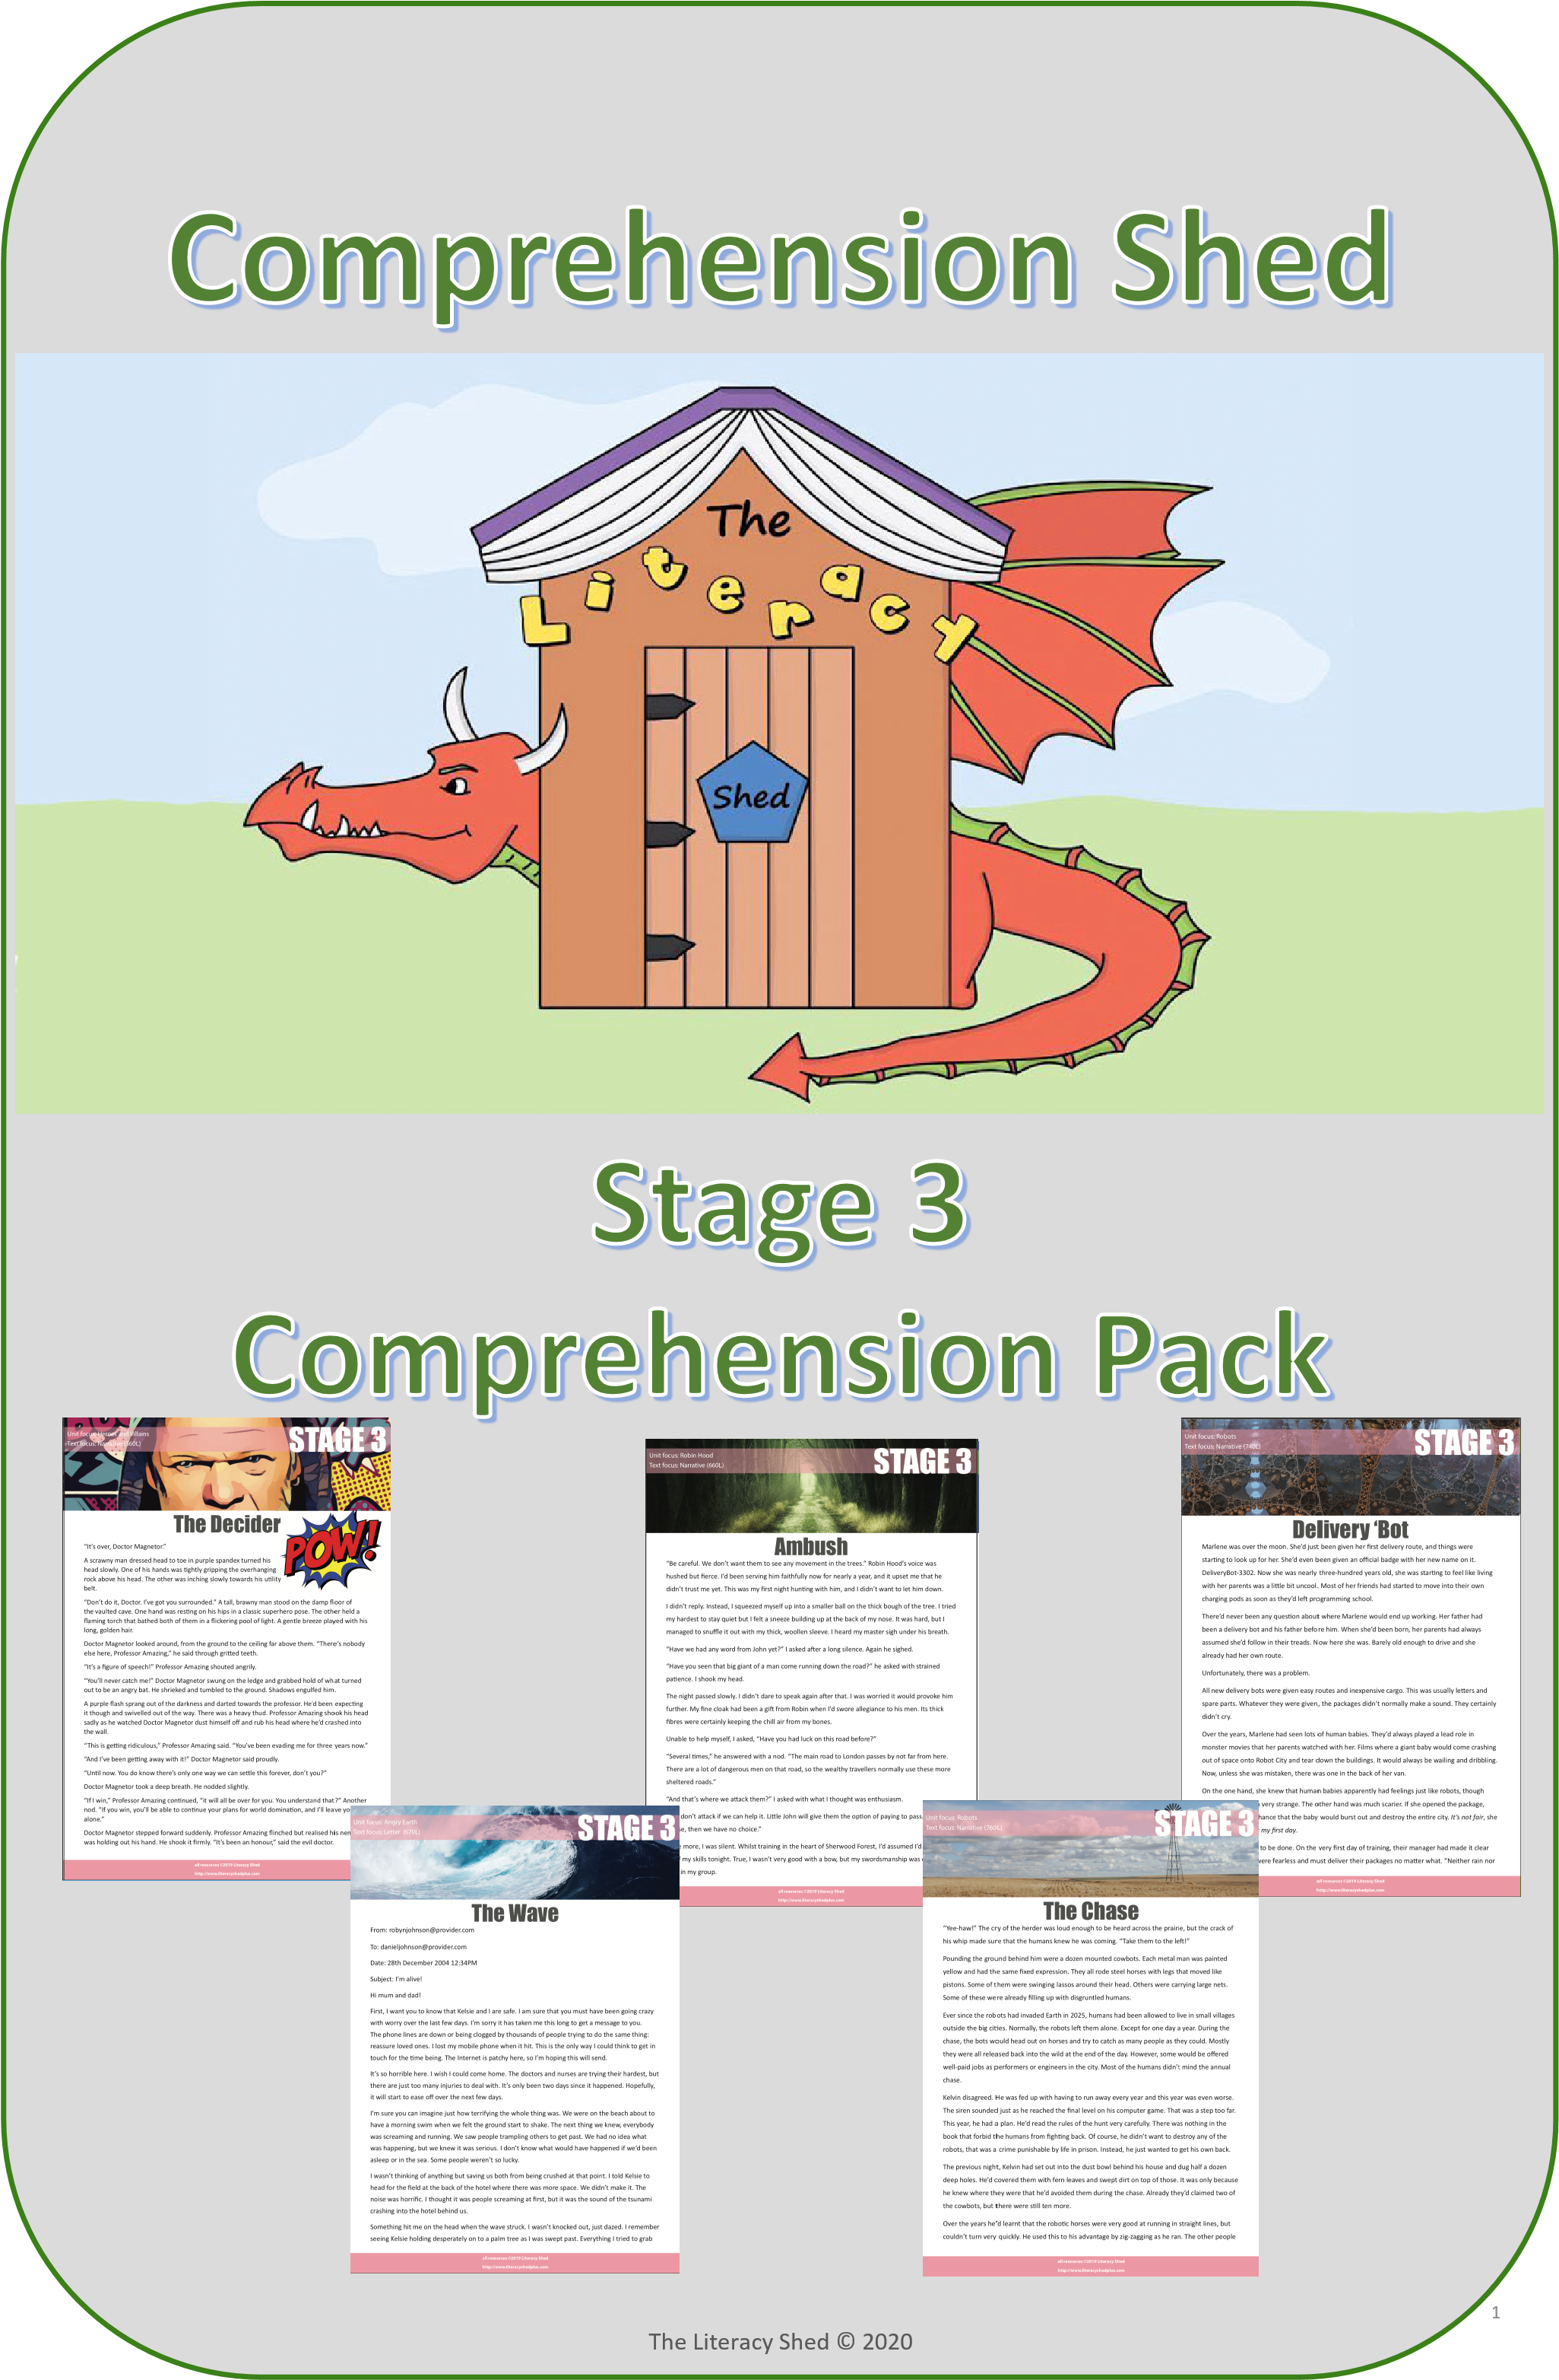

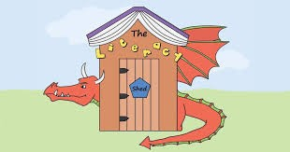
Stage
3

Comprehension Pack

This free pack is aimed at those children working at the expected reading level for a child in Y3 in England. P4 in Scotland and Ireland. (Ages 7-8) The texts have a Lexile level range between 560L and 760L.

What do the letters mean?
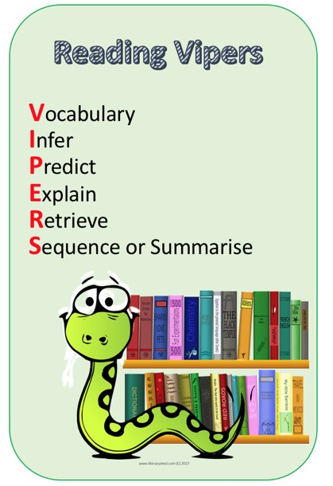
The questions in the comprehensions are not numbered but labelled with a letter from VIPERS.
These letters correspond with key reading skills. Many schools use these codes in reading lessons so lots of children will be familiar with them.

If your child is not familiar with the letter codes, then do not worry – it is just highlighting the skill for them.

If you would like to read more about VIPERS then there is an explanation on our blog here:
www.literacyshedblog.com/vipers

If you enjoy these comprehensions, then further comprehensions can be found in our membership area on www.literacyshedplus.com

Ambush
“Be careful. We don’t want them to see any movement in the trees.” Robin Hood’s voice was hushed but fi erce. I’d been serving him faithfully now for nearly a year, and it upset me that he didn’t trust me yet. This was my fi rst night hunti ng with him, and I didn’t want to let him down.
I didn’t reply. Instead, I squeezed myself up into a smaller ball on the thick bough of the tree. I tried my hardest to stay quiet but I felt a sneeze building up at the back of my nose. It was hard, but I managed to snuffl e it out with my thick, woollen sleeve. I heard my master sigh under his breath.
“Have we had any word from John yet?” I asked aft er a long silence. Again he sighed.
“Have you seen that big giant of a man come running down the road?” he asked with strained pati ence. I shook my head.
The night passed slowly. I didn’t dare to speak again aft er that. I was worried it would provoke him further. My fi ne cloak had been a gift from Robin when I’d swore allegiance to his men. Its thick fi bres were certainly keeping the chill air from my bones.
STAGE 3
Unit focus: Robin Hood
Text focus: Narrative (660L)
Unable to help myself, I asked, “Have you had luck on this road before?”
“Several ti mes,” he answered with a nod. “The main road to London passes by not far from here. There are a lot of dangerous men on that road, so the wealthy travellers normally use these more sheltered roads.”
“And that’s where we att ack them?” I asked with what I thought was enthusiasm.
“We don’t att ack if we can help it. Litt le John will give them the opti on of paying to pass. If they refuse, then we have no choice.”
Once more, I was silent. Whilst training in the heart of Sherwood Forest, I’d assumed I’d get to use all of my skills tonight. True, I wasn’t very good with a bow, but my swordsmanship was one of the best in my group.
As if out of nowhere, I heard the low rumble of a cart on the track. A piercing whistle came from directly below my branch. I looked down and saw the broad back of Little John. How had somebody of his size managed to sneak so close to me?
“One day, take a minute to watch him move,” Robin Hood said as if he’d read my mind.
I didn’t have time now to watch him, he was striding out into the middle of the road just in time for the cart to pull up.
“What the devil are you doing?” the driver was clearly in no mood to surrender to our demands.
“This is a toll path.” Little John’s voice was calm. It didn’t need to be big or loud, his size did that for him.
“Over my dead body!” The driver banged on the roof of the carriage, and several armed guards stepped out.
all resources ©2019 Literacy Shed
http://www.literacyshedplus.com
“That can be arranged,” said Robin as he dropped from the tree and drew his sword. “Take them as a prisoner if you can. They’re worth more that way!”

VOCABULARY FOCUS
- What word or phrase tells you that Robin Hood’s voice was quiet?
- Find one word in the text which means “in a loyal way”.
- What does the phrase “I didn’t dare” say about the author?
- What does the phrase “strained patience” tell you about Robin?
- Write a definition for “piercing”. You may use a dictionary if you are stuck.
VIPERS QUESTIONS
Why did Robin sigh under his breath?
What type of traveller are they expecting to use the road?
I
R
S | What happened immediately after the driver refused to pay?
E | In the paragraph that starts “The night passed…”, what effect does the use of short sentences have?
R | Where had the author trained?
Answers:
- Hushed
- Faithfully
- He is scared of Robin and wants to please him
- He is trying to be patient but it is hard
- Extremely high or loud (ensure definition is of a piercing sound and not another definition)
I: He was disappointed in the author
R: Wealthy
S: He banged on the roof and armed guards got out
E: It builds tension and pace or equivalent explanation
R: Sherwood Forest

The Literacy Shed © 2020 2

Delivery ‘Bot
Marlene was over the moon. She’d just been given her fi rst delivery route, and things were starti ng to look up for her. She’d even been given an offi cial badge with her new name on it. DeliveryBot-3302. Now she was nearly three-hundred years old, she was starti ng to feel like living with her parents was a li le bit uncool. Most of her friends had started to move into their own charging pods as soon as they’d le programming school.
There’d never been any questi on about where Marlene would end up working. Her father had been a delivery bot and his father before him. When she’d been born, her parents had always assumed she’d follow in their treads. Now here she was. Barely old enough to drive and she already had her own route.
Unfortunately, there was a problem.
All new delivery bots were given easy routes and inexpensive cargo. This was usually le ers and spare parts. Whatever they were given, the packages didn’t normally make a sound. They certainly didn’t cry.
STAGE 3
Unit focus: Robots
Text focus: Narrative (740L)
Over the years, Marlene had seen lots of human babies. They’d always played a lead role in monster movies that her parents watched with her. Films where a giant baby would come crashing out of space onto Robot City and tear down the buildings. It would always be wailing and dribbling.
Now, unless she was mistaken, there was one in the back of her van.
On the one hand, she knew that human babies apparently had feelings just like robots, though she found that idea very strange. The other hand was much scarier. If she opened the package, there was a good chance that the baby would burst out and destroy the enti re city. It’s not fair, she thought angrily. It’s my fi rst day.
Something needed to be done. On the very fi rst day of training, their manager had made it clear that delivery bots were fearless and must deliver their packages no ma er what. “Neither rain nor snow nor gloomy night,” their manager had said. He’d been annoyingly quiet on the subject of babies though.
Behind her, the honking of horns started to irritate Marlene. She knew her van was holding up the other drivers, but this was important. The address on the label was clear and well wri en. No chance of returning it to the depot and claiming she couldn’t read it. And the address was right there in front of her. A perfectly normal tower block fi lled with robot charging pods.
What would a robot want with a human baby?
all resources ©2019 Literacy Shed
http://www.literacyshedplus.com
She had to fi nd out. Nervously, she rolled up to the front door and pressed the buzzer.

INFERENCE FOCUS
- How do you think Marlene felt about human babies a er watching the fi lms?
- Why was Marlene so happy to be given a delivery route?
- Why did she fi nd it strange that human babies had feelings?
- Why was she annoyed that her manager never menti oned babies?
 | VIPERS QUESTIONS
V | What word tells us that Marlene’s parents expected her to become a delivery bot?
R | What things did her manager say wouldn’t stop a delivery bot?
E | Explain how this package was diff erent to most others.
P | What do you think will happen now that the monster has been discovered?
S | Summarise what has happened so far on Marlene’s fi rst day.
Answers:
- Scared / terrified
- She felt grown-up and independent
- She was used to them being strange, alien beings. She’d never considered them like her
- She wanted to know what to do now
V: Assumed
R: Rain, snow and gloomy nights
E: It was making a sound and crying
P: Any suitable prediction
S: Any suitable summary including the key facts

The Literacy Shed © 2020 3

The Chase
“Yee-haw!” The cry of the herder was loud enough to be heard across the prairie, but the crack of his whip made sure that the humans knew he was coming. “Take them to the le !”
Pounding the ground behind him were a dozen mounted cowbots. Each metal man was painted yellow and had the same fi xed expression. They all rode steel horses with legs that moved like pistons. Some of them were swinging lassos around their head. Others were carrying large nets.
Some of these were already fi lling up with disgruntled humans.
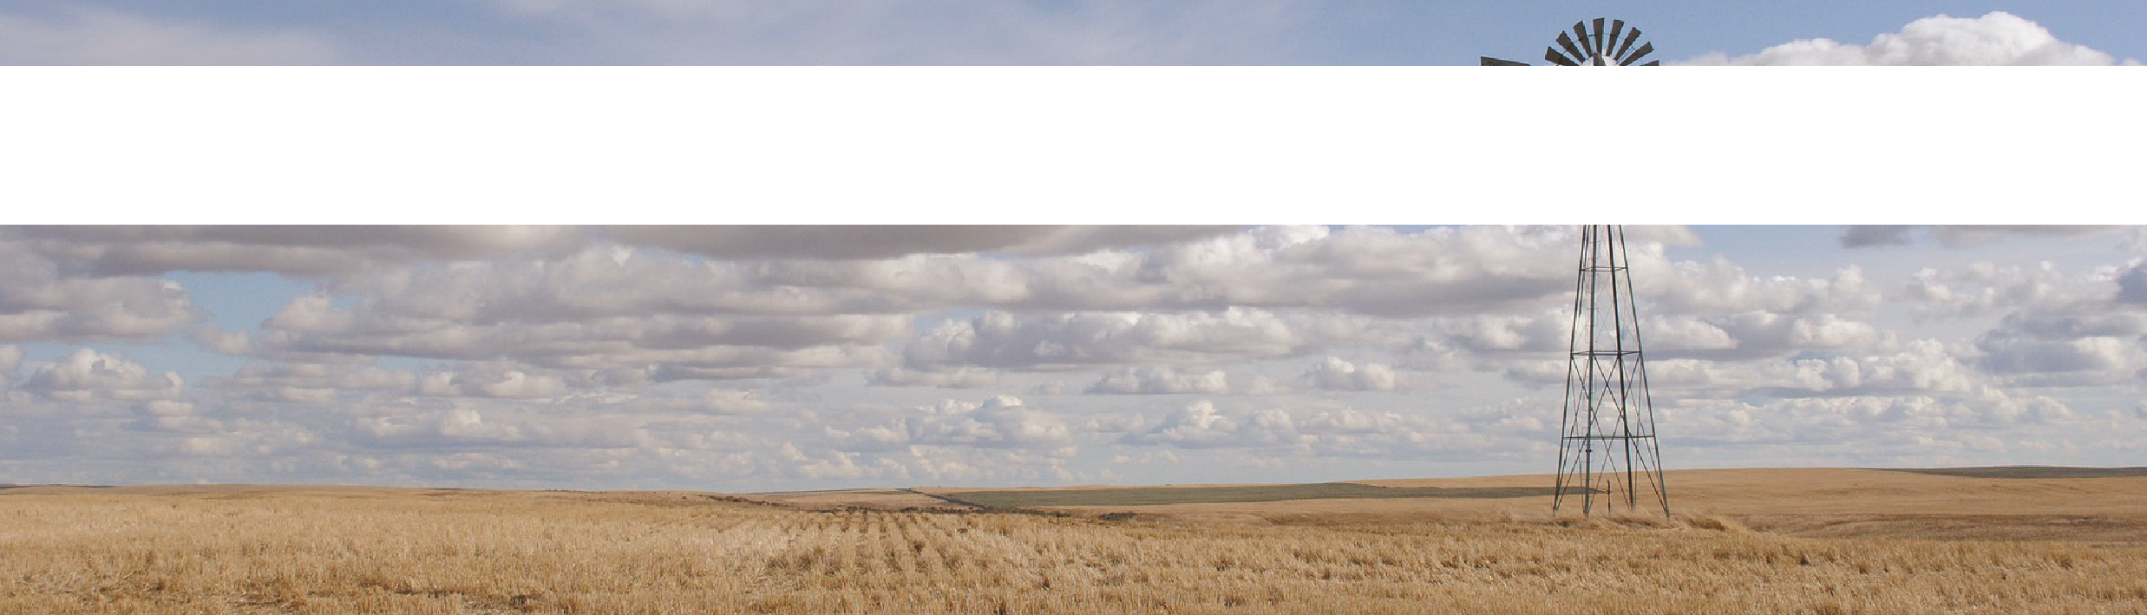
Ever since the robots had invaded Earth in 2025, humans had been allowed to live in small villages outside the big citi es. Normally, the robots le them alone. Except for one day a year. During the chase, the bots would head out on horses and try to catch as many people as they could. Mostly they were all released back into the wild at the end of the day. However, some would be off ered well-paid jobs as performers or engineers in the city. Most of the humans didn’t mind the annual chase.
STAGE 3
Unit focus: Robots
Text focus: Narrative (760L)
Kelvin disagreed. He was fed up with having to run away every year and this year was even worse.
The siren sounded just as he reached the fi nal level on his computer game. That was a step too far. This year, he had a plan. He’d read the rules of the hunt very carefully. There was nothing in the book that forbid the humans from fi ghti ng back. Of course, he didn’t want to destroy any of the robots, that was a crime punishable by life in prison. Instead, he just wanted to get his own back.
The previous night, Kelvin had set out into the dust bowl behind his house and dug half a dozen deep holes. He’d covered them with fern leaves and swept dirt on top of those. It was only because he knew where they were that he’d avoided them during the chase. Already they’d claimed two of the cowbots, but there were sti ll ten more.
Over the years he’d learnt that the roboti c horses were very good at running in straight lines, but couldn’t turn very quickly. He used this to his advantage by zig-zagging as he ran. The other people in his village had copied him, and he could hear the frustrated cries of the herders behind him.
Digging hidden pits wasn’t all he’d been up to during the night. A few hundred yards away was a small group of trees, and he’d spent a few hours tying very fine but very strong nets between them. Unless you were very close, you wouldn’t know they were there. If you were that close on a horse, it was too late. His lungs were burning, and his heart racing, but he could practically feel the trees around him. Once he got there, he knew the other herders would become entangled.
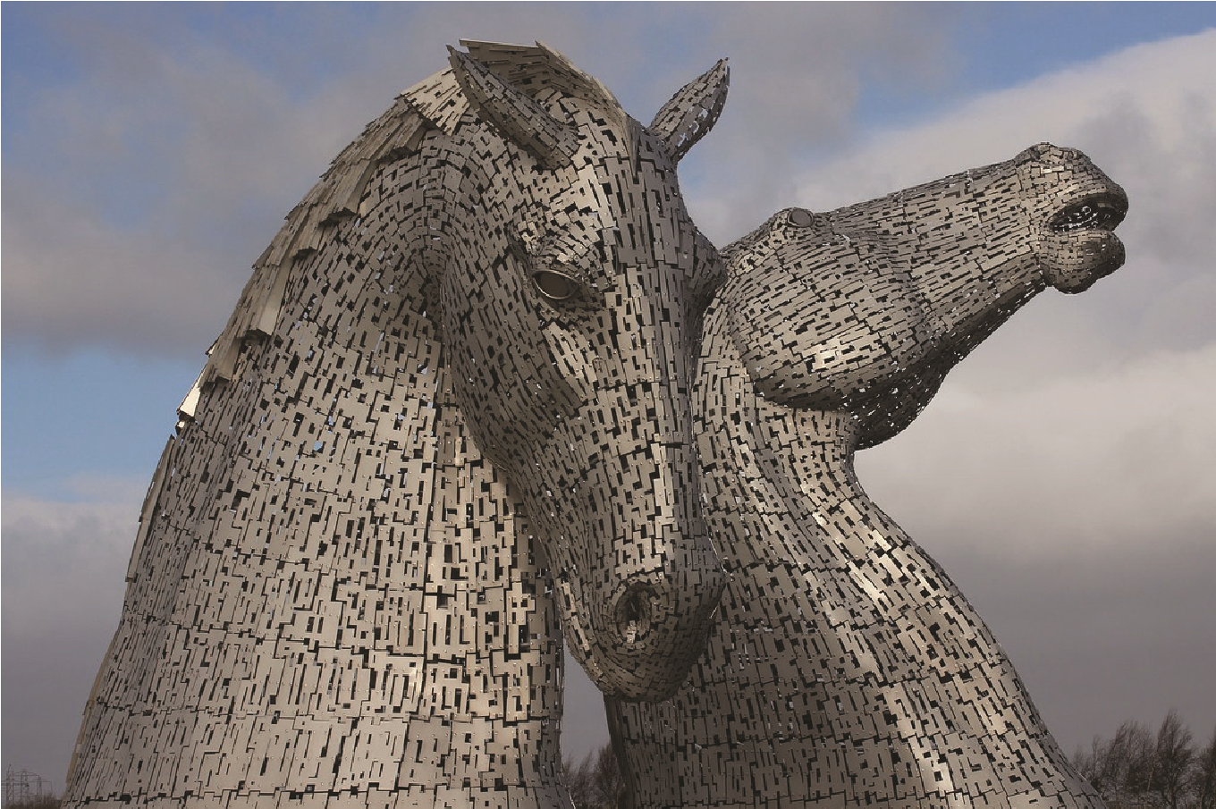
“Ooomph!” The word escaped him along with his breath. A rope snapped around his ankles and dragged him to the floor. He rolled onto his aching back and looked up into the grinning yellow face of a cowbot.
all resources ©2019 Literacy Shed
http://www.literacyshedplus.com
“Bad luck, little human!” the tinny voice crackled. “Better luck next year!”

RETRIEVAL FOCUS
- How many cowbots were there to start with?
- When did the robots invade?
- How many holes did he dig?
- How did he run to escape the horses?
 | VIPERS QUESTIONS
V | What does the word “mounted” tell us about the cowbots?
V | Find another word to replace “entangled”.
E | Explain why Kelvin doesn’t normally agree with the annual chase.
P | How do you think Kelvin will try to stop the chase next year?  How did Kelvin feel as he got closer to the trees? Explain your answer.
I
Answers:
- A dozen (12)
- 2025
- Half a dozen (6)
- In zig-zag lines
V: They are riding something
V: Any suitable word
E: He was fed up with running away. Look for more than just the disturbance of his computer game P: Any suitable prediction
I: Happy and excited because he thought he would escape. Look for more inference than out of breath and a racing heart.

The Literacy Shed © 2020 4

“Don’t do it, Doctor. I’ve got you surrounded.” A tall, brawny man stood on the damp fl oor of the vaulted cave. One hand was resti ng on his hips in a classic superhero pose. The other held a fl aming torch that bathed both of them in a fl ickering pool of light. A gentle breeze played with his long, golden hair.
Doctor Magnetor looked around, from the ground to the ceiling far above them. “There’s nobody else here, Professor Amazing,” he said through gritt ed teeth.
“It’s a fi gure of speech!” Professor Amazing shouted angrily.
“You’ll never catch me!” Doctor Magnetor swung on the ledge and grabbed hold of what turned out to be an angry bat. He shrieked and tumbled to the ground. Shadows engulfed him.
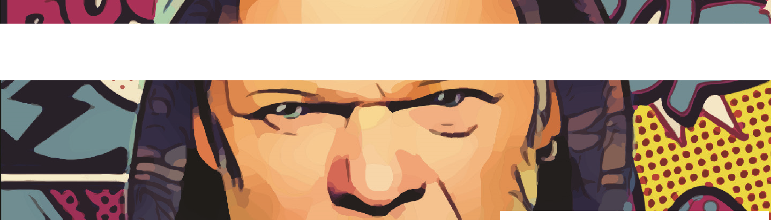
A purple fl ash sprang out of the darkness and darted towards the professor. He’d been expecti ng it though and swivelled out of the way. There was a heavy thud. Professor Amazing shook his head sadly as he watched Doctor Magnetor dust himself off and rub his head where he’d crashed into the wall.
STAGE 3
Unit focus: Heroes and Villains
Text focus: Narrative (560L)
“It’s over, Doctor Magnetor.”
A scrawny man dressed head to toe in purple spandex turned his
head slowly. One of his hands was ti ghtly gripping the overhangin
rock above his head. The other was inching slowly towards his uti l
belt.
g
ity
The Decider
“This is ge ng ridiculous,” Professor Amazing said. “You’ve been evading me for three years now.” “And I’ve been ge ng away with it!” Doctor Magnetor said proudly.
“Unti l now. You do know there’s only one way we can sett le this forever, don’t you?” Doctor Magnetor took a deep breath. He nodded slightly.
“If I win,” Professor Amazing conti nued, “it will all be over for you. You understand that?” Another nod. “If you win, you’ll be able to conti nue your plans for world dominati on, and I’ll leave you alone.”
Doctor Magnetor stepped forward suddenly. Professor Amazing fl inched but realised his nemesis was holding out his hand. He shook it fi rmly. “It’s been an honour,” said the evil doctor.
“Any last words?” asked the professor.
“You need a better catch-phrase.”
“What’s wrong with ‘You’ve been caught by Professor Amazing’?”
“It sounds too much like a TV advert.” The doctor thought for a moment. “Maybe something like ‘There’s only room for one Amazing’.” He thought again for a second and said, “Maybe not. But work on it. It’s pretty terrible.”
“Fair enough. Is that it?”
“Will you pass on a message to my dear old mum?” Professor Amazing nodded, and Doctor Magnetor continued, “Tell her to send me my sonic blaster hidden in a birthday cake. It will help me escape.”
“No,” said Professor Amazing, flatly. “Let’s get this over and done with. I don’t want to drag it out any longer.”
The two men cautiously approached each other. “Are you sure you’re ready for this?” Professor Amazing asked.
all resources ©2019 Literacy Shed
http://www.literacyshedplus.com
“Get on with it.”
“Okay.” Both men held out their right hand in a tensely curled fist. They raised them together three times and muttered under their breath, “Rock, paper, scissors…” Each of them opened their hand at precisely the same time.

VOCABULARY FOCUS
- What is a pose?
- What does “Shadows engulfed him” mean?
- Find a word that has a definition closest to “trying to avoid or not be found”.
- Which word tells you how Professor Amazing shook Doctor Magnetor’s hand?
- What does the word “cautiously” tell you about how they felt as they approached each other?
VIPERS QUESTIONS
Why does the purple man talk through gritted teeth near the beginning?
What did Doctor Magnetor grab hold of?
I
R
S | What did Doctor Magnetor do after he raced towards Professor Amazing?  How do you think they settled their argument?  Write the next paragraph in the story. Think about what might happen.
I
P
Answers:
- A position that somebody is holding
- He was swallowed by the shadows/they covered him completely
- Evading
- Firmly
- They didn’t trust each other not to do something
I: He is holding on to the ledge tightly
R: An angry bat
S: He bumped his head on the wall
I: Rock, paper, scissors
P: Any suitable prediction that links back to the game.

The Literacy Shed © 2020 6

The Wave
From: robynjohnson@provider.com
To: danieljohnson@provider.com Date: 28th December 2004 12:34PM
Subject: I’m alive!
Hi mum and dad!
First, I want you to know that Kelsie and I are safe. I am sure that you must have been going crazy with worry over the last few days. I’m sorry it has taken me this long to get a message to you. The phone lines are down or being clogged by thousands of people trying to do the same thing: reassure loved ones. I lost my mobile phone when it hit. This is the only way I could think to get in touch for the ti me being. The Internet is patchy here, so I’m hoping this will send.
It’s so horrible here. I wish I could come home. The doctors and nurses are trying their hardest, but there are just too many injuries to deal with. It’s only been two days since it happened. Hopefully, it will start to ease off over the next few days.
STAGE 3
Unit focus: Angry Earth
Text focus: Letter (670L)
I’m sure you can imagine just how terrifying the whole thing was. We were on the beach about to have a morning swim when we felt the ground start to shake. The next thing we knew, everybody was screaming and running. We saw people trampling others to get past. We had no idea what was happening, but we knew it was serious. I don’t know what would have happened if we’d been asleep or in the sea. Some people weren’t so lucky.
I wasn’t thinking of anything but saving us both from being crushed at that point. I told Kelsie to head for the fi eld at the back of the hotel where there was more space. We didn’t make it. The noise was horrifi c. I thought it was people screaming at fi rst, but it was the sound of the tsunami crashing into the hotel behind us.
Something hit me on the head when the wave struck. I wasn’t knocked out, just dazed. I remember seeing Kelsie holding desperately on to a palm tree as I was swept past. Everything I tried to grab just slipped through my fingers. At that point, I felt sure I was going to drown.
I got lucky. Something hard hit me on my back and knocked the air from my lungs. I tried to see what it was, but the water was pressing me so hard against it that I couldn’t turn. I could see Kelsie still, but she was too far to reach.
By now, the flow of water had started to ease off slightly, and I turned around. I’d been washed into a billboard by the side of the main road. We were nearly half a mile from the hotel.
I swam over to Kelsie as soon as the water was slow enough and we made our way back to where our hotel had been. Everything had been devastated. One of the medical people told us that he thinks there are tens of thousands of people who died. Both of us are just feeling so blessed to have made it.
Anyway, I’ve got to go. Somebody else needs to use the computer. I’ll tell you the rest when I get home.
All my love.
Robyn

INFERENCE FOCUS
- Why does the author start by saying that they are safe?
- How does Robyn feel throughout the email? What tells you this?
- When they ran from the beach, why did Robyn head for the field behind the hotel?
- Why is Robyn happy to let somebody else use the computer?
- How do you think Robyns parents will feel to receive the email? Explain your thoughts.
 | VIPERS QUESTIONS
V | Which word tells you that there isn’t the best Internet service?
R | On what date did the tsunami hit?
S | What did the girls do after they felt the ground shaking?
R | What was Robyn washed up against that saved her life?
V | What does the word devastated tell you about what they found at the hotel?
Answers:
- They don’t want their parents their worry
- She feels lucky. She talks about other people not being so lucky, and about how she got lucky when she hit the billboard. She also talks about feeling blessed.
- There was more space so they would be less likely to be crushed by the crowd
- She knows how hard it is to send messages home so wants the other person to have the chance
- Accept answers that link to being relieved because they know she is safe or concerned because of what she has been through.
V: Patchy
R: 26th December (don’t accept 28th as this is when the email was sent)
S: They noticed everybody start to run and they ran away from the crowds R: A billboard
V: Everything was broken and ruined

The Literacy Shed © 2020 5

