ART/ DT
It was very important to ancient Egyptian religious beliefs that the human body was preserved. A method of artificial preservation, called mummification was developed by the ancient Egyptians.
Mummification was a complicated and lengthy process which lasted up to 70 days. Using special processes, the Egyptians removed all moisture from the body, leaving only a dried form that would not easily decay. Mummies of humans and other animals have been found on every continent. Over one million animal mummies have been found in Egypt, many of which are cats.

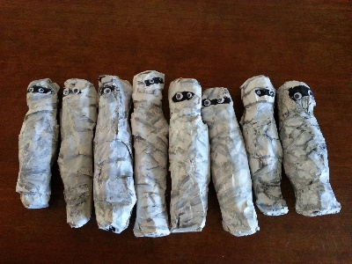

Your task this week is to create a mummy. It can be as simple as the toilet roll idea or as complicated as the paper mache one. Some people have even mummified fruit!

Please take a picture of your Egyptian mummy and upload it to Class Dojo.

