Reading
Week Beginning 29th June 2020

For reading for the next few weeks we are going to read a different book linked to our science topic about the human body.

There will be 3 planned lessons this week. For the other 2 reading lessons we would like you to read a book of your choice. This could be a book from home or an online book. We’d love to see pictures on Class Dojo of you reading a book, magazine or newspaper!

Week 1: Lesson 1
Before we open and read the book, let’s make a prediction using the title and the front cover. You should also include if you think it will be a fiction or non-fiction book and why.
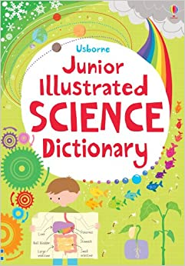
Task: Make a prediction about what this book will be about.

Remember to add a photo of your work onto Class Dojo or write your answer directly onto Class Dojo.

Week 1: Lesson 2
For this lesson we will begin to read the book. You will need to open the pdf book called “Junior Illustrated Science Dictionary Part 1” which is on the class page of the school website.

Task: Clarify
Look up the meaning of any words you did not understand. You may want to use this online dictionary. https://kids.wordsmyth.net/we/?ssid=pwonvtru6schofgbq5pft0rxe275svlb

Make a note of the words you clarified and their meanings. If you understood all the words then create a dictionary entry for these words to help a child who did not understand them.
- Position
- Nutrients
- Energy
- Oxygen
- Substances

Remember to add a photo of your work onto Class Dojo or write your answer directly onto Class Dojo.

Week 1: Lesson 3
For this lesson you will need to open the pdf book called “Junior Illustrated Science Dictionary Part 2” which is on the class page of the school website.

Use the online dictionary to help you clarify any words you need to https://kids.wordsmyth.net/we/

Task: Questions

1) What can you do to work out if something is a living thing or non-living thing? (2b)
2) What are all living things made from? (2b)
3) Why would you need a microscope to see a cell? (2d)
4) Why might some people think that a flame is a living thing? What proves it is a non-living thing? (2b)
5) Are all cells the same? (2b)
6) Why has the author used separate boxes to describe cells, tissues and organs? (2f)

Remember to add a photo of your work onto Class Dojo or write your answer directly onto Class Dojo.

