ART
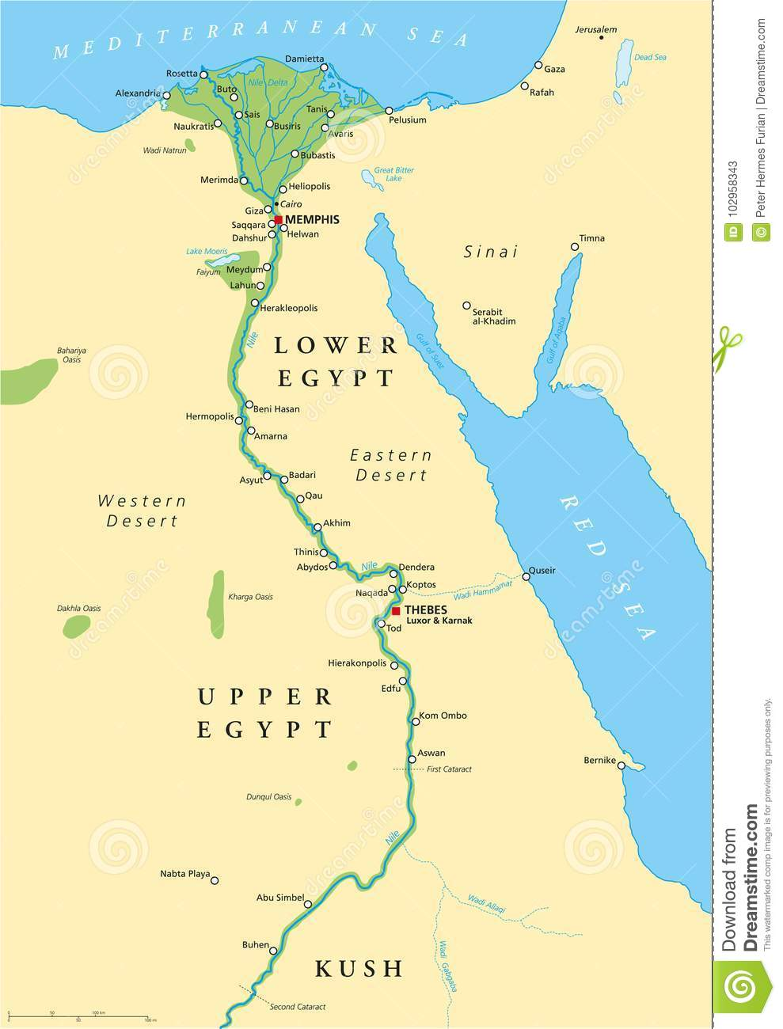
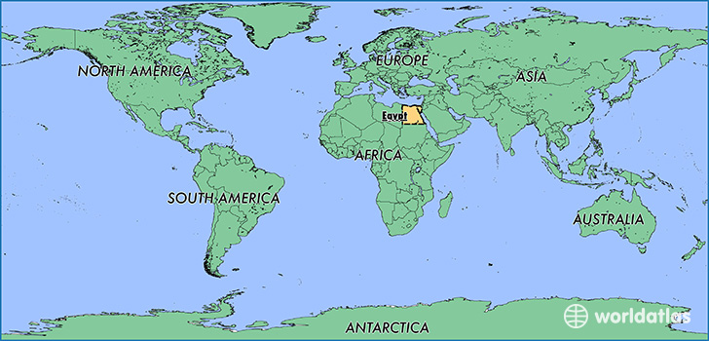
This summer term, our topic is all about Ancient Egypt. Egypt is located in Africa and is mostly desert.
One of the most famous things about Egypt are the pyramids.
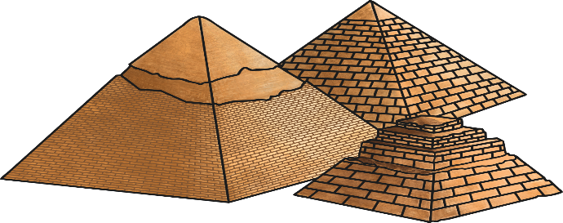

This week you can make a pyramid either by yourself or with members of your family.
Here are some suggestions:
- Make a pyramid using paper or card and colour in the finished product. If you wanted, you could use paint with some sand mixed into it to give it some texture instead of colouring pencils or felt tip pens.
- Make a pyramid using salt dough, Play-doh or modelling clay. Once dry, these could be painted.
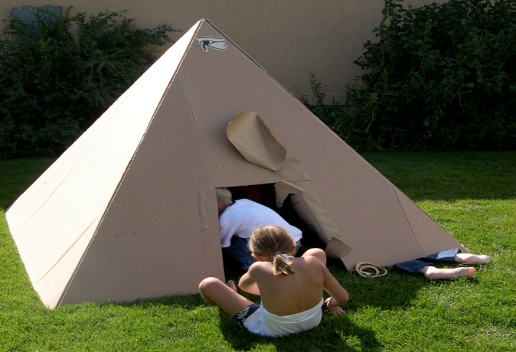
- Create a pyramid in your garden using materials, garden chairs etc.
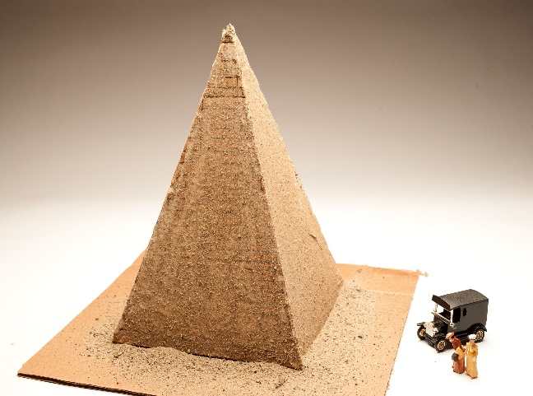
Please take a picture of your pyramid and send it as soon as you can

