Lesson 1
Ancient Egypt
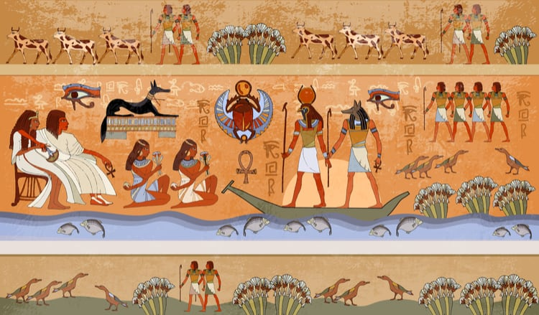
This Summer term, our theme is all about the Ancient Egyptians. To help, with learning all about Egypt’s history, here is a book for us all to read and together we can explore this mysterious land.
Before we open the book, let’s think about:
What do you already know about Egypt?

What would you like to know about Ancient Egypt?

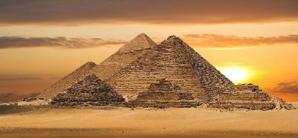
Lesson 2
The Ancient Egyptians

Today we are going to start reading the book ‘The Ancient Egyptians’. This book is a non-fiction book full of facts from the River Nile to the powerful Pharaohs.
Open the book that has been attached. It is a PDF file.
Read the sections called ‘Who they were and The Land’.
Task
Answer the questions carefully and make sure your handwriting is beautiful.
When did the Ancient Egyptians exist? (2b)

Where did the Egyptians live? (2b)

Why were the Egyptians very successful? (2b)

Why do you think the Egyptians had many rivals, people who want the same things? (2d)

Lesson 3
The Ancient Egyptians.
Open the book that has been attached. It is a PDF file.

Read the sections called ‘Farming, The Seasons and the Tools They Used’.

Task
- Using the images from the book and the images below to help you, create your own drawing of the Egyptians farming the land.

- Write a paragraph about the farmer’s year and the three seasons:
The flooding season.
The growing season.
The harvesting season.

