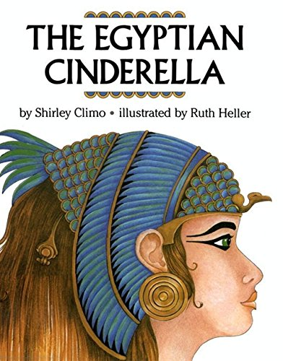
Lesson 1
Literacy
This week we are going to continue to look at the story ‘The Egyptian Cinderella’.
To remind ourselves of the story, please read the story, click on the link below and follow the story as you listen to the book being read to you.
https://www.youtube.com/watch?v=dSVfIc4l8Lk
Rhodopis is a slave who works for a kind, old man. She has made friends with the animals and loves to dance with them when all of her chores are done. Her master also likes to watch Rhodopis dance and bought her some dainty slippers to wear.
Task
Write down:
What does Rhodopis think about herself?
What do other people think about Rhodopis?
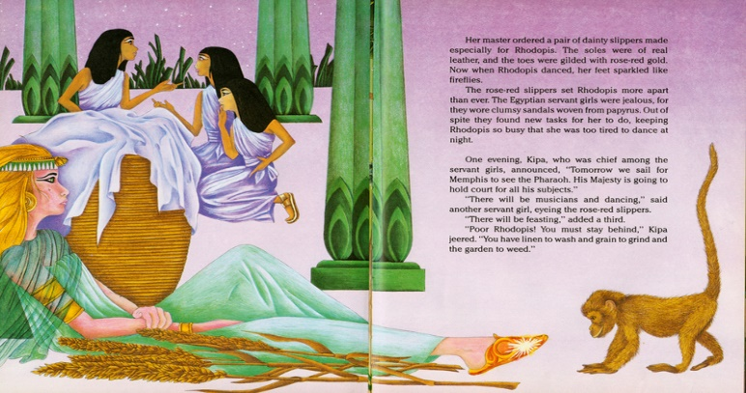
Use the story book to help you.

(Remember to upload a picture of your work onto Class Dojo.)
Lesson 2
You do not have to read the story today, but if you wanted to, click on the link below and follow the story as you listen to the book being read to you.
https://www.youtube.com/watch?v=dSVfIc4l8Lk
At the beginning of the story, we discovered that Rhodopis was kidnapped by pirates from her home in Greece.
How do you think her parents might have felt?
Task
Create a missing poster.
On your poster you need to include:
- A picture of the person missing.
- Contact number.
- A reward.
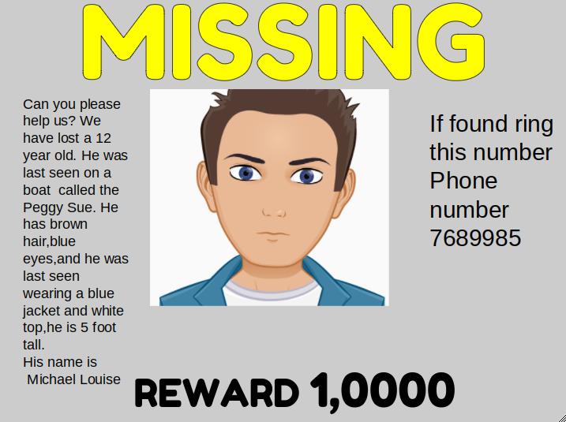
- A description of what they look like and what they were wearing and where they were last seen.
(Remember to upload a picture of your work onto Class Dojo.)
Lesson 3
You do not have to read the story today, but if you wanted to, click on the link below and follow the story as you listen to the book being read to you.
https://www.youtube.com/watch?v=dSVfIc4l8Lk

We know from reading the story that Rhodopis has many chores to do throughout the day. Think about all the different chores that have been mentioned in the story.
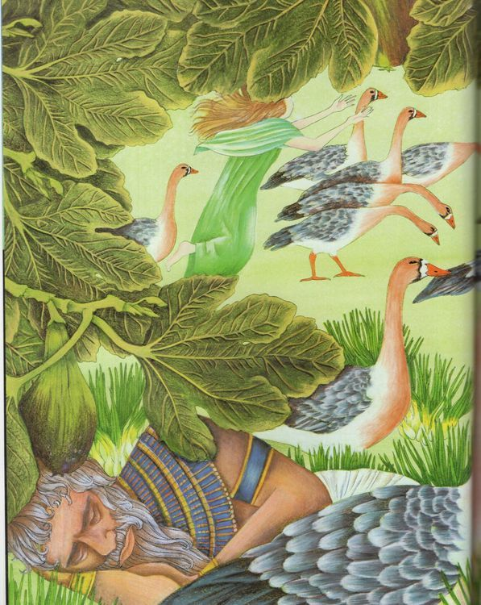
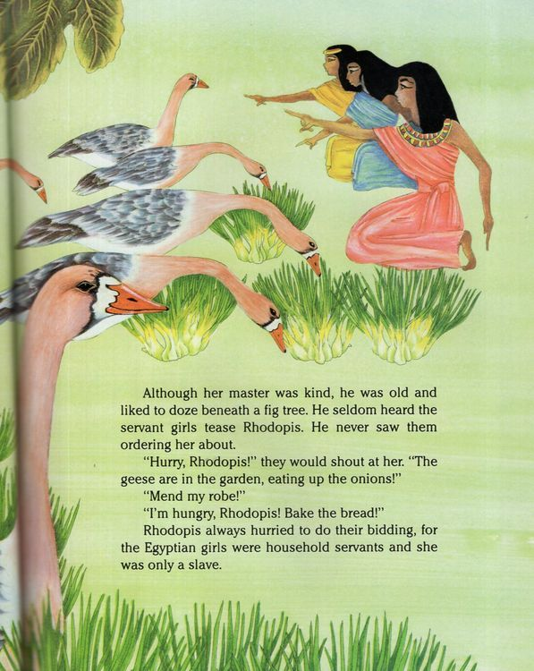
Task
Write a diary extract. Imagine that you are Rhodopis and you are writing in your diary about your day. Remember to write in the first person, so you can use: I, me, my.

(Remember to upload a picture of your work onto Class Dojo.)
Lesson 4
You do not have to read the story today, but if you wanted to, click on the link below and follow the story as you listen to the book being read to you.
https://www.youtube.com/watch?v=dSVfIc4l8Lk

In the story, Rhodopis was at the river washing clothes when a great falcon swooped down and snatched one of her beautiful slippers.
Task
Again, you are going to imagine you are Rhodopis and after the day you have had by the riverside, you have decided to write a letter home.
- Your letter is going to tell your family back home everything that you have been doing.
- Make sure you add as much detail as possible.

(Remember to upload a picture of your work onto Class Dojo.)
Lesson 5
You do not have to read the story today, but if you wanted to, click on the link below and follow the story as you listen to the book being read to you.
https://www.youtube.com/watch?v=dSVfIc4l8Lk

In the story, the great falcon took the slipper that belonged to Rhodopis to the Pharaoh, Amasis. The Pharaoh knew that this was a sign from the Gods, so Amasis, declared that whomever the slipper fit, he would marry and she will be his queen!
Task
You are Amasis, write a message, to be put onto a scroll, to help find the owner of the red slipper. This will be read to every maiden who is to try on the beautiful, dainty slipper.
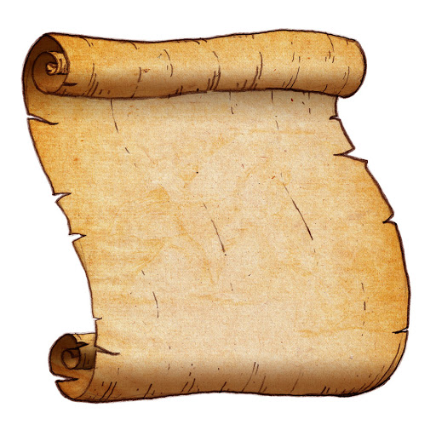
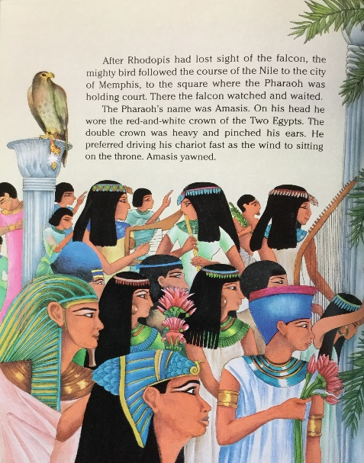

I, Amasis, the Pharaoh of Memphis declare that …

(Remember to upload a picture of your work onto Class Dojo.)

