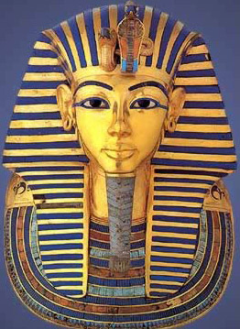
ART
When someone died in Ancient Egypt, their body would have been preserved by being mummified. This meant that the soul would have somewhere to return to after death. A death mask was created so that the soul would recognise its body, and return to it safely. Death masks were also believed to help to guard a dead person from evil spirits in the afterlife.
This week you can create your own death mask just like Tutankhamun’s death mask. (Don’t forget to send your photograph as soon as you can.)
Here are some suggestions:
- Make a cardboard or paper death mask and decorate it using paint or colouring pencils.
- Make a paper mache death mask, then paint or colour it in.
- Make a mosaic death mask using different coloured small square pieces of paper.
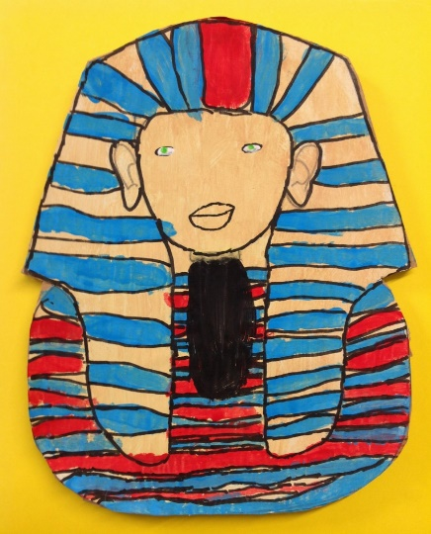
- Create a death mask using different coloured Lego blocks.
