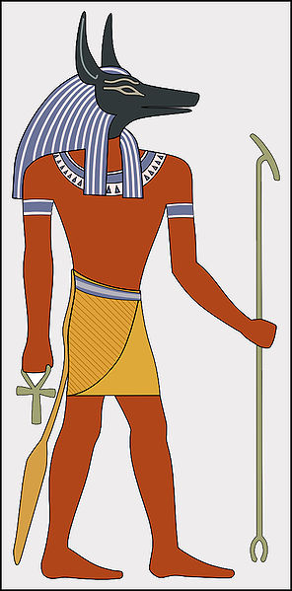
Lesson 10
The Ancient Egyptians.
This week we are continuing to read the book ‘The Ancient Egyptians’.
Open the book that has been attached. It is a PDF file.
Read the section called ‘Gods and Goddesses, Ancient Egyptian Religion’.

Task
Create your own Egyptian God or Goddess.
- Draw a picture of your God or Goddess. Think carefully about what you want your God or Goddess to look like.
- Now think about, what is your God or Goddess a God or Goddess of? For example a God of plants, a Goddess of pets.
- Write underneath your drawing, a few sentences explaining what your God/Goddess is a God/Goddess of.
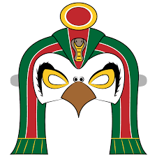
This is Passerine. He is the God of Birds.
He created all birds and gave them their ability to fly high and explore the magnificent skies around them.
He is their protector and guardian.
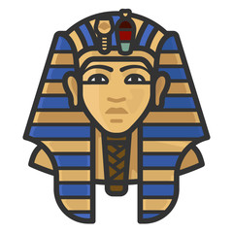
Lesson 11
The Ancient Egyptians.

Open the book that has been attached. It is a PDF file.

Read the section called ‘Egyptian Pharaohs’, please read both pages.

Task
Answer the questions carefully and make sure your handwriting is beautiful.
Why were Pharaohs the most important people in the land? (2b)

What did the Egyptians believe Pharaohs were? (2b)

Why do you think Cleopatra made a lot of money for the Egyptian kingdom? (2d)

Why do think Ramses II had the most statues made of him out of all the Pharaohs who have ruled Ancient Egypt? (2d)

Lesson 12
The Ancient Egyptians.

Open the book that has been attached. It is a PDF file.

Read the section called ‘Tutankhamun, The Boy King’, please read both pages.

Task
Write a paragraph about Tutankhamun and his tomb, include information about:
- Tutankhamun.
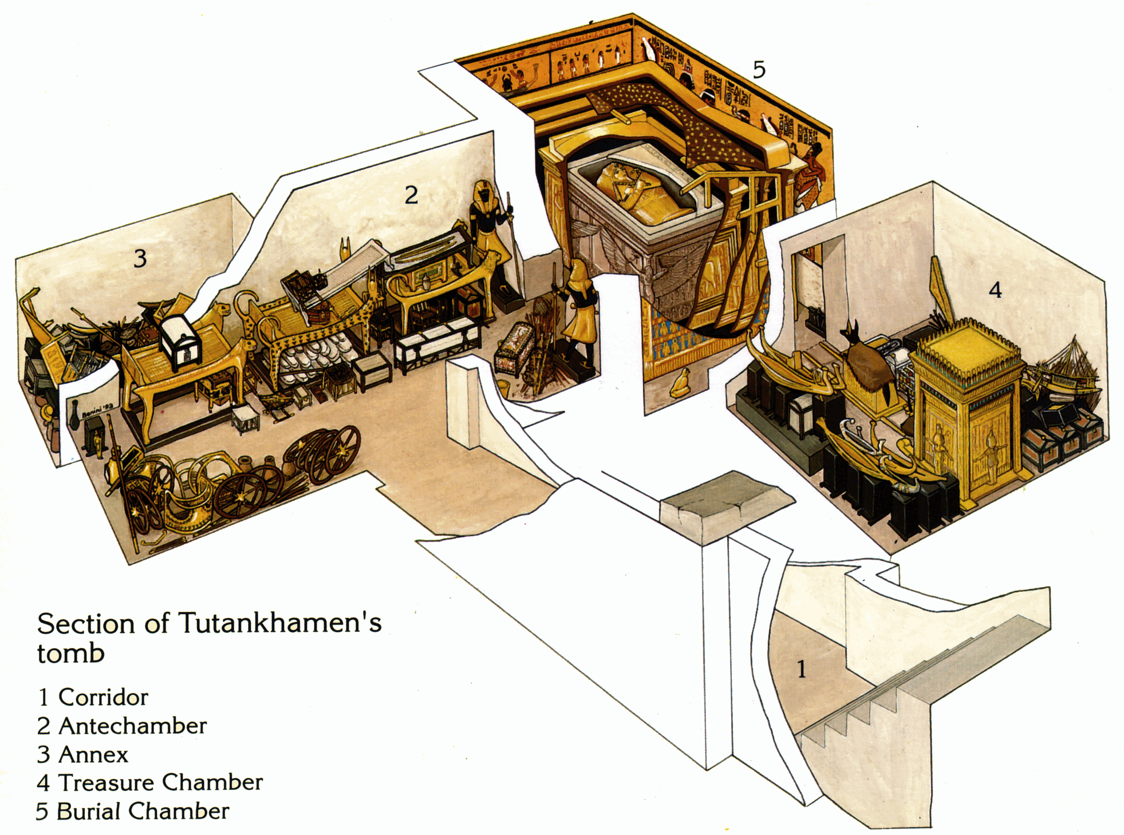
- The discovery of his tomb. The treasures found inside his tomb.
If you would like, as a challenge you could also design the layout of this famous Pharaohs tomb and label it.

