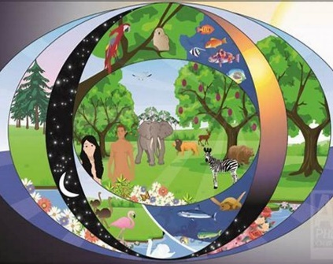
Lesson 6
R.E
Now you know all about the Christians, Jews and Muslim’s stories about how the world was created, we can look at both stories and think about parts that are the same or similar and parts that are different.

Task.
On paper, split the paper in half. Label one half similarities and one half differences.

Differences
Similarities

List the similarities and differences between the two stories.

Don’t forget to take a picture and upload it onto Class Dojo as soon as you can.

