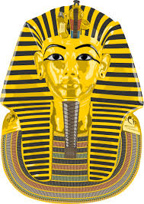
Lesson 1
Today, you are going to sketch diagrams, label them and place Tutankhamun’s objects in his tomb, just like Howard Carter did in 1922.

Howard Carter and his team had uncovered
the greatest discovery of all time.

In all Howard Carter found over 3,000 items in Tutankhamun's tomb, he found:
Luxurious chests, thrones, beds, linens, clothing, necklaces, bracelets, rings, earrings, chariots, bows and arrows, swords, daggers, shields, ostrich feather fans, trumpets, statues of Tutankhamun and many Egyptian gods, figures of animals, models of ships, toys, games and storage jars containing precious oils.
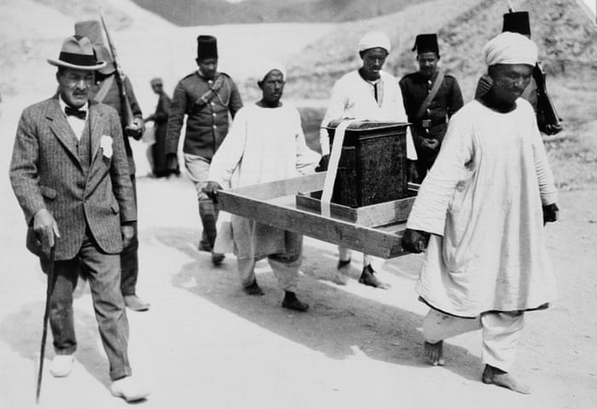

Howard Carter, labelled every item found and where it had been found before he removed the objects from the tomb.
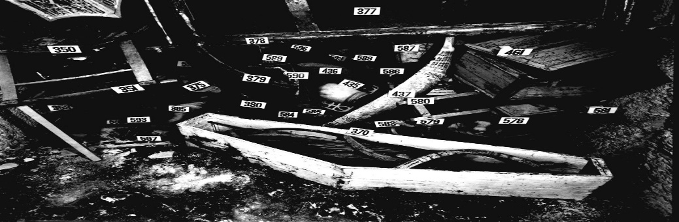

Task
Just like Howard Carter, you are going to draw the items found. You can choose just one chamber or more than one chamber if you would like a challenge!
Using the information from the last lesson, you can draw the items and place them where you would like in the tomb.
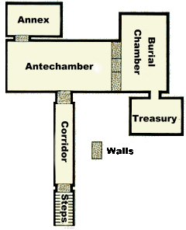
This is tomb layout.
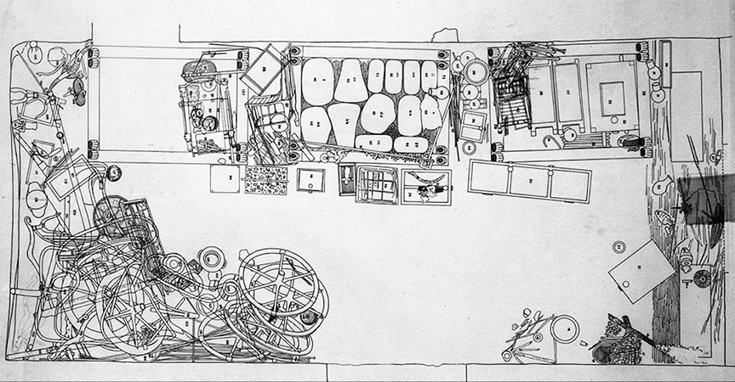
This is a sketch of the items found in the antechamber.

(Remember to upload a picture of your work onto Class Dojo.)
Lesson 2
Today, you are going to be looking at the features of a newspaper report. Next week, you will be writing a newspaper report all about the discovery of Tutankhamun’s tomb.

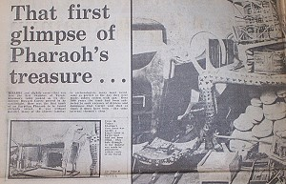
A newspaper report has many features that make it a newspaper report.
Here are the features of a newspaper report:

Masthead: The title of a newspaper.
Headline: The title of an article.
Standfirst: Introductory paragraph that summarises the article. It is often printed in bold to make it stand out.
Lead Paragraph: Opening paragraph which answers the questions; Who? What? Why? When? and Where? This comes after the standfirst.
Columns: The text is broken up into columns to make it easier to read.
Photograph: Carefully chosen to interest or inform the reader.
Caption: Tells us who or what the picture is about and makes a link to the story.
Quote: Tells us who or what a person has said about the event when they were interviewed by the reporter.

Task.
You are going to find the features of a newspaper report.
The features you are looking for are:
Masthead. Columns.
Headline. Photograph.
Standfirst. Caption.
Lead paragraph. Quote.
Look at the newspaper report attached (Week 7 literacy lesson 2)
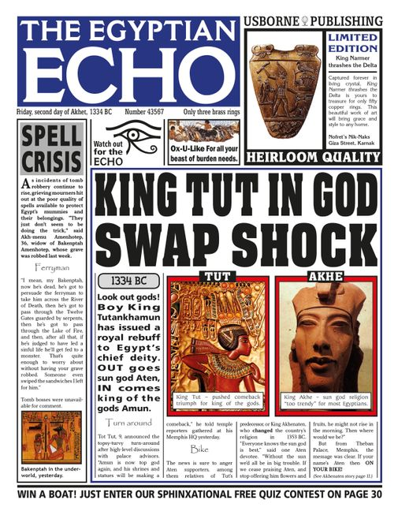
Find the features of a newspaper report from The Egyptian Echo.

Set your work out like this:
Masthead - The Egyptian Echo.
Headline – King Tut in God swap shock.
Columns – Yes.
Picture – Yes

(Remember to upload a picture of your work onto Class Dojo.)
Lesson 3
Today, you are going to be looking at another feature of a newspaper report. Today you are going to focus on the 5 W’s.

The 5 W’s of a newspaper report are:
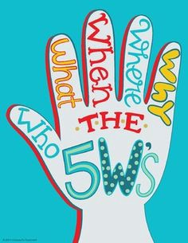
- Who was involved?
- Where did it happen?
- When did it happen?
- What happened?
- Why did it happen?

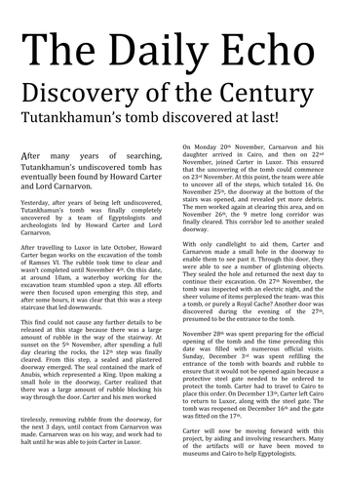

Task 1
Read the newspaper report attached (Week 7 literacy lesson 3)

Task 2
Thinking about the 5 W’s, read the newspaper report again and see if you can find the 5 W’s:
- Who was involved?
- Where did it happen?
- When did it happen?
- What happened?
- Why did it happen?

Now, write down the 5 W’s that you have found and set your work out like this:

Who was involved?
Howard Carter and Lord Carnarvon were the people involved in the discovery of Tutankhamun’s tomb.

Where did it happen?
The discovery of the tomb happened in Luxor, Egypt in a place called the Valley of the Kings.

(Remember to upload a picture of your work onto Class Dojo.)
Lesson 4
Today, you are going to use of all your knowledge about the discovery of Tutankhamun’s tomb to write a short report.

We know from all the literacy, reading and history from previous lessons, that Howard Carter recorded 3,000 items inside the tomb of Tutankhamun. These artefacts are still on display today in a museum in Cairo, Egypt.
The discovery of Tutankhamun’s tomb was the greatest find in Egypt’s history. These artefacts, along with hieroglyphs found inside the burial chamber, have helped historians all over the world understand what it was like to live in Ancient Egypt during the reign of Pharaohs.

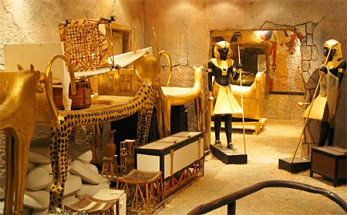
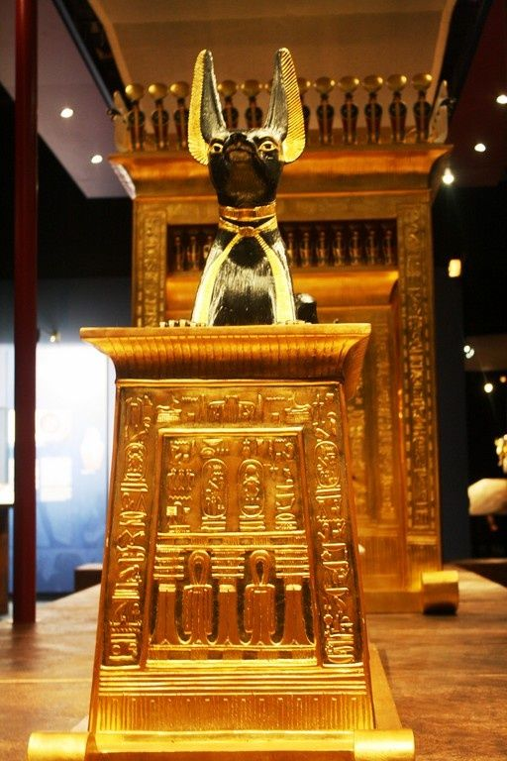
Artefacts from Tutankhamun’s tomb in a museum in Cairo, Egypt.
Task
Write a short report about the artefacts found in Tutankhamun’s tomb.
Your report needs to include:
- Detailed descriptions of the artefacts.
- Adjectives so the report is interesting to the reader.
- You could use a quote from Howard Carter.
- Where are the famous artefacts found today?
- Who is the report by?
Use all of the knowledge you know from previous lessons as well as your own research.
How Howard Carter Almost Missed King Tut's Tomb!
British backer Lord Carnarvon wanted to call off the search for the lost tomb of Tutankhamun after six, long years of searching, but Howard Carter convinced him to stick it out for one more season.
Having cleared the debris from the stairs, Carter’s team revealed the top of a doorway. Upon it were the undisturbed seals of the royal stamp, a sight that made Carter’s heart race with excitement.
Howard Carter peered into the sealed room through a tiny hole. He heard Lord Carnarvon asking, “Can you see anything?”
“Yes,” Carter replied. “Wonderful things. Wonderful things!”
By Mrs Boult.

` (Remember to upload a picture of your work onto Class Dojo.)
Lesson 5
Today, you are going to be interviewing Howard Carter. You will be able to use this interview when you are writing your newspaper report next week.
We have already looked at the features of a newspaper report, one feature is the use of quotes. Quotes within your newspaper report makes the report more interesting to the reader and gives them an idea of what happened.
Before you can interview a person, you have to think of a number of questions you would like to ask.
Task 1
Think about what questions you would have liked to ask Howard Carter if Tutankhamun’s tomb was discovered in 2020.
Some examples you could use:

How did you feel when you saw a room filled with amazing artefacts?
How would you describe the things you saw?
How did you know the tomb was going to be something incredibly special?

Write your questions down.
Task 2
You can now use your to interview Howard Carter.
You could use other members of your family to help you with this task.

Here are a number of suggestions for you to carry out your interview.
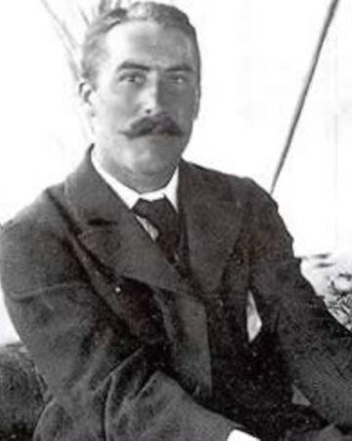
You are Howard Carter.
- Ask another member of your family to interview you and video the interview.
- Ask another member of your family to interview you and write your answers down.
- You could play both roles of Howard Carter and the interviewer and write your answers down.
- You could play both roles of Howard Carter and the interviewer and video the interview.
Think about your questions and answers carefully as you can use these quotes in your newspaper report.
Good luck reporters and have lots of fun!

(Remember to upload a picture of your work or your video onto Class Dojo.)

