PHSCE
Lesson 6
Our objective this week is to know why it is sometimes important to stop and think when we feel angry or stressed.
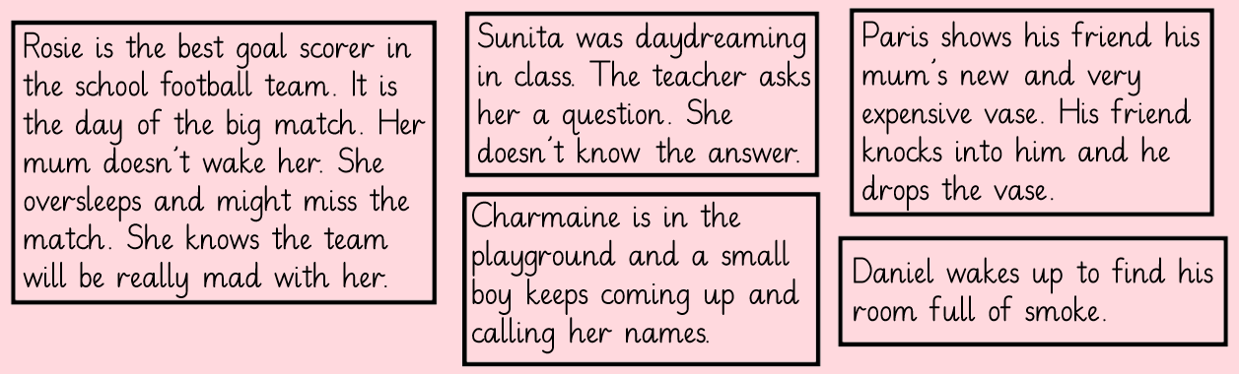
The fight or flight response is the instinctive way to act in a threatening situation. It means you stand and resist it (fight) or you run away (flight).
Read the above statements and decide which response (fight or flight) would be best to tackle each of these situations.
……………………………………………………………………………………………………………………………………………………………………………………………………………………………………………………………………………………
