GEOGRAPHY
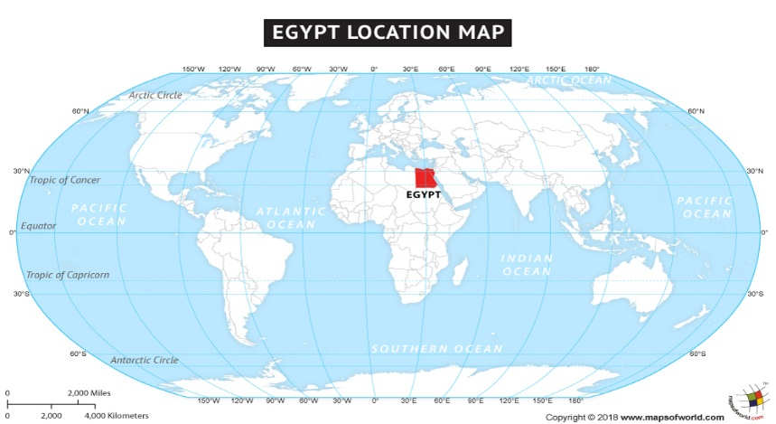
Lesson 5 and 6
Today, you are going to use all the knowledge you have learnt in Geography about Egypt to create a fact file.

Over the past few lessons, you have learnt many things about Egypt. You now know lots of information about Egypt’s location and size, climate, population and the River Nile.

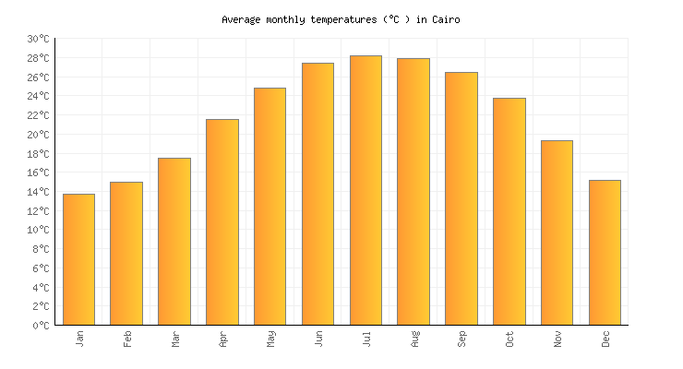
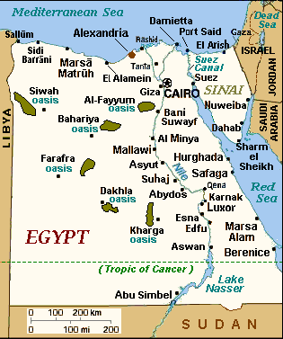

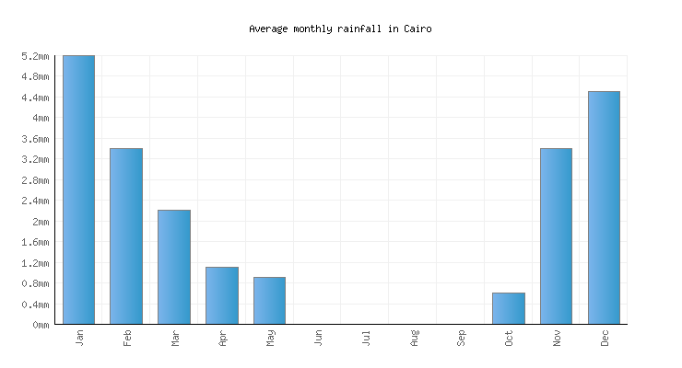

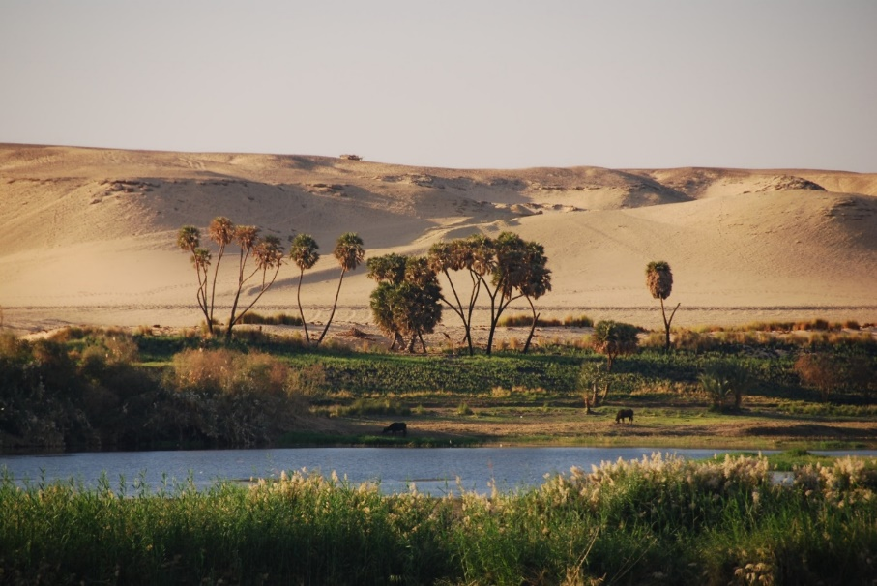

Now, look at the work you have produced and think about all the things you know about Egypt.
Task
Over the next two weeks, you will have time to create a fact file all about Egypt.
Create a fact file which includes:
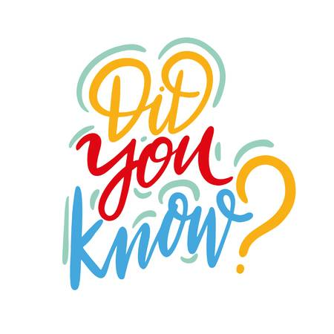
- Title.
- Use sub-headings:
Location and size.
Climate.
Population.
River Nile.
Interesting facts.
- Pictures with captions.
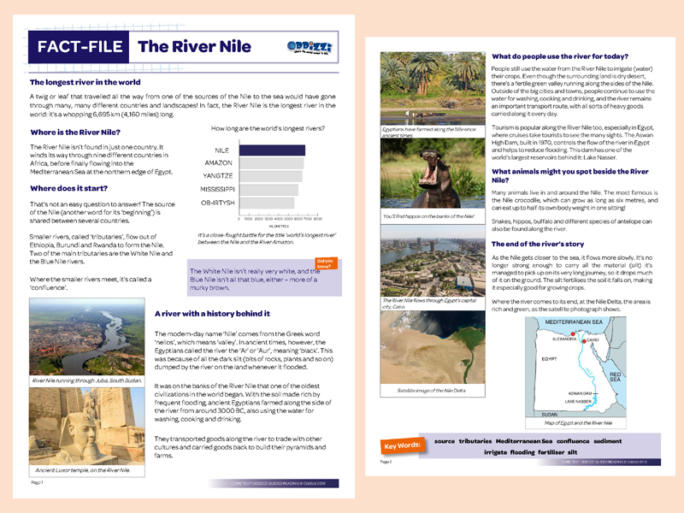

Remember you have two weeks to complete your fact file so take your time and make it amazing!
Put a photo on Class Dojo of your work, don’t forget to label the work Geography.

