Science – lesson 3
Identify the similarities and differences between skeletons and explore their functions

What do you know about Skeletons? Write here:

First, we are going to look at animal skeletons. Open up the power point here

Q: Which bones are for protection?

Q: What do they protect?

Q What else helps them to move?

Q What would happen if you did not have a skeleton?

If you are unsure, watch these videos to help
https://www.bbc.co.uk/bitesize/clips/ztfnvcw
https://www.youtube.com/watch?v=SiBzCpg6vu8

Task 1:
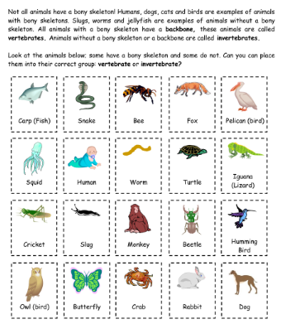

Sort the animals according to whether they think they have a skeleton or not. Use the internet to check whether each of the animals has a skeleton.
Vertebrates | Invertebrates
e.g. Dog | e.g.Slug

Task 2: Look at the key words. What have you learnt today about skeletons? Use the key words to write what you have learnt below:
protect muscles support
backbone move brain
skull skeleton ribs joints
bones heart spinal column
invertebrate vertebrate

Task 3: Finally, let us see how much you have learnt today. Have a go at the quiz and post your score on Dojo.

https://www.educationquizzes.com/ks2/science/skeletons/

What do you now know about Skeletons, that you did not before? Write here:

